**Northern Fury 39 -** **Anvil**

14 March 1994, 0600 Zulu, 0600 Local

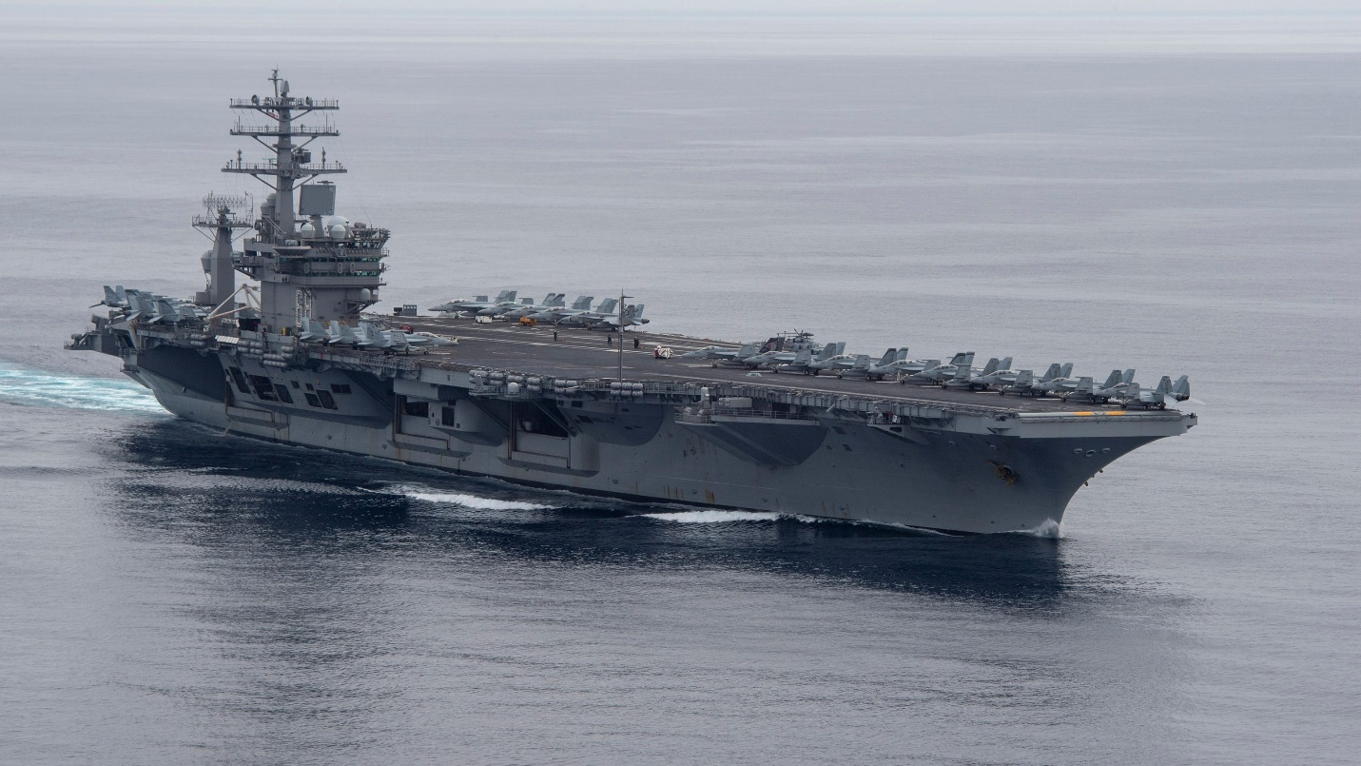

You are commanding TF 20.2 centered on two CVBG’s: *Nimitz* and *Carl Vinson*. You job is to quickly follow a divisionary attack set by the British (TF 20.3) to your south and strike the Bodo/Evenes/Andoya area to neutralize those three airbases. In the overall plan – You are the ‘**Anvil’** and have 24 hours to crush your targets. 25th Air Force’s attacks against the Land Lines of Communications (**Hammer**); which are just completing now should have the defences off balance. Tomorrow TF 20.1 (Enterprise & Roosevelt) will carry out precision strikes to your North as ‘**Tongs’** is put into action.

**Northern Fury #39** is a large scenario where you have two US aircraft carriers and 24 hours with which to shut down three Soviet airbases. The defences have been attrited but not destroyed, they remain a threat to operations.

