**Northern Fury 40 ‘Tongs’**

16 March 1994, 1800 Zulu, 1900 Local

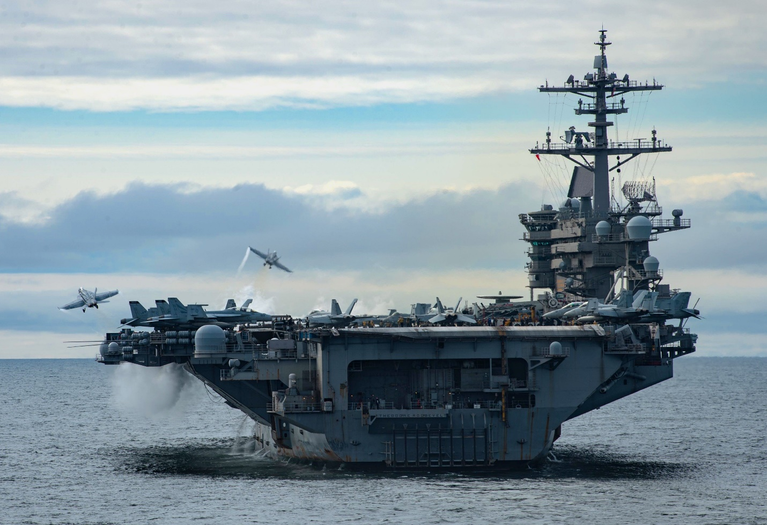

You are commanding TF 20.1 centered on a powerful two carrier Battle Group: ***Theodor Roosevelt*** and ***Enterprise***. You task in the final element of **Operation Thor’s Lightning** is to interdict the ground line of communications and C2 of the Soviet land forces in Norway. In the overall plan – You are the ‘Tongs’ and have 24 hours to conduct precision strikes in the Narvik area.

**Northern Fury #40** is the final phase in of **Operation Thor’s Lightning** and reaches the furthest north of any other action so far. If the Soviet are going to try and interfere, this would be a good time to do it. Unfortunately, the ‘bean counters’ at Fleet, have started to realize that continuous operations are chewing through the missile stockpiles very quickly. That will certainly have an impact on your operations.

