**Northern Fury 41 Tour de Force**

18 March 1994, 0800 Zulu, 0700 Local

You are in command of Strike Fleet North (STRIKFLTNOR) and control all naval and air assets north of the GIUK gap and above the Arctic Circle in Norway. Your boss, Admiral Falkner commanding Strike Fleet Atlantic (STRIKFLTLANT) from shore at Faslane Scotland has given you his command ship (USS Mount Whitney) and most of the offensive power of NATOs Atlantic Fleet.

You’ve just wrapped up **Operation Thor’s Lightning** with a two-carrier strike on the Command and Communications structure in the Narvik area, but we’re not ready for the next major operation yet. You’ve been informed that the amphibious/airborne operation planned for northern Norway is at least two weeks away. Therefore, you have the problem of keeping the pressure on the Soviets without risking any major losses. Of course, *Ivan* will see this as an opportunity to strike back, he still has lots of ways to do that.

Your role in this scenario is one that is seldom depicted in CMO, that of a ‘holding action’. You are not on the defensive, but your offensive actions need to be limited and have the general effect of tying the enemy down for the next 10 days. Physically, you have the capacity to restore cave-dwelling as an acceptable way of life in north Norway – but that would be counterproductive and not fit the overall plan of action for the next month. Going on the attack now would expend tremendous resources, both logistically and in the form of loses, bringing the Strike Fleet to a much weaker state when it is needed to support the amphibious operations in a couple weeks. From a *Principles of War* perspective, you are conducting an *Economy of Effort* operation to allow Admiral Falkner (and you in later scenarios) to *Concentrate Force* and *Maintain the overall aim* of the campaign.

This scenario is playable by NATO:

You are commanding a Fleet, there are initially four growing to five USN Carrier Battle Groups, augmented by two British CVs and first one then two French CVs. You also have significant logistics forces and one of your main tasks is to replenish your forces and set up for the next major operation. In total there are over 120 vessels and 650 aircraft. The scenario lasts for 10 days and you will receive new intelligence and further tasks each day.

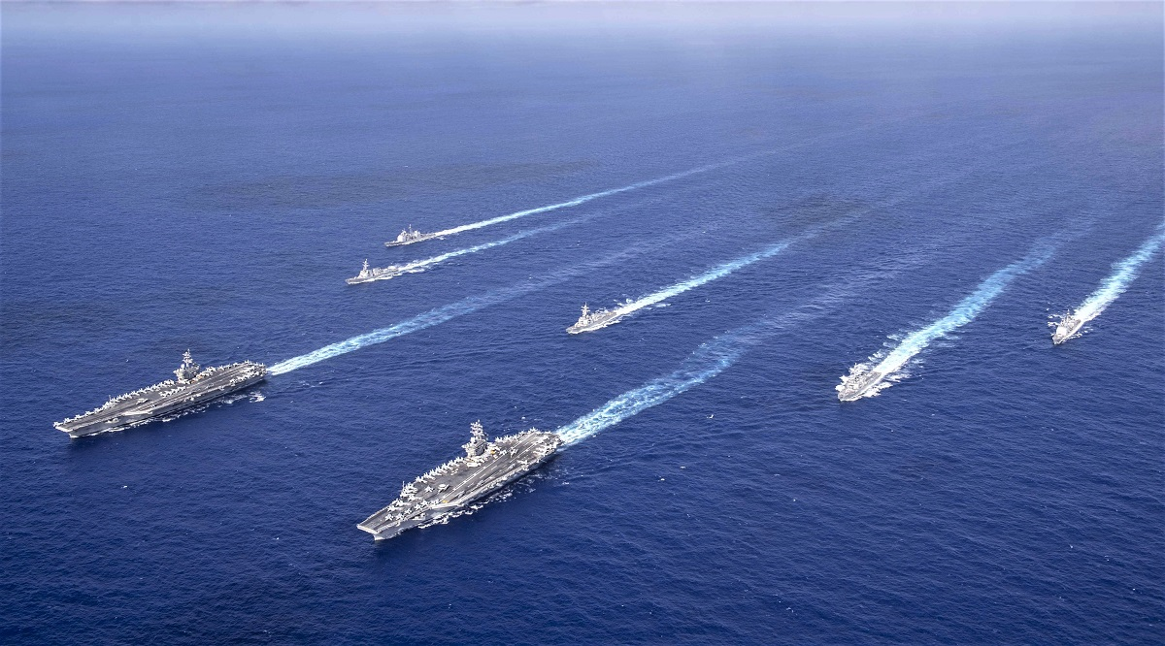

**Northern Fury #41** is a massive and complex scenario. In total the player controls nine aircraft carrier battle groups and dozens of other smaller groups or individual ships. Each day new tasks will arrive causing a re-shuffle of resources and risk. The Soviets still have a lot of combat power left to throw into the fight.