**Northern Fury 42 – Blast from the Past**

20 March 1994, 2200 Zulu, 2300 Local

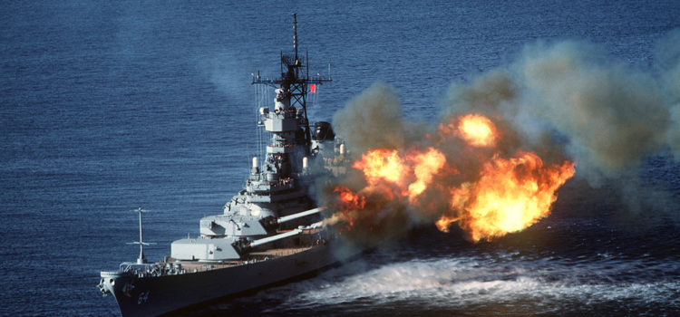

**You are commanding the USS Wisconsin Task Group** and are charged with destroying several coastal fortresses that were built by the Norwegians to fend off an attack from the sea. The Soviets are now manning these guns and have expended a reasonable amount of ammunition to become proficient with them. You also need to insert a Special Forces team undetected into the mountains near the Swedish border – but most of all you need to convince the Soviets that we are very interested in this area.

**Northern Fury #42** is a small scenario with features a classic Big Gun Battleship against shore installations harkening back to bygone days. The scenario happens concurrent with NF #41 but is a bit of a sideshow so is much more fun played on its own.

