**Northern Fury 43, Red Devils**

31 March 94 1200 Zulu, 1400 Local (in the drop zone)

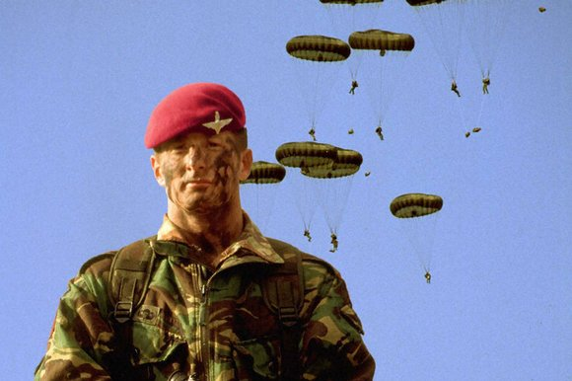

Six weeks into World War Three and the Warsaw Pact has been halted on all fronts, now NATO is striking back. Overnight 31 March/1 April STRIKEFLTLANT will conduct amphibious and airborne operations to sever the Soviet land and sea line of communications (LOC) in Norway. This is a major operation, and you will play a key role in this critical phase of the war.

**OPERATION ODIN’S THRUST** is a major joint/combined operation, planned to take place over the next 96 hours. You will command the British 5th Airborne Brigade [5th (GB) AB Bde] ***The Red Devils***in a bid to seize Banak Norway as the Left Flank of a Corps sized operation. To your west ***[not in scenario***], 3 (Royal Marine) Commando will secure a major logistics and road hub at Alta. Beyond that two Regimental Landing Teams from the US Marines will land and to the south two Brigades of the US 82nd Airborne Division will drop in the Narvik area.

A follow-on force of a US National Guard Division and several independent Brigades is already at sea. In several days [***not in scenario***], the ACE (Allied Command Europe) Mobile Force Land (AMFL) and the Portuguese Amphibious brigade will arrive under the command of 6th (GB) Division, absorb your Brigade and the Royal Marines and Guard the left flank of the operation.

Your task in this scenario is to seize and hold the Banak area; you have a large brigade but deploying it will be complex, and the Soviets will surely strike back hard.

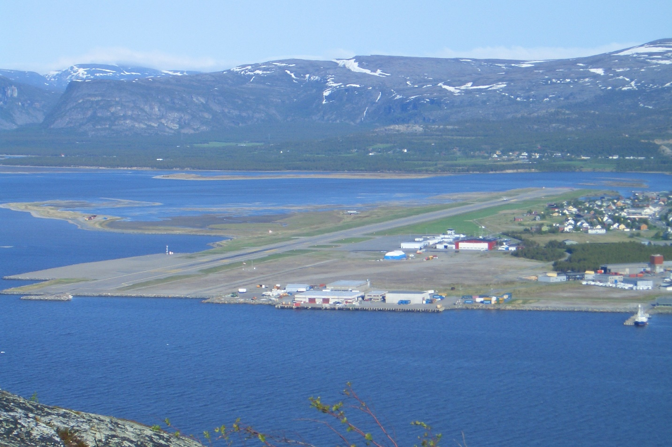

**Northern Fury #43** covers a lot of area with the Bde elements taking off from the UK and Iceland, landing in a small area near Banak, Norway - using essentially the same drop zones the Soviets did on day one of the war. The Red Devils are a powerful, elite force but not heavily equipped. The Soviets are a heavily equipped force but not overly well trained. Once again the British Paratroopers are going further and deeper than the rest of the force, the player needs to make sure it is not a bridge too far…

