**Northern Fury 44, Into the Bastion**

31 March 94 0200 Zulu, 0400 Local

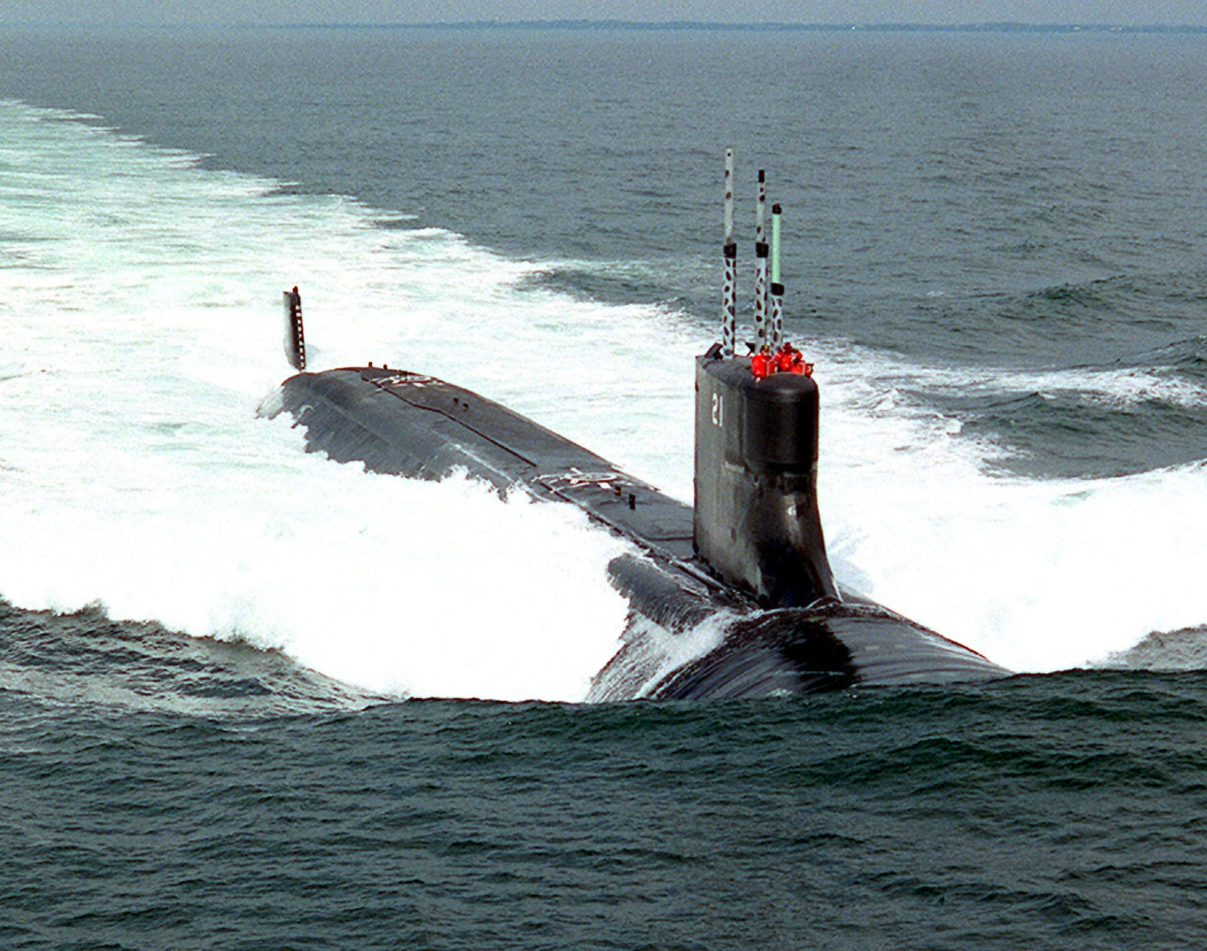

Six weeks into World War Three and the Warsaw Pact has been halted on all fronts, but before any serious NATO offensive takes place a question must be resolved. The Nuclear question.

While NATO leaders are confident that they have halted the Soviet advance, much hard fighting lies ahead if the alliance is to liberate territory now in the hands of the Soviets. Including the capital cities of two NATO members. Right now, the Norwegian front appears to present the best opportunity to rapidly reclaim territory without incurring heavy losses. Of course, the ever-present concern is that the Soviets may resort to nuclear weapons if they feel too hard pressed. Therefor, NATO needs to send them a message that such escalation is folly.

Many Soviet leaders, however, believe that special weapons are like any other weapons – made to be used if needed. The one significant holdout on the Soviet side however is the President, and he holds the final decision.

In this scenario the US decides that it should send a clear and unmistakable message to the Soviet President, to make sure he doesn’t change his mind.

**This scenario is playable by either NATO or the WP**:

**Into the Bastion**, is a small, submarine focused scenario with the most advanced submarines in the 1994 world pitted against each other.

As NATO you will take two ***Seawolf*** class SSNs into the Soviet Barents Sea Bastion, eliminate any Soviet SSNs and identify their SSBNs without being detected. The tracking data you obtain will find its way into President Medvedev’s hands as a signal of what the US could do - but didn’t.

As the WP player you have two ***Typhoon*** class SSBNs and their escorts. You expect the Americans to penetrate your bastion at some point and you are ready to destroy them when they do. Keep your Boomers hidden while you sink the intruders.

**Northern Fury #44** is a scenario focused on the use of submarines in a contested space. The US player needs to show both aggression and restraint, killing a Soviet Boomer will undoubtably unleash the nuclear monster as surely as launching missiles at Soviet space. From the Soviet perspective, the SSBNs are the last line of national survival, if they are lost – so is the war.

