**Northern Fury 45, Rock on the Beach**

2 April 94 0300 Zulu, 0400 Local

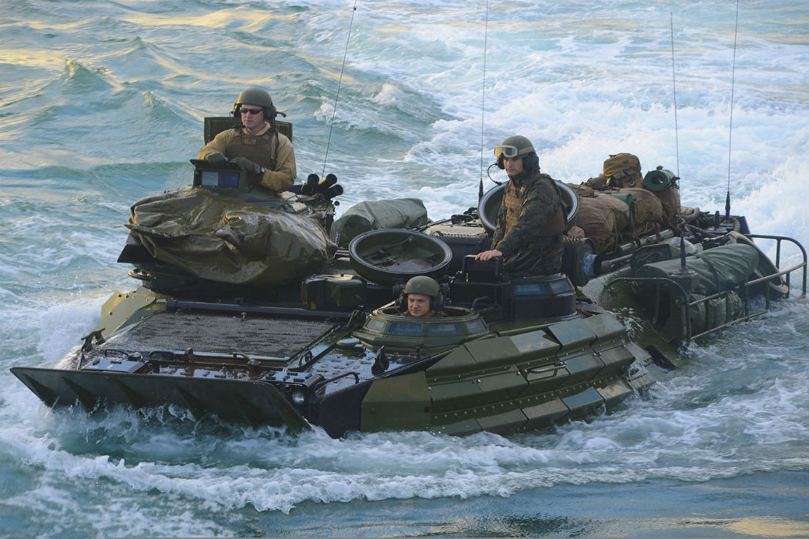

Six weeks into World War Three and the Warsaw Pact has been halted on all fronts, now NATO is striking back. Overnight 31 March/1 April STRIKEFLTLANT conducted amphibious and airborne operations to sever the Soviet land and sea line of communications (LOC) in Norway. As anticipated the Soviets reacted strongly and you, as commander of the 6th Marines Regimental Landing Team (RLT), acting as the floating reserve have been committed to stabilize a difficult situation.

As part of **OPERATION ODIN’S THRUST** your Regiment, veterans of the ferocious fighting on Iceland last month, were held back a reserve. Your sister RLTs, 2nd Marines who have spent the war afloat, and 25th Marines, a reserve formation just arrived in theater, went ashore two days ago and have run into some trouble.

The British Royal Marines, and airborne units to the north have had a tough time but are holding firm, Soviet forces are mounting on the eastern flank however. To the south, two brigades of the 82nd Airborne Division landed successfully but are under heavy pressure from the south.

Your task in this scenario will be to seize and hold the area north of Narvik, in preparation for another brigade of the 82nd Airborne to jump in and seize the town itself [not in scenario].

**Northern Fury #45** is a scenario set in a very complex environment, the Soviets are split in two on an operational level, with an Army to the east and north and several large formations trapped to the south. Additionally, there are forces trapped in the middle between the Brits, the other Marine Regiments and the 82nd Airborne – these are the ones you are fighting. These trapped elements are well positioned, well equipped and show no sign of giving up, which makes them quite dangerous.

