**Pacific Fury 1: Bolt from the Blue!**

13 Feb 1994, 1200 Zulu, 2100 Local

You are the commander of the USS *Independence* Carrier Battle Group. Your carrier and its battle group are the US Navies ‘Forward Deployed’ force based in Yokosuka Japan as part of the US 7th Fleet. In a normal year, your force would spend the winter months in port refitting, but this is not a normal year. Instead, the battle group deployed to the Philippians in early January for a multi-carrier exercise with USS *Constellation* and USS *Abraham Lincoln*, then a Freedom of Navigation run through the Strait of Taiwan, and finally an amphibious exercise with the South Koreans.

Now, plans to head home were canceled last night and we’ve been ordered to deploy to the south coast of Hokkaido for a deterrence operation. The Japanese government has been getting extremely nervous over the past few weeks and the fiasco at the Olympics has spooked them. We are planning to do a restricted passage drill through the Tsugaru Strait and spend about 72 hours patrolling up as far as the southern Kurils. The 35th Fighter Wing at Misawa has promised us a squadron of F-16s to run some air defence drills for us as well.

Should be a quiet week. What could possibly go wrong?

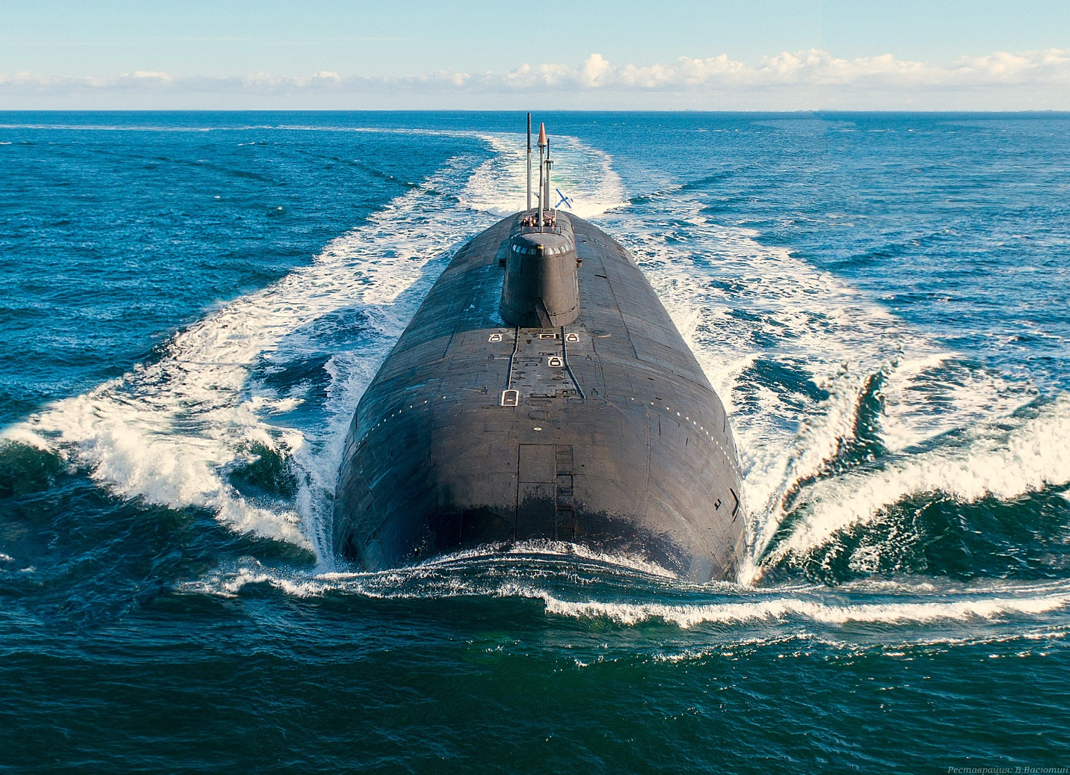

**Pacific Fury #1** is an and intense scenario. As the player moves his forces up the west coast of Japan, the Soviets spring a well orchestrated ambush which will be very difficult to contend with.

Other events will also keep the player busy but surviving the first few hours of the war will be paramount.

