**Pacific Fury 2: Bombeska on Hokkaido**

13 Feb 1994, 1230 Zulu, 2230 Local

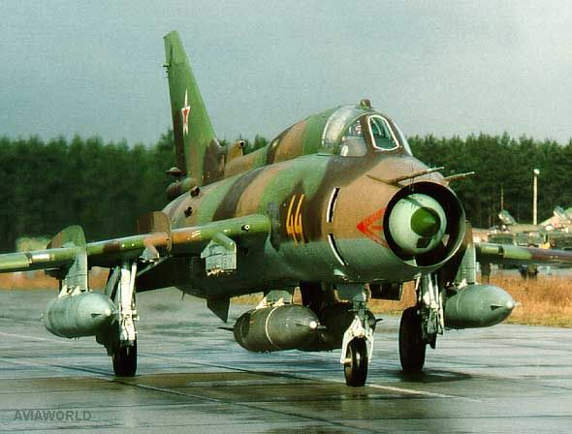

You are the Deputy Commander of the Soviet High Command of the Far East (GKVDV). You have been given the task of neutralizing Japanese and American forces on the island of Hokkaido to ensure safe passage of naval and air forces into the Pacific. While your commander is dealing with Moscow you have been given this critical but secondary task. It won’t be easy, especially when many of your assigned forces have a separate chain of command and/or have different objectives.

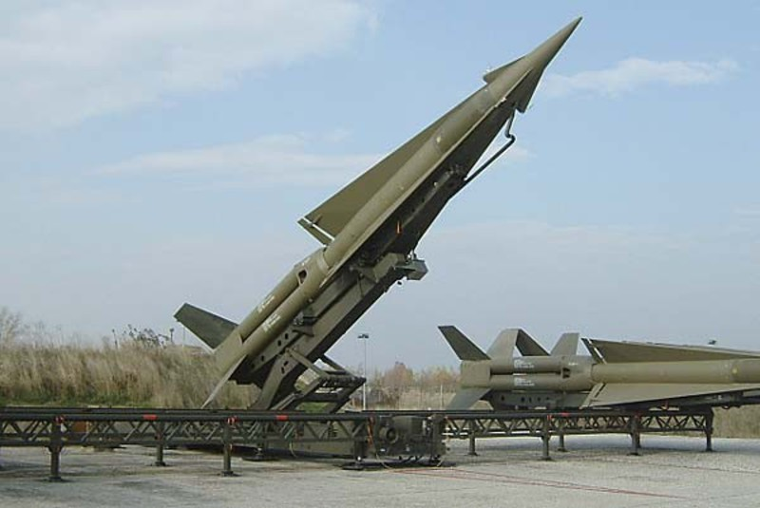

**Pacific Fury #2** is an interesting scenario played from the Soviet side. Although the Japanese and American defenders on Hokkaido have the technological edge over the players air forces, the Soviets have numbers on their side. However, one of the key complications to be negotiated is the divergent chains of command and different objective of each force contributor.

The main objective is to close the massive fighter base outside Sapporo, Chitose airbase, home to Japanese F-15 and supported by American F-16s from Misawa to the south. Secondary objectives include the air defence network, Electronic Warfare and Communications facilities and ensuring that the La Pirouse Strait is open for the navy to use.

