**Pacific Fury #2 – Bombeska on Hokkaido**

**Playtest Report by AndrewJ April 2021**

**SITUATION**

At long last, the Soviet Union will no longer tolerate the endless provocations and aggression of the West. In half an hour we strike! Our specific mission here in the east is to hit the northern Japanese island of Hokkaido, including ELINT stations around the island and the important airport of Chitose, as well as taking control of the La Perouse strait around the north end of the island.

There are a lot of assets in the area, but unfortunately, they’re not all for us, and there are plenty of signs we’re moving hastily, before everything is ready. Fighter strength is adequate, but not outstanding. We’ve got a pack of MiG-23s in the Kuriles, another of Su-27s on the mainland (but only half are ready), plus another of MiG-29s (none ready, waiting to ferry Sakhalin Island). That’s not actually a huge amount to begin with.

Attack plane strength isn't all in place either. We’ve got a base at Mongokhto stuffed to bursting with 64 Fitters, but they won’t actually be ready until dawn. We’ve also got two sets of Su-24s, some older Cs and newer Ds, but the better ones aren’t actually ours, and they’re only on loan for one strike. Annoyingly, they’re our only good PGM carriers. We’ve also got the usual brace of AEW and Elint birds, plus a few jammers.

Our helicopter strength is actually quite interesting, with plenty of different ASW, maritime patrol, and even some minesweeping helicopters near the straits. On top of that we’ve got some jammers, and some transport and attack Hips, complete with teams of SOF and demolitions experts to ride in them.

Our final assets are a series of small craft (minesweepers, ASW patrol boats, and lesser frigates) in the straits, plus some SAMs and even some long-ranged shore-based Sepal anti-shipping missiles guarding our islands.

For opposition, we can expect heavy fighter activity from Japanese F-15s operating out of Chitose, and American F-16s further south in Misawa. We’ve got two Japanese Nike sites plotted at the south end of Hokkaido, but the bases are sure to be heavily defended, and I expect more SAMs in that area. Most of the Japanese navy is probably further south, but we have warnings that a few of their ships may be operating in our area, and their submarines may try to control the straits (possibly with mines, though that might be counterproductive if they want to use the straits themselves. We have no indications of heavy American naval activity in our region. Hopefully that will remain true, at least for the moment.

**THE PLAN**

Our first order is to abandon the straits! All boats are directed to head for the south tip of Sakhalin Island at flank speed, and shelter there under the protection of the nearby SA-10 battery. No aircraft are to conduct ASW operations in the straits until further notice. I am not certain what the situation there will be, and I suspect that forces operating there (especially helicopters) will be at great risk from enemy aircraft. My forces will stay out of the straits until my MiG-29s have flown in to Yuzhno-Sakalinsk airport, and have set up combat air patrols over the area. They should be ready to resume patrols in about four hours from now.

The second order is to send out the usual array of scouts, AEW, ESM, etc. In addition to aircraft operating over Sakhalin Island and the mainland coast, I am also going to send my MiG-25 probing towards Chitose, as well as sending one of my AEW planes east towards the Kuriles, and then sweeping south-west along the chain towards Iturup. I am concerned about Americans potentially operating in that area and want to take a look. (A few of their destroyers hiding out there with TLAMs could make a mess of my eastern airfields.)

The third set of orders concerns the Japanese radar and electronic intelligence installations along the north side of Hokkaido. My armed Hip helicopters are directed to make commando raids on the installations at Wakkanai, Nemuro, and Abashin. The two eastern raids will have to refuel at the little airfield on Kunashir Island before returning home.

The final set of orders involves a lot of discussion among the staff. What is the best way to attack Chitose? It’s sure to be heavily defended, although we’re not yet sure how, but the single Nike in the area can’t be all of it. Cracking the base will be tough, and the current general-purpose loadouts on our Su-24s probably aren’t up to the task. An immediate SEAD strike is ordered (under heavy fighter guard) using the 8 Fencers which are currently loaded with ARMs. While they are conducting this initial reconnaissance in force, the remaining Su-24s will re-arm. Our older Su-24s will load every ARM they can, plus heavy conventional bombs, while the newer Su-24Ms will concentrate on heavyweight penetrating PGMs and some standoff ordnance. They should be ready in time for a concentrated dawn strike, supported by our Fitters, which will be ready at the same time. The Su-24Ms will be recalled for other duties at that time.

For the moment, we do not plan to ask for extra support from high command. The possibility of some loaned MiG-31s is extremely tempting, but the amount of political favours they want in return is extortionate. If something goes wrong in the first hour (such as F-14s showing up) we will still have some time to start begging.

**INITIAL RECONAISSANCE OPERATIONS**

As our reconnaissance and surveillance assets spread out, we begin to get a picture of the initial Japanese operations. There are F-15s over mid and northern Hokkaido, and F-16s in the south, plus occasional signs of MPA radars and an E-2 over the waters south of the island. My MiG-25 approaches at high altitude, getting good reads on the pair of Nike batteries near Chitose and Setana, as well as two additional radars (type unknown) operating on either side of Chitose. The Japanese navy also makes an appearance, in the form of a lone ASW destroyer operating just west of northern Hokkaido, but he’s all alone, and not a threat in his current position. There are a number of other ships in the La Perouse strait, and its approaches. A few get visually ID-ed as fishermen, the others seem to be acting like commercial vessels, and none seem to be of immediate concern.

**OPENING ATTACKS**

At 1:00 AM local time the order to commence hostilities is distributed to all stations. All but two of our Su-27s are in the air, headed for Chitose and northern Hokkaido, with the SEAD Su-24s securely guarded in the middle of the pack. On the other side of the theatre, nearly half my MiG-23s from Iturup are underway along the eastern side of the island.

Fighting breaks out in the north first, with a pair of F-15s succumbing to discrete AA-10-B shots, and then moves south. The Sukhois do quite well against the F-15s but are hard pressed to get an advantage over the F-16s, whose AMRAAMs are a continual thorn in my side. It takes a lot of weaving and dodging and wasted missiles to get to them, and a number of them take their shots and get away again, covered by the Japanese SAMs as they retreat. My MiG-23s also make some attempts to tackle the F-16s, but the results aren’t so great. Despite a numerical advantage of three or four to one on my part, the F-16s still manage to hold their own in the casualty exchange. Every time I think I’m free and clear another AMRAAM seeker clicks on out of nowhere, and I’m forced to flee again. Still, numerical superiority does have its advantages, and a few of my fighters manage to break free of the scrum and murder a pair of MPA, one on each coast. 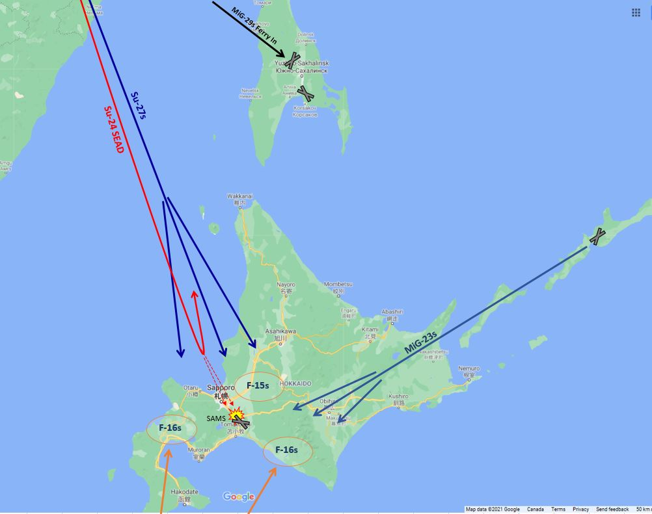

The heavy fighting guards my Fencers effectively, and they close to within launch range without being engaged. The first launch of AS-9s targets the Nike battery at Chitose, and the two radars adjacent to it. As these hurtle in, more SAM radars start turning on, prompting the Su-24Ms to open fire with their more modern AS-17s. Multiple hits are achieved, and as the Fencers head home they assess that they have hit the Nike site hard, killed the two (surveillance?) radars, and bruised a pair of HAWK sites. The problem is that three more HAWK sites lit up during the attack, and the two HAWKs which are wounded probably still retain their optical guidance systems. Those will work just fine during the dawn raid we have planned. Clearly, it’s not going to be an easy time in the morning.

(Plus, that other Nike further south is still being a pest, and hampering my freedom of maneuver on the SW side of Chitose to a surprising degree. Unfortunately, I don’t really have assets to spare for him at this time.)

**INVADE JAPAN!**

As the aerial fighting rages above, my helicopters are conducting a much more discrete war below. Slipping in at wavetop height, the Hips deliver highly trained commando teams at the ELINT stations. They can’t break into the bunkers in the time they have, but they quickly pack their explosives around the sensitive antennae, and fall back before the series of blasts turn the precision structures into heaps of scrap metal. They hasten to their helicopters, before nearby troops can react effectively, and hurry back out to sea towards the safety of their own bases.

Some of the helicopters also take the time to shred nearby radar installations with barrages of rocket fire, and a pair of Su-24Ms with conventional bombs sweep low across Hokkaido, killing the radar north of Sapporo, and the one on the south-east point of Hokkaido near Erimo. By the time the commandos and the Fencers are done Japan has lost all its land-based radar and ELINT stations on the main portion of the island. It will be several days before the troops in the ELINT bunkers can repair their antennae, while the radars are permanently destroyed.

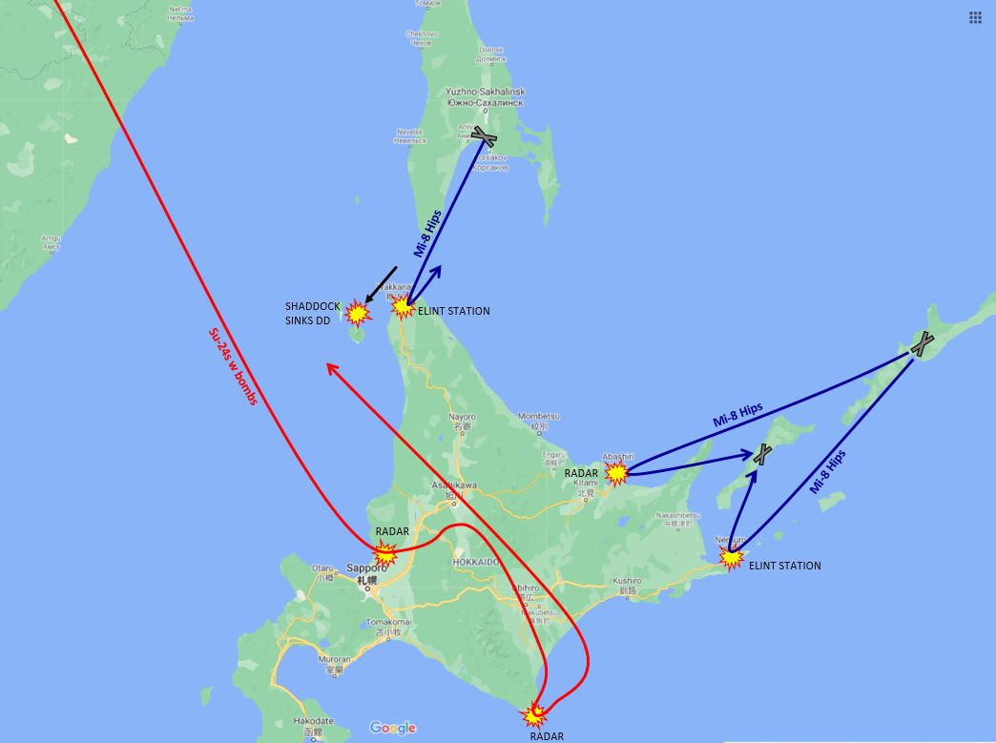

**RETIRE**

The last shot, as the planes retire, is a single Sepal missile fired from Sakhalin Island, which comes cruising along and smashes into the lone Japanese destroyer, sinking it in moments.

All my fighters and Fencers are retiring now, low on fuel and munitions, and pretending they’re not being driven away by fresh F-16s. I don’t have a lot left at this point. I have just under half a regiment of MiG-23s in the Kuriles, and two (2) whole Su-27s left up north to guard the mainland. That’s all.

I’m hoping the Japanese won’t be able to mount a credible offensive soon. It’s going to be two and a half hours before my MiG-29s start becoming available on Sakhalin, so things could get mighty lonely if the Japanese manage to move fast.

**INTERMISSION**

As the last of my planes continue home, nervously eyeing their dwindling fuel reserves, a Japanese F-15 makes an aggressive afterburner run from behind, forcing some of my Su-27s to turn around and pry him off. They manage to do it, but a few are so short on fuel that they have to land early at Maygatka, rather than making it all the way home. More and more Japanese fighters start showing up on radar, and its not long before the last of my planes are forced out of Japanese airspace. Most head home for refuelling, and only the surveillance planes and a few MiG-23s remain up on patrol.

As the enemy fighters accumulate, six more un-recognized contacts appear, and head north. Four of them turn out to be F-1A attack planes, and my radar operators track them as they start making passes over the merchant ships in the La Perouse strait. Fortunately, my flotilla of small ships is still sheltering near the SA-10 battery on the SE tip of Sakhalin Island, so the enemy does not spot them, and soon flies home. The other two contacts turn out to be P-3s, and they’re flying up the west coast of Hokkaido and heading for the straits too. These definitely merit a response, and a pair of MiG-23s hurries in to knock them down before running away from the F-15s.

Speaking of naval matters, my maritime surveillance helicopters are continuing to check out suspicious-looking ship contacts out east (basically, anything moving quickly), but so far nothing seems dangerous. AEW radar does spot another stationary warship far down the west coast of Hokkaido, which seems to be some sort of patrol craft. It’s just within Sepal range, so a few missiles are sent its way. Unfortunately, it easily decoys them all with chaff, so we cease fire, and pretend it was never worth engaging anyway. Besides, we may have something else to do with our Sepals anyway…

**HUNTING AT SEA**

At this point my air liaison officer announces that the MiG-29s at Yuzhno-Sakalinsk are coming on-line, and can now provide cover for operations in the La Perouse strait. My ships are ordered back into the straits, which they do a little timidly, with minesweepers leading. They’re also joined by minesweeping helicopters and ASW helicopters, and together they’ll hunt for any underwater intruders hanging out in the restricted waters. With AEW nearby and fighters overhead, I hope they’ll be able to withstand any pop-up Harpoon attacks from lurking SSKs.

**HUNTING EAGLES**

My MiG-23s over in the Kurile Islands want to do some hunting of their own, and they’ve been eyeing the Japanese F-15s which have been operating over northern Hokkaido. The AMRAAM-equipped F-16s further south are too dangerous, but the Eagles seem like fair game if treated carefully. They’re mostly operating as a couple of pairs, so we start launching eight-plane attacks, feinting and running away with the first four MiGs, and then closing for the kill with the second four. It actually works quite well, and my pilots claim over a dozen kills for minor losses. A few of the MiG-29s get in on the action too, although I’m trying to keep them out of the fight for now, since they have no reloads at their forward base. Congratulatory messages go out to all the pilots, since their efforts will have significantly cleared the way for the dawn strike.

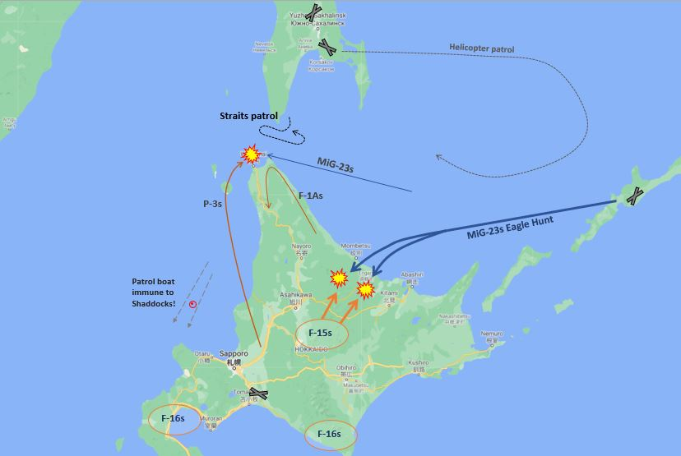

**COMING DAWN…**

Speaking of dawn, the clock is ticking away faster than I would like. My Su-24s and Fitters have just completed their loading process, and staff are doing the final review of the strike timeline. Launches are expected to begin shortly. Do the Japanese have a spoiling attack in the works? Have we spotted all their defences? Dawn will tell.

A weekend’s always more enjoyable with a little Command!

**FINAL PREPARATIONS**

As the last of our planes are readied, the pilots review their targeting information and launch schedules, and then settle in to endure the last tense hours before commencing the attack. Most of our planes have no night-vision capability, so the plan is for the strike to arrive as early as possible in the full light of day, so the attack planes can actually see their targets. Until then, all they can do is wait.

In the meantime, skirmishing continues over NW Hokkaido, as two more separate pairs of F-15s fall to a four-ship of MiG-23s out of Iturup, unfortunately taking one of my planes with them. Some of my Fencers, hastily launched with ferry tanks and nothing else, also conduct some last-minute radar-reconnaissance off the south end of Hokkaido, looking for more enemy ships. Nothing turns up, but they do detect signals from an E-2 orbiting in the area and are forced to flee at high speed and low altitude when some F-16s come to investigate.

**ADVANCE ON CHITOSE**

The carefully timed attack on Chitose commences with multiple streams of fighters lifting off from all my bases: Su-27s, MiG-29s, and MiG-23s. They converge on Chitose, expecting a fierce fight to clear the skies before the strike arrives, but the skies are empty. Nobody’s there… Some of the Su-27s pass around Chitose, and finally find some F-16s to skirmish with south of Hokkaido, eventually chasing them all the way back to Misawa. Our missiles always fall a little short, and we have to abandon the futile pursuit when a HAWK opens fire and drives us off.

In the meantime, my attack planes are en-route, lead by ARM-carrying Fencers and Fitters, followed by long-range (AS-18) and short-ranged (AS-10) PGM carriers, and then Fitters with cluster bombs and heavy rockets. This first SEAD wave is followed by more iron bomb and rocket-carrying attackers, who will hit the soft airfield infrastructure, and then crucially important LGB-carrying Su-24s, who must shut the runways and taxiways to complete the destruction of the base.

The last aircraft to launch have no pilots at all. The 451st independent Coastal Missile and Artillery Brigade turns its launch keys and fires the last four Sepal anti-ship missiles on bearing-only attacks at Chitose! These massive 30-foot-long missiles will act like high-speed decoys, hopefully prompting the SAM gunners in Chitose to open fire, without risking my aircrew to do so. That will give all those ARMs I’m carrying something to shoot at.

**STRIKE!**

The first shots actually come from a pair of Fencers, firing a salvo of AS-17 ARMs at the Nike site at Yakumo, on the narrow south-western ‘neck’ of Hokkaido. The Nike’s not the most modern SAM any more, but it’s still dangerous enough to restrict maneuver on that flank, and it gives good radar coverage to the enemy. As my missiles roar in the Nike turns on its illuminators – and so does every single other SAM site in the Chitose area! So much for my clever plan to trick them with Sepals…

I’m looking at four active HAWK sites, and two, no, three smaller SAM sites of some sort, all clustered around Chitose. My Fencers deliver a barrage of long-ranged AS-9s and AS-17 ARMs, plus low-altitude AS-18 cruise missiles. Some of these manage to punch through the SAM defences, wounding some, but not all, of the SAM sites. The Sepals arrive, hurtling into the confusion, and some of the smaller SAM sites open fire on them, wasting a number of missiles, and giving a little bit of time for the Fitters to launch their short-ranged AS-12 ARMs.

Most of the radars go down, and AS-10-armed Fitters start engaging from medium altitude, others come dashing in as low as they can to strike the battered defences with cluster bombs and rockets. But we’ve kicked the hornet’s nest, and now the air is full of Stingers! It’s not a good day to be a Fitter pilot, and swarms of the nasty little MANPADS start knocking planes out of the sky. I’m deeply regretting the choice not to load every AS-10 I could, but my brave pilots use what they have. Many of them are carrying huge 266mm rockets, with massive 150 kg warheads, and their crushing impacts turn out to be superb against the dismounted SAM gunners. Mixed in with all this chaos, Vulcans start blazing away, sending ropes of tracer towards my twisting planes.

It’s a horrible mess, and in a couple of short minutes I’ve lost six Fitters and had two more damaged, and almost all of them are my most modern M-3s which were leading the assault. But, the weight of a Soviet assault is an implacable force, and so many planes arrive that the defences are overwhelmed. The LGB-carrying Fencers fly over, and their massive penetrating bombs systematically wreck the runways and taxiways from safe altitude, while streams of lesser Fitters continue to pummel hangars, fuel tanks, and other structures, until the base is a flaming wreck.

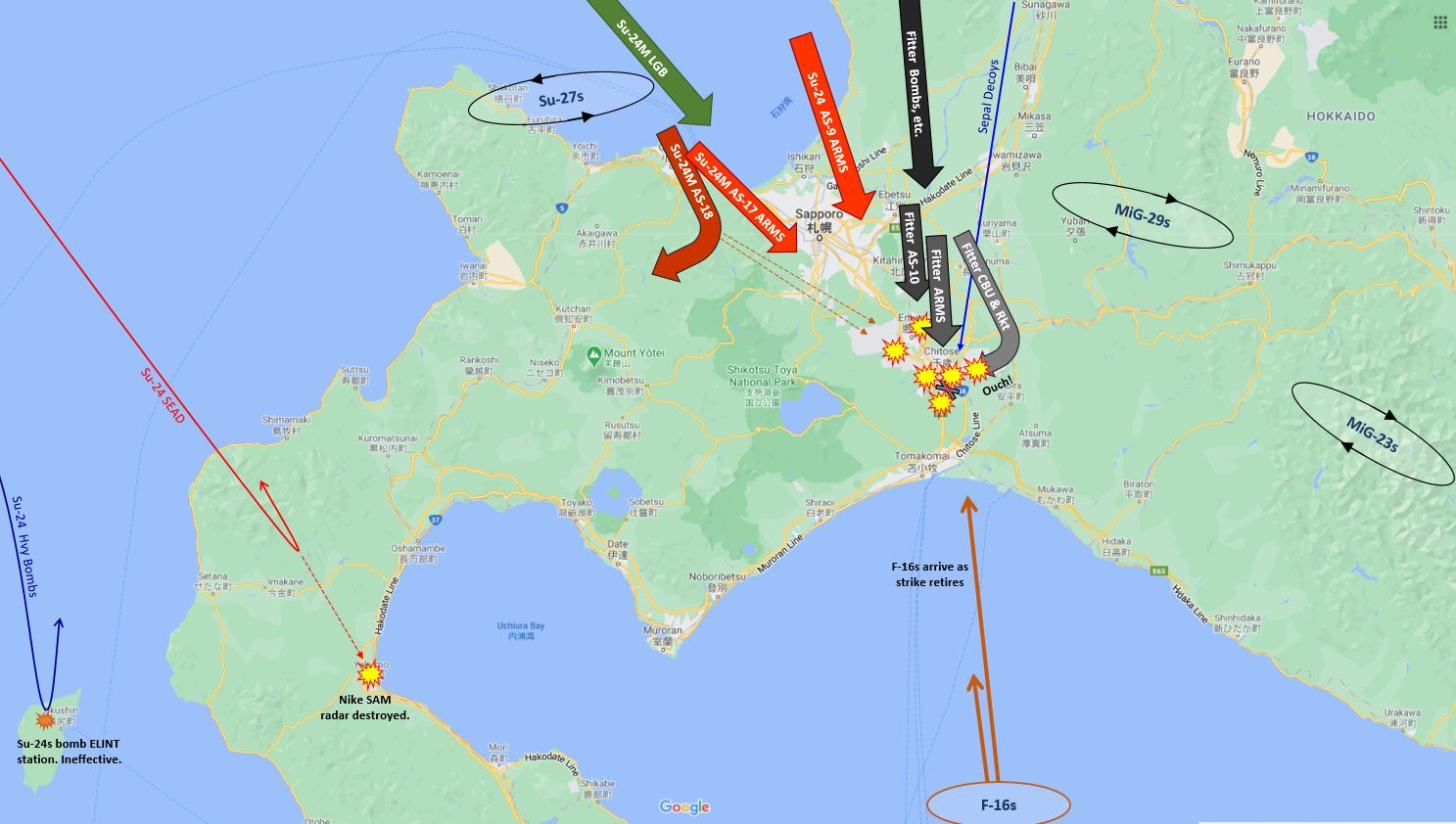

**FALL BACK**

Only now do the enemy start to respond, as we detect radars on F-16s approaching from the south. The last of my attackers drop their bombs and hurry north at low altitude, joining the stream of planes retiring to their bases. As they go, a flight of Fitters finally sinks that patrol boat (a hydrofoil, no less) with a brace of AS-7s, and four Fencers strike the southern ELINT station with heavy 3,000lb iron bombs. (That turns out to be completely ineffective, and the ELINT station remains fully operational for the remainder of the operation.)

Does the approach of the F-16s finally mean my pilots descend on them and engage boldly? Well, no. Almost all my fighters are very low on fuel now, far from home, and poorly positioned to engage. Most of them are forced to withdraw. Eight enemy planes are coming in, and that’s a lot of AMRAAMs for the remainder to face. Fortunately, four of them actually turn out to be attack planes headed north at a really bad time, and my MiG-23s manage to take them in the flank and destroy them, but we only manage to kill one of the F-16s, at the cost of one of our own. The rest disengage south for more missiles, while we’re forced north again when we detect more F-16s coming in.

Meanwhile, some Su-27s on the flank overfly the damaged Nike site to snipe a reckless E-2, before running away again, and fresh MiG-29s are called south to cover our retreat. Angry F-16s are headed north at supersonic speeds, closing in on our retreating planes who don’t have the fuel to outrun them. The MiGs manage to arrive just in time to concentrate a 3:1 numerical superiority, and this time, when we have plenty of fuel and the F-16s do not, we finally manage to achieve some decisive kills.

**REASSIGNMENTS**

At 22:00Z our liaison officer salutes the Deputy Commander of the 1st Red Banner Air Army of the VVS, and reports that the Su-24 regiment 302nd BAP has been returned to VVS control as planned. He thanks the Deputy Commander for the VVS’s support for their comrades in arms in the fleet, neglects to mention that the 302nd is actually somewhere over the Sea of Japan, low on fuel, and out of ordnance, and tactfully retires before questions can be asked.

We also have a number of fighters and strike planes bumping down on the wrong airfields all around the theatre, wherever their fuel-starved engines can reach. Lingering on station, chasing down F-16s and outrunning AMRAAMs has taken a heavy toll in fuel. It’s well into the afternoon before all the planes are finally ferried back to their home bases and readied for use again. Some MiG-29 pilots are also assigned to do shuttle runs back to Khabarovsk, where the remainder of their munitions are stored, and then return to the front lines with full loadouts.

**LOW-LEVEL HOSTILITIES**

The next hours pass at a lower level of hostilities. We hear reports of furious fighting involving the Americans and our comrades to the south in Vladivostok, but fortunately the American navy isn’t active here. Our ships continue to patrol and hunt for mines in the La Perouse strait, but other than some puzzling biological contacts, nothing shows up on sonar.

Shortly before noon the Japanese attempt a strike on our forward base in the Kurile Islands, but the attack planes don’t have any escorts. MiG-23s from Iturup are able to pounce on the strike while it’s still over Hokkaido, and they destroy it without any losses. Our disguised refuelling ship would have made a vulnerable target if they had gotten through, and it is a relief when it finally completes its task and starts sailing north again after lunch.

Our own air activity is kept low key. Su-27s snipe the second E-2, and a few Fitters bomb the remains of the southern Nike site before it can repair itself, but that is the extent of our offensive action. Our ESM planes detect the emissions of patrolling F-16s from Misawa, but I’m reluctant to go so far south and tangle with them where they have the advantage. Instead, we patrol, monitor the situation, and let our pilots rest to prepare for the next stage of our glorious revolution!

**PLAY IMPRESSIONS**

It’s fun to be on the Soviet side from time to time, and give a nice mass-attack thumping to the foe. This is an interesting test of timing to get all the planes from different bases to coordinate and arrive at the proper moment. The player’s got an important choice to make early on, about whether to try and sneak in an early night attack on Chitose with the existing loadouts on the Fencers, or to adjust their loadouts, wait for morning, and make a combined attack with the Fitters.

(Out of curiosity I turned off the enemy fighters and ran a night attack, to see what would happen. The result was disastrous, and the SAMs ate me alive. My recommendation? Don’t! Besides, the Fencers didn’t really have effective night-vision anyway. I tend to forget how limited night vision was for dedicated attack planes of that era. Coming out of the tail of the Cold War, if you weren’t American or British (F-111s, A-6s, Harriers, Buccaneers, pods) or carrying American IR munitions (Maverick, GBU-15, etc.) the odds were that you tended to bomb on radar, under flares, or not at all. The Soviets were rather low on the night-vision totem-pole.)

I was definitely tempted to shell out 100 points for those MiG-31s, but they were so expensive that in the end I made do without them. The other fighters were less capable and further away, and didn’t seem to be worth the cost. Those first six hours, with half my Su-27s still down, and the MiG-29s ferrying and readying, had me quite worried about my fighter strength. I had thought the F-15s would be the big threat, but it turned out to be the F-16s which were the real problem. Their AMRAAMs were much more dangerous, they were at the far end of my fighter range, and they could easily disengage and RTB where I couldn’t follow them. It was not until the end of the scenario that I started to catch them in disadvantageous positions.

It certainly felt like we were in a hasty and disorganized start, with fighters not ready or out of position, and I would have loved an hour or so of extra time for loading and launching helicopters and positioning ships. The constant worry that my comrades down south would kick things off just a little too soon made for very enjoyable opening tension.

I never saw any sign of the Japanese sub, which went to the SE corner of its zone, far out of my assigned area of operation in the straits. Still, I spent a lot of time cautiously cringing around at low speed, looking for mines and subs, worried that at any moment I might stumble on something. The mere risk of an SSK has that effect!