**Pacific Fury 3: Caught Flat Footed!**

13 Feb 1994, 1200 Zulu, 2100 Local

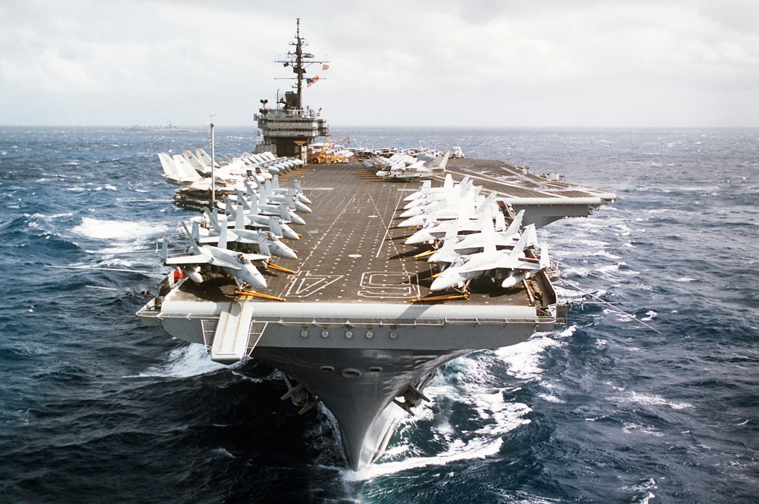

You are the commander of the USS *Constellation* Carrier Battle Group (CVBG). Due to the increased tensions with the Soviets, the Pacific Fleet’s exercise schedule has been ramped up, and your CVBG has been participating in a series of exercise over the past six weeks. Departing San Diego, a couple days after Christmas you deployed to the Philippians in early January for a multi-carrier exercise with USS *Independence* and USS *Abraham Lincoln*. Following that, in company with the *Lincoln* you sailed to Australia conducting ASW and strike exercises along the way. Your battle group has now returned to the Philippines for Defensive Counter Air (DCA) training with the Philippine Air Force and about half your Carrier Air Wing (CAW) acting as the aggressor.

Those plans changed about five hours ago with a FLASH message from 3rd FLEET HQ in San Diego. You are now tasked to collect your battlegroup together and take *Connie* and her chicks north to reinforce the *Independence* around Japan. Unfortunately, a series of seemingly disconnected events have created a situation which you are not at all comfortable with.

It is time to get things under control and get back on the front foot.

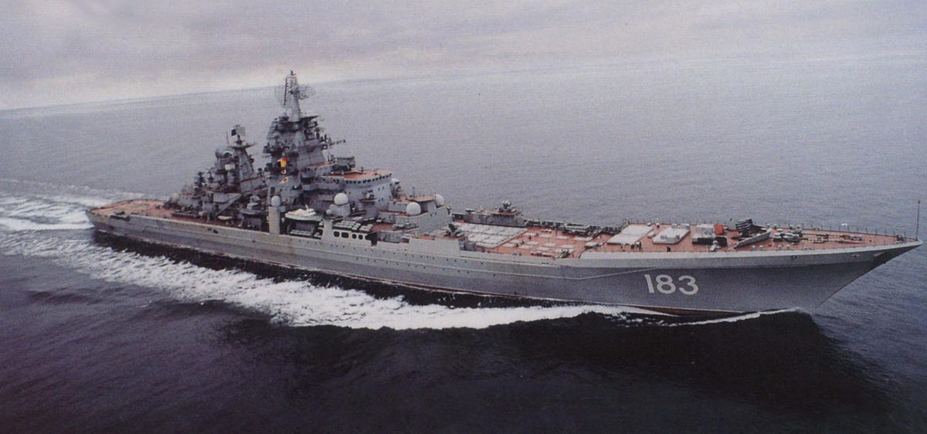

**Pacific Fury #3** opens with some desperate moments as a surprise attack from several angles catches dispersed elements of the CVBG unprepared. Once the initial shock is over the player has some good opportunities to strike back and exert a little revenge.

