**Pacific Fury 4: I Come from a Land Down Under**

15 Feb 1994, 0400 Zulu, 1200 Local

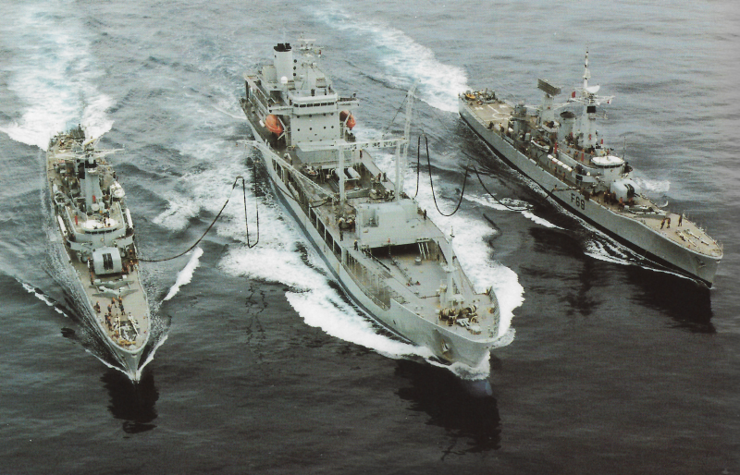

You are Commander of the newly formed Combined Task Force 165 (CTF-165). Your TF consists of mostly Australian and New Zealand assets but there are also American, Pilipino, Bruneian and British forces assigned to you. Your primary task is the reinforcement of Brunei, a small British aligned Sultanate rich in oil and natural gas on the Northwest coast of Borneo.

The main opposition is from the Soviet base at Cam Ranh Bay Vietnam but based on events of the past few days you should be prepared for anything.

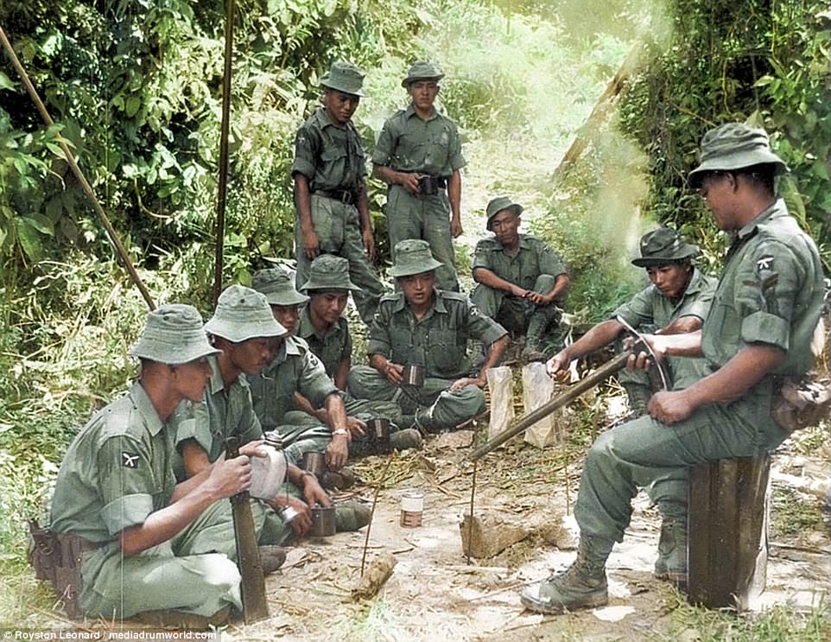

**Pacific Fury #4** places the player in the awkward position of having to steam at high speed into the unknown while navigating restricted waters, difficult political challenges and an elusive enemy.

The players forces, land sea and air – are spread from west of Singapore to east of Darwin and they all need to converge on Brunei. The Soviets at Cam Ranh Bay, Vietnam are a problem but so are insurgents in Bruni and elsewhere and the ever-present danger of submarines.

