**Pacific Fury 5: Shemya Shakedown**

15 Feb 1994, 1200 Zulu, 2300 Local

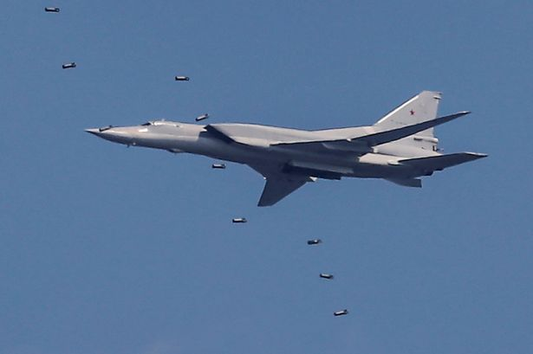

You are Commander of [143rd Red Banner Missile Aviation Division](http://www.ww2.dk/new/navy/143mrad.htm) based at Mongokhoto Airbase, part of the Soviet Pacific Fleet. In response to an American attack on the Crimea a couple days ago, you have been tasked to attack an American base in the Near Islands, part of what the US calls the Aleutian Islands chain.

Of course, there are a few complications; the Americans have deployed a squadron of F-15s there as part of their NORAD defence, you have the unreliable support of a PVO squadron of MiG-31s, and you must be very careful not to damage their COBRA DANE radar or they will think we are starting a nuclear war.

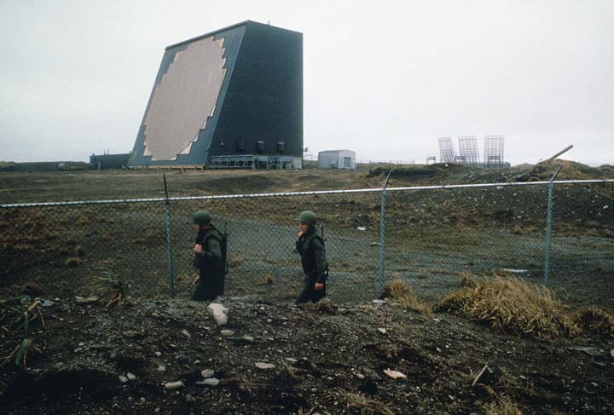

**Pacific Fury #5** as the Soviet player once again, the friction between branches of the military remains a concern, but so do the Americans. Shemya is the closest American base to Soviet soil and this operation is meant to send a message to Washington. The player’s task is to send the correct message – damaging the COBRA DANE will most certainly send the unintended message that you are preparing for nuclear war – this must be avoided. Unfortunately to remain safe, the bombers must stay above the range of ground based air defences, which means that many of their 1950’s era bombs may miss their intended target by several hundred meters, and it is a very small island.

