**Pacific Fury 6: Priorities**

20 Feb 1994, 0400 Zulu, 1200 Local

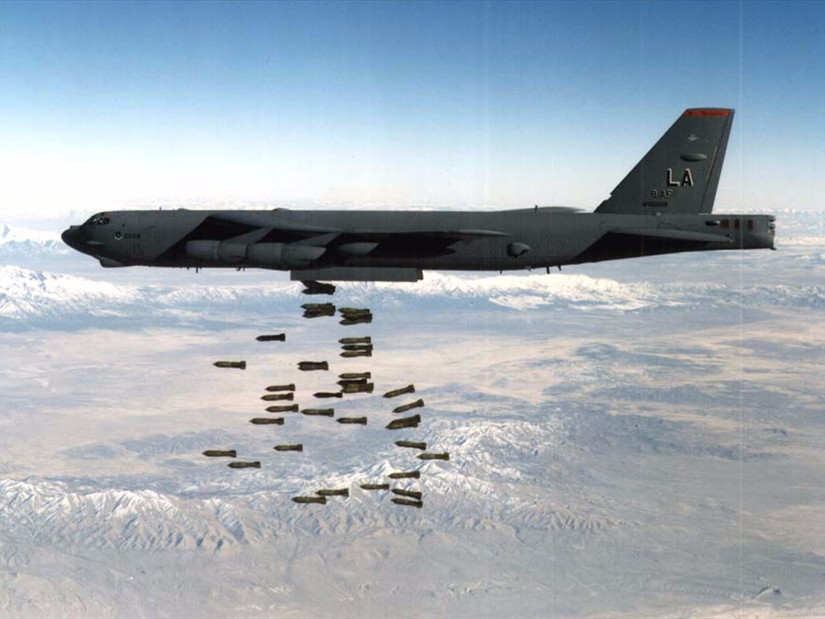

Your Combined Task Force (CTF) 165 is the centerpiece of the newly formed Southeast Asia (SE Asia) Command consisting of units from Australia, New Zealand, Malaysia, Singapore, Indonesia, the Philippines, as well as the UK and US. Located in Darwin, the HQ is mostly made up of Australians, but the international numbers are growing quickly.

For the past four days your staff have been planning a series of strikes against the Soviet Base at Cam Ranh Bay Vietnam as a cover for sending a convoy north to resupply Hong Kong. The centerpiece of the operation was to be the US aircraft carrier ***Abraham Lincoln*** as it transited from the Indian Ocean to the Western Pacific. Four hours ago, that all changed! Although your mission remains, the US carrier group will be steaming through at high speed to counter a potential amphibious threat in the North Pacific.

You are now left holding the proverbial ‘bag’ and scrounging resources from everywhere you possibly can.

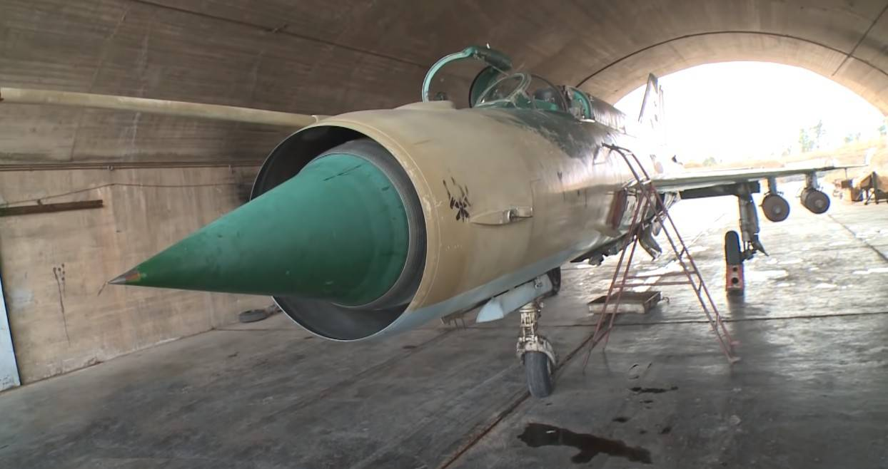

**Pacific Fury #6** is a challenging scenario in several ways. Initially the player needs to plan a major air strike operation using short-ranged aircraft over long distances. Many of the aircraft are older, day-use only with poorly trained pilots, most but not all are able to refuel from the very limited supply of airborne tankers. The next challenge is time, many of the resources available are only available for a limited window of opportunity. Finally, there is the enemy and the probable enemy of Vietnam, currently neutral but likely to react strongly to a strike on the Soviet base, this won’t be the first time that US B-52s face Vietnamese Migs.

And of course there is the convoy to Hong Kong that must get through.

