**Belgian Arm**y

The Belgian army fields a Corps sized force with five active Brigades, four within the Corps and the Para-Commando Brigade. The Corps HQ, 16th Division, portions of 1st Division and many of the Corps Troops are located in Germany in the Soest Area; 250Km East of the Belgian border. Up to 40,000 of the 68,000 regular soldiers in the Belgian Army were stationed in Germany. The Para Commando Bde is assigned to the AMF (ACE [Allied Command Europe] Mobile Force) and expected to deploy to North Norway in an emergency.

**13x Alouette II**

**U**

**L**

**U**

**L**

**24x I-Hawk**

**18x M109 A2**

**12x M115 203mm**

**11x M110 A2**

**4x Lance**

**27x Gepard**

**12**

**Res**

**7**

**1**

**BE**

**1**

**BE**

**16**

**BE**

**1**

**10**

**Res**

**4**

**17**

**L**

**H**

**H**

**H**

**U**

**L**

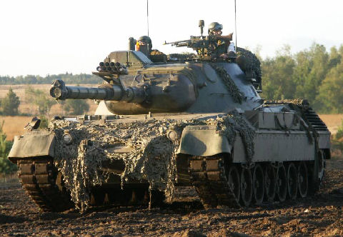

**Leopard I**

The main battle tank of the Belgian Army is the Leopard I, and eight tank regiments (battalions) were each equipped with 40 (3x Coy of 13 + 1 Command). Each Mechanized Brigade had one unit, 17th Armoured Brigade had two and the eighth was the ‘2nd Jaagers te Paard’, a reconnaissance unit.

**AIFV-B**

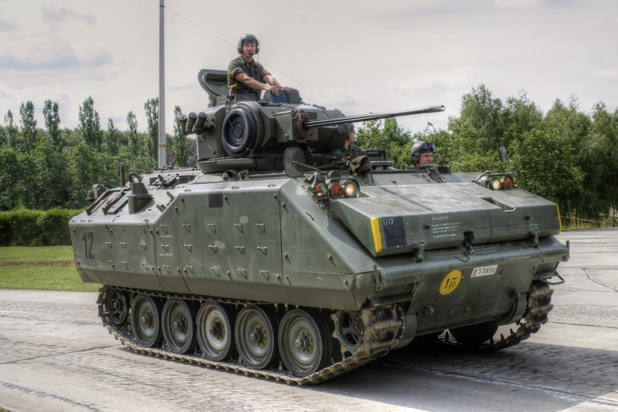The Belgian Army’s main Infantry Combat Vehicle is the AIFV-B. This is a development of the ubiquitous M-113 but improved to provide infantry with improved fire power, Halon fire suppression systems and better suspension. 514 AIFV-B’s were purchased in addition to 525 M113A-B. About half of the AIFV-B’s were equipped with the 25mm gun, while most of the remainder had a .50 Calibre Heavy Machine Gun, many of the M113’s were the 81mm Mortar or Milan ATGM variants. These vehicles were delivered in the late 80’s to replace the AMX-VCI family of APCs, up to 500 of which were still available in 1994.

**Artillery**

1st Belgian Corps fields a wide variety of artillery including 117 M109A2 and 41 M109A3 155mm Self Propelled guns, 11 M110 203mm and numerous older pieces and 5 Lance Missile Launchers.

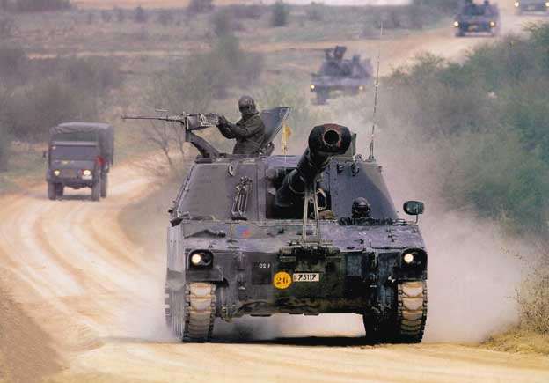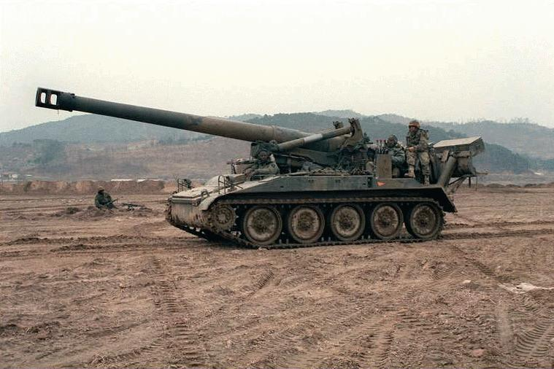

M109A3 SP Howitzer, 155mm. Bde & Div Close Support M110 SP Howitzer, 8" or 203mm. Corps Arty General Support

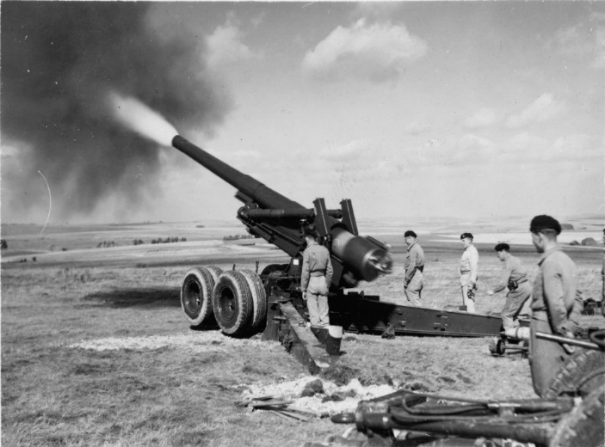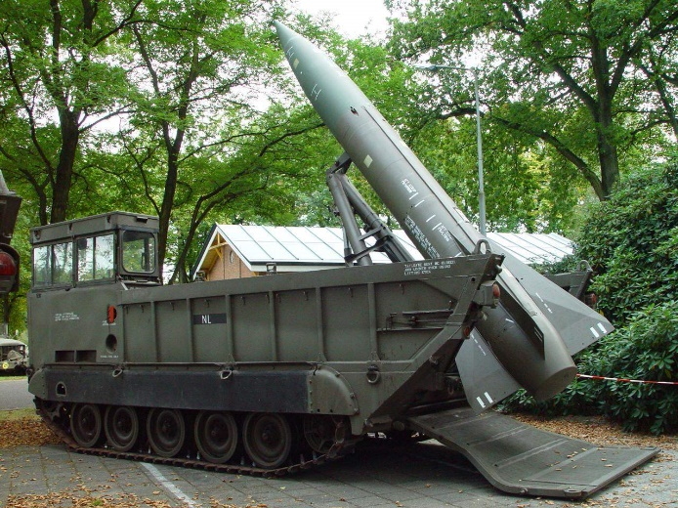

M115 Howitzer, 8" or 203mm. Corps Arty General Support Lance Missile. Corps Arty General Support

**Air Defence**

Various gun and missile systems were used at all levels for Air Defence. 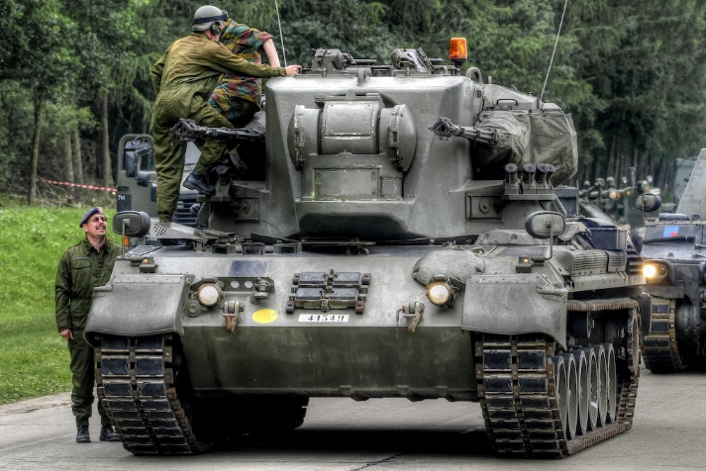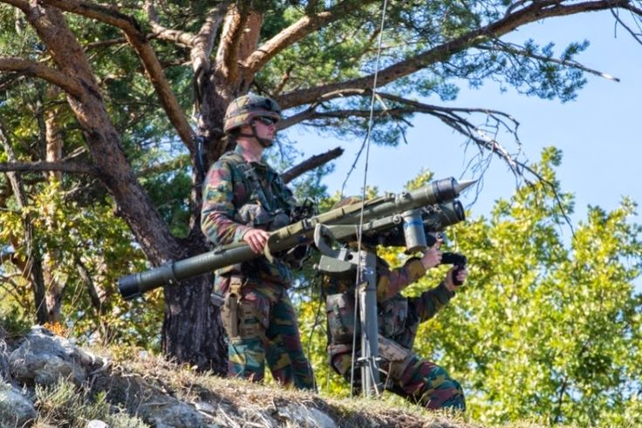

54 x Gepard Twin 35mm Very Low Level AD Over 700 Mistral Very Low Level Missile vehicle or pedestal mount

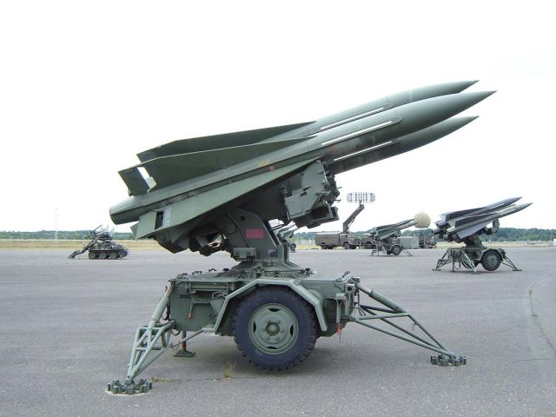

24 x I-Hawk Missile Launchers, medium level