**Belgium** 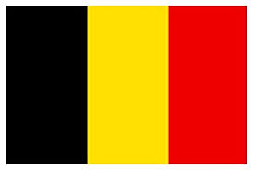

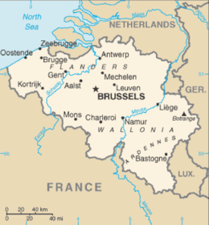**Belgium:** One of the original 12 nations that formed NATO in 1952, strategically Belgium sits at a critical crossroads in Europe. The plains of Wallonia and the forests of the Ardennes have been the main access of advance both westward and then eastward in both World Wars. Based on this Belgium is firmly ensconced in the idea of collective defence, and of maintaining Germany as a NATO partner.

Belgium’s armed forces are completely integrated in the NATO command structure. Indeed, **NATO HQ** in Brussels and **SHAPE** (Supreme Headquarters Allied Powers Europe) near mons hosts the leadership of all allied nations.