**Northern Fury (Alternate Cold War History)**

**Note that these notes are for scenarios developed in *Command: Modern Air & Naval Operations* and may not match the storyline in the books.**

On the 19th of August 1991, hard-liners in the Soviet leadership, calling themselves the 'State Emergency Committee', launched the ‘August Coup’ in order to remove Gorbachev from power and prevent the signing of the new union treaty. Although experiencing some initial setbacks and resounding world condemnation – the coup was a success. The concepts of Perestroika and Glasnost, and the economic and political restructuring they implied, were abolished overnight. Independence movements in 14 states were ruthlessly quashed, including those in Estonia, Latvia, Lithuania and Georgia where self-rule had already been declared. Internal strife reminiscent of the 1920’s lasted for just several months but the iron rule of the reinvigorated Communist Party prevailed in all areas.

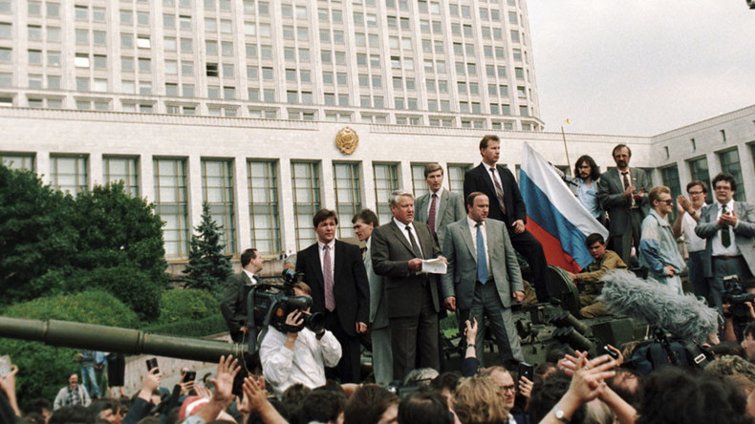

NATO watched nervously as their efforts to encourage Eastern European countries away from Dictatorship were methodically dashed. Only Poland and the re-unified Germany managed to avoid the restoration of the Warsaw Pact. Poland has declared itself Neutral and Non-aligned; however significant pro Eastern Bloc movements exist and are in a constant struggle with its emerging Capitalist economy. Germany is in a difficult position as many of its Left Wing political elements have been proposing the abandonment of collective defense as a viable strategy for the future.

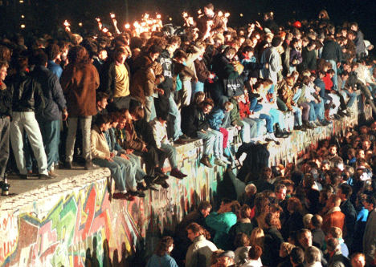

Meanwhile, NATO was decisively engaged as its (original 16) various governments were attempting to realize the ‘peace dividend’ by reducing military forces, and employing what is left in non-traditional roles in order to justify costs. With significantly reduced Land, Sea and Air forces embroiled in the Balkans, the Persian Gulf, Somalia, Rwanda and The Sudan. Resources are spread thinner than they have been since the 1940’s. Tensions with Iraq are high and the threat to stability in the Middle East is extreme.

On the 9th of February 1994, a Soviet supported Coup toppled the Polish government and sent the emergent democratic state into anarchy. The UN Security council response was futile and an emergency sitting of NATO’s North Atlantic Council (NAC) was called for the 12th of February.

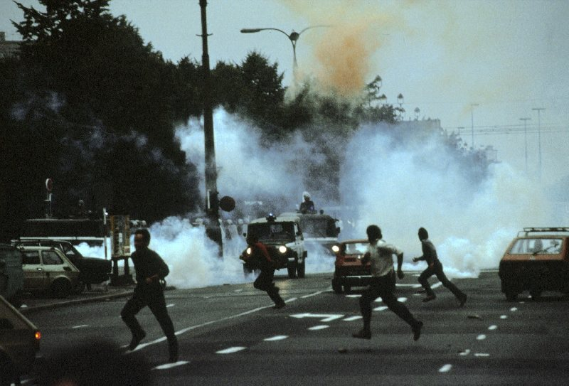

In Norway - The International Olympic Committee (IOC), in consultation with the UN decided to carry on with the Winter Games which were opened in Lillehammer, on February 12th. Soviet and Eastern Bloc countries were represented at the opening ceremonies but many of their athletes were not present for the start of the actual events on the 13th. The Russian Olympic village was empty and initial investigation found that many of the athletes had simply disappeared, while only a few had flown home. Norway has called up its reserves and ordered the IOC to cancel the games and evacuate the Olympic Village. The world is in an uproar over the loss of the Olympic spectacle and TV commentators all over the Globe are criticizing Norway’s decision.

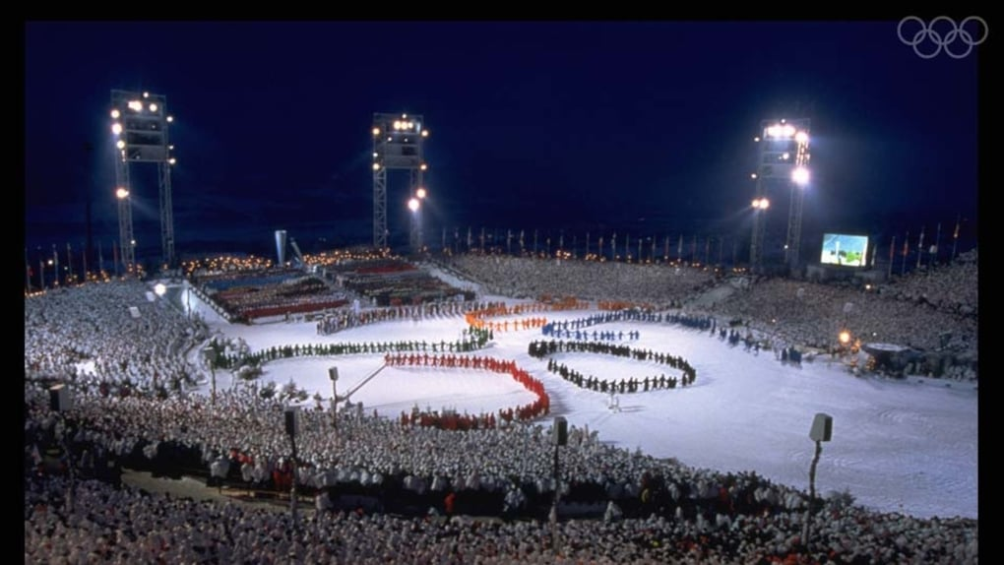

**Designer’s Notes**:

This is a Classic Third World War setting which focuses on the breakout of the Red Banner Northern Fleet and its operations in the North Atlantic. Many Soviet platforms historically decommissioned between 1989 and 1994 remain active.

In response to the ‘91 Coup, the US military has had some success with Congress in obtaining needed funding. The *USS Ranger (CV-61)* was not decommissioned but instead, held in San Diego with reduced crew and no air group as ready reserve. The *USS Forrestal (CV-59)* was retained as an air training carrier. *USS Enterprise (CVN-65)* completed an accelerated overhaul 8 months early and is deployed to Puerto Rico on her sea trials at the end of Jan 94. All other CV/CVN refits were put on hold or hastily completed which necessitated the retention of Carrier Air Wing (CAW) 10 on the *USS John F. Kennedy (CV 67)* and authorization of a 13th CAW. CAW 6 formed initially from USMC and reserves, is now fully established from regular USN squadrons, causing the retention in service of some additional A6-Es, (which had been on a fast track to decommissioning in order to man F/A-18 Squadrons) and is now on *Enterprise*. *USS Carl Vinson (CVN 70)* remained in the Atlantic to fill a scheduling gap in 91/92 but the *USS George Washington (CVN 73)* has now deployed to fill the gap in the Pacific (a reversal of historic real world deployments). *USS John C. Stennis (CVN-74)* is nearing completion and will begin its workups in June 94, once she is deployed *CV 61 Ranger* will de-commission and *CV 60 Saratoga* will take up the reserve role in San Diego.

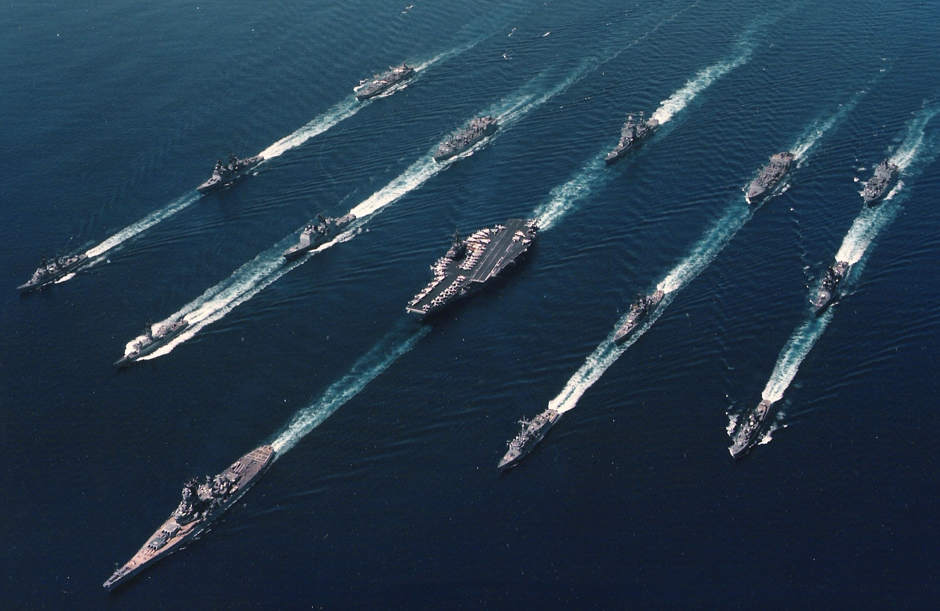

All of the *Iowa* class BBs were retained in service. Many other ships historically decommissioned due to the ‘piece dividend’ were retained; in particular, the CGNs the *Belknap* and *Leahy* CGs and some older DDG/FF/FFGs; some construction and refits were accelerated. Some details here:

* The *USS Ranger (CV-61)* was not decommissioned but instead, held in San Diego with reduced crew and no air group as ready reserve. But will be retired when *USS John C. Stennis (CGN-74)* is commissioned.
* The *USS Forrestal (CV-59)* was retained as an air training carrier.
* *USS Enterprise (CVN-65)* completed an accelerated overhaul 8 months early
* All of the *Iowa* class BBs were retained in service
* All CGNs were retained.  Total 9: 4 x *Virginia*, 2 x *California*, *Long Beach*, *Bainbridge* & *Truxton*.

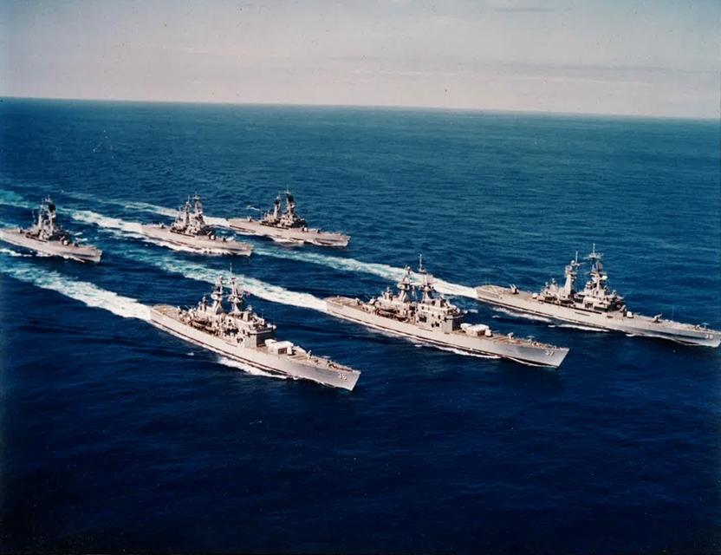

* All *Belknap* & *Leahy* CGs were retained (9 of each) with the NTU (New Threat Upgrades) complete. The additional 27 CG/CGNs means that a third CG/CGN can deploy with most CVBGs as well as act as Flag for smaller TGs.
* 4 of 29 *Seawolf* Class SSNs have been completed with 3-5 commissioning per year.  The *Virginia* Class has not been designed or considered.

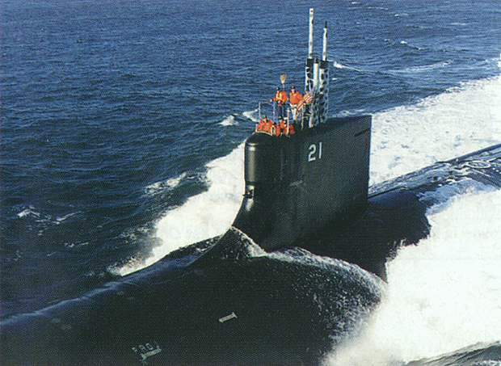

* 28 *Sturgeon* Class plus the 9 long hull (*Archerfish*) Class, the *Narwhal* and 3x *Permit* class SSNs were retained. The *Permit’s* followed by the *Sturgeons* will decommission as the *Seawolf’s* come on line once the fleet stabilizes at 100 fleet boats and 12 special mission boats
* 7 *Arleigh Burke’s* have been completed with 5-6 per year planned to the planned 62 units.
* Because of the urgent need for ASW escorts, the shortage of dry-dock space and the increased number of TLAM carrying ships; the last 7 of 31 *Spruance* class DDGs will not be upgraded to carry the Vertical Launch System but will remain ASW DDs and undergo shorter mid-life refits than the other 24 ships. The 4 *Kidd* Class DDGs received their NTU in the late 80’s and will serve another 20 years.
* The *Farragut* Class DDGs have been retained, 6x NTU refits have been completed, all based on the East Coast, the remaining 4 completing later this year
* Only 3 *Charles F. Adams* NTU DDGs are ready but another 12 are undergoing refit and will complete in the next 18 months. Both of the older DDG classes will serve until ~2000 when enough of the *Arleigh Burke’s* are available
* The 51 unit *Oliver Hazard Perry* Class had completed commissioning in 89 with no replacement on the horizon. The Navy pointed out this gap to Congress and a further 12 were ordered in 91 with the first 4 already launched and due to commission later in 94. As a stop-gap 4 *Brooke* Class FFG’s (FFG-3-6) were retained but will be decommissioned later this year. A ‘Follow on Frigate’ program is underway with a bid for 72 units, the first being laid down in early 95 and will replace both the OHP and the *Knox* Class in the escort role. The OHP will average 30 years of service when decommissioned.
* 36 of the 46 ship *Knox* class FFs remain in service, the remaining 10 are mothballed. The problem plagued design will be replaced by the ‘Follow on Frigate’ program on a 2 for 1 basis starting in 96 with most only serving 25-27 years. (Historic real life service was only 23 years)

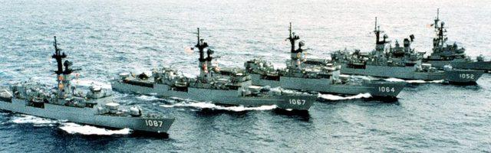

The START II treaty limits were largely adhered to, with the major exception that 96 B-52Gs and the single B-1 due to retire are retained, as well as a reduced fleet of F-111 E & F. The first 6 B-2s were rushed into service and along with 2 of the prototypes have formed the first Squadron of 8 stealth bombers. The remainder will be produced at a rate of 6/year and will allow for the gradual retirement of the B-52G’s. SSBN limits were complied with although 1 x Ohio class SSBN was put in service 2 months early.

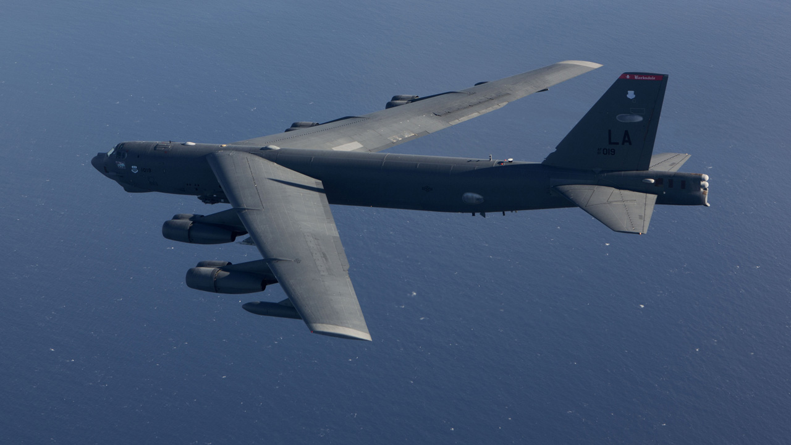

The US Army is in the most difficult position. A Brigade sized force remains in Soudi Arabia and Kuwait on Operation SOUTHERN WATCH. In Europe, V Corps remains active in Germany with *1st Armd* and *1st Infantry Divisions* supported by *2nd Armd Cavalry Regiment* (ACR). Also, VII Corps which was due to decommission after the Gulf war was retained but reduced to 1 Brigade for each Division in Germany and the remainder in the US (*3rd Armd, 3rd* and *8th Infantry Divisions*), *11 ACR* remains in Germany. The POMCUS sites have been kept fully operational and 6 Brigades worth of equipment have been added (for VII Corps units).

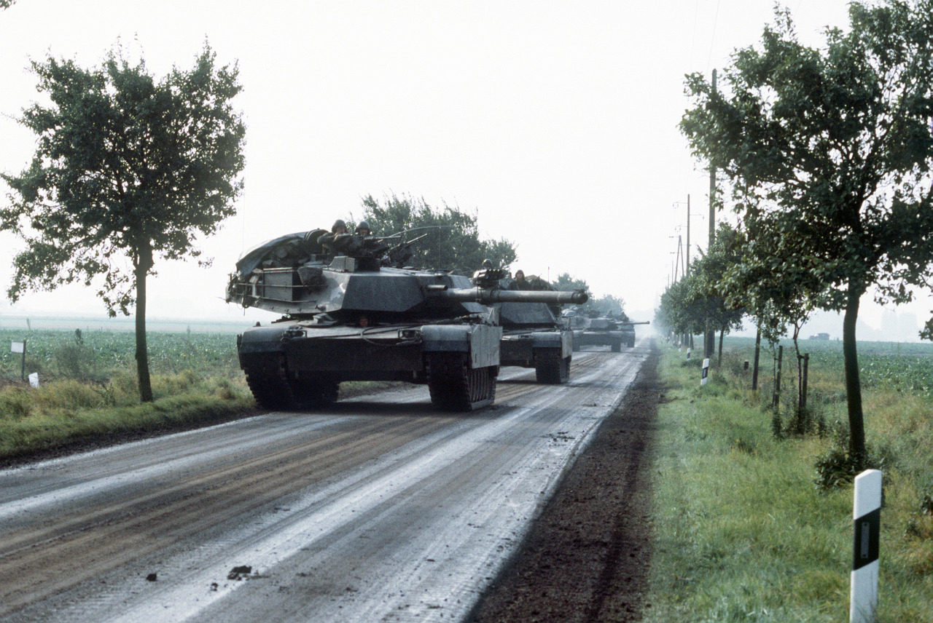

Scenarios planned for this campaign are:

|  |  |  |  |  |
| --- | --- | --- | --- | --- |
| Scen | Date | Title | Description | Remarks |
| 1 | 13 Feb | H-Hour | Surprise Air and Airmobile Op, North Cape | Final |
| 2 | 13 Feb | X-Ray Station | ASW sweep of NATO picket subs | Final |
| 3 | 13 Feb | Dagger to the Heart | Sub attack on Civilian shipping off New York Harbour | Final |
| 4 | 14 Feb | A Cold and Lonely Place | Quick and dirty fight to fend off a Soviet move to seize Jan Mayen Island | Final |
| 5 | 14 Feb | Bardufoss Blues | Air superiority fight over Bardufoss | Final |
| 6 | 14 Feb | Trondheim Express | Soviet Amphibious attack on Trondheim. STANAVFORLANT is in the way | Final |
| 7 | 15 Feb | Keflavik Capers | Airborne assault on Iceland | Final |
| 8 | 16 Feb | Plug the GAP | Amphibious assaults on the Faros and Shetland Islands. HMS Invincible responds. | Final |
| 9 | 17 Feb | Hold the Line | USS Enterprise Blocks attacks on the Air and Sea LOCs | Final |
| 10 | 19 Feb | Eisenhower moves North | USS Eisenhower CVBG regroups after a fight in the Med and steams north to engage | Final |
| 11 | 19 Feb | Changing of the Guard | USS Carl Vinson CVBG relives the embattled Enterprise group south of Iceland | Final |
| 12 | 19 Feb | Command at Sea | USS Mount Whitney with Comd 2nd Fleet and staff embarked come under attack | Final |
| 13 | 21 Feb | Cutting the Tether | Special Ops on Jan Mayen Islands | Final |
| 14 | 21 Feb | Here Comes the Cavalry | Carl Vinson and Eisenhower counter attack | Final |
| 15 | 21 Feb | Stab in the Dark | Special Ops insertion on Iceland | Final |
| 16 | 22 Feb | Sub Surge | Task Force 42 consisting of 9 Subs move to interdict Soviet forces North of Norway | Final |
| 17 | 22 Feb | Poke in the Eye | Small targeting action near Reykjavik | Final |
| 18 | 22 Feb | Ant Eaters Revenge | F-111 strike to neutralize Soviet forces in Iceland | Final |
| 19 | 23Feb | Decapitation | Carl Vinson and Eisenhower visit Iceland again to target Soviet C2 | Final |
| 20 | 23 Feb | BUFF Stampede | B-52 strike on Iceland | Final |
| 21 | 24 Feb | Sweep-up | Carl Vinson and Eisenhower strike Iceland a 3rd time while Eisenhower heads deeper into Soviet held territory and Carl Vinson supports the initial USMC insertions | Final |
| 22 | 25 Feb | Vagar Vengeance | UK lead NATO TG retakes Faros Islands | Final |
| 23 | 25 Feb | Swift, Silent & Deadly | Force Recon insertion onto Iceland | Final |
| 24 | 26 Feb | Battlewagons to War! | USS Wisconsin and Missouri conducting Pre amphibious bombardment of Iceland | Final |
| 25 | 26/27 Feb | Jar Heads on Ice | Amphibious assault to retake Iceland | Final |
| 26 | 28 Feb | Land of Fire & Ice | Hy fighting, not sure how I’ll portray this yet. |  |
| 27 | 28 Feb | Out on a limb | Eisenhower gets whacked by ~100 Bmrs | Final |
| 28 | 1 Mar | Bump in the night | Small convoy action | Final |
| 29 | 9/10 Mar | Something’s Fishy | Unconventional amphibious assault across Trondheim Fjord | Final |
| 30 | 10/11 Mar | Lance to the Chest | Missile Boat Action off Bergan | Final |
| 31 | 10/11 Mar | Shield of Faith | A2A fight over South Norway while 82nd arrives | Final |
| 32 | 10/11 Mar | Sneak & Peek | Small submarine action | Final |
| 33 | 10/11 Mar | Into the night | SOF insertion in Norway (representative of several) | Final |
| 34 | 30 days | Longest Battle | Convoy Campaign | Testing |
| 35 | 11 Mar | Shoulder to Shoulder | 4 CVBGs attack towards Norway – major counter attack | Final |
| 36 | 13 Mar | Wrestling an Octopus | Tactical JAAT near Lillehammer | Testing |
| 37 | 13/14 Mar | Charge of the Lt Bde | 3 CVs attack North supported by LBA to knock out the 2 southern bases | Final |
| 38 | 14/15 Mar | Hammer | LBA attack against Sov Locs (F-15E, WW & others) | Final |
| 39 | 15/16 Mar | Anvil | 2 CVBGs attack Central Norway. | Final |
| 40 | 16/17 Mar | Tongs | 2 CVBGs take over attack in Central and North Norway |  |
| 41 | 18 Mar | Tour de Force | 10 Day scenario where the whole CV group parades up the coast one by one in a wagon wheel of attacks & resupply |  |
| 42 | 20 Mar | Blast from the Past | Coastal Bombardment | Final |
| 43 | 31 Mar | Death from above | Air Assault Banak area, 2 CVBGs covering. 82nd (-) and the Brit Para Bde |  |
| 44 | 31 Mar | Into the Bastion | Seawolf & Connecticut prowl the Boomer bastion on the hunt. Detect, strip away escorts and ping only – if player kills he loses the game |  |
| 45 | 1 Apr | Fjord Follies | Amphib to seize Narvik and Bardufoss. The full Mar Div plus Brit Cdo Bde will assault. Covered by the 3 Lt carriers and the Amphib ships |  |
| 46 | 4 Apr | Leap-frog | The 2 CVBGs that were not engaged pass through the 2 that were protecting the air landing and slide into the western Barents Sea. Hy counter attack. Wdr quickly |  |
| 47 | 6 Apr | Bandits | Air fight in southern Norway revisited |  |
| 48 | 8 Apr | Infiltration | This is a good place for a SOF fight |  |
| 49 | 10 Apr | Thrust & Perry | Small ship engagement where patrol craft intercept a Sov supply convoy south of Bodo. While protecting NATO supply convoy |  |
| 50 | 14 Apr | Clearing the net | Sub vs sub as Sov subs come back from the Atlantic to re-arm |  |
| 51 | 17 Apr | Bear Hunting | Bears are still leaking into the Atlantic over Greenland. Time to close the door. |  |
| 52 | 20 Apr | Tote that Barge | Supply convoy into Narvik heavily attacked |  |
| 53 | 24 Apr | Counter point | Sovs attack out of Kola, Marines and Para’s defend, CVBGs (x2) come to the rescue |  |
| 54 | 30 Apr | Into the Hornet’s nest | 6 CVBGs push into the Barents Sea and conduct strikes on the Kola |  |
| 55 | 2 May | Extraction | Extract SOF team in trouble |  |
| 56 | 3 May | Bury the Hatchet | Massive Tomahawk strike on the Kola as well as a wing of B-52s hitting with CALCMs to build the corridor to Moscow |  |
| 57 | 8 May | Russian Roulette |  |  |
| 58 |  |  |  |  |

Created by Bart Gauvin, AKA Gunner98