**Caribbean Fury Background**:

Note that this is fictional background to the scenarios for Command: Modern Air & Naval Operations. Events depicted here many not be exactly the same as in the books.

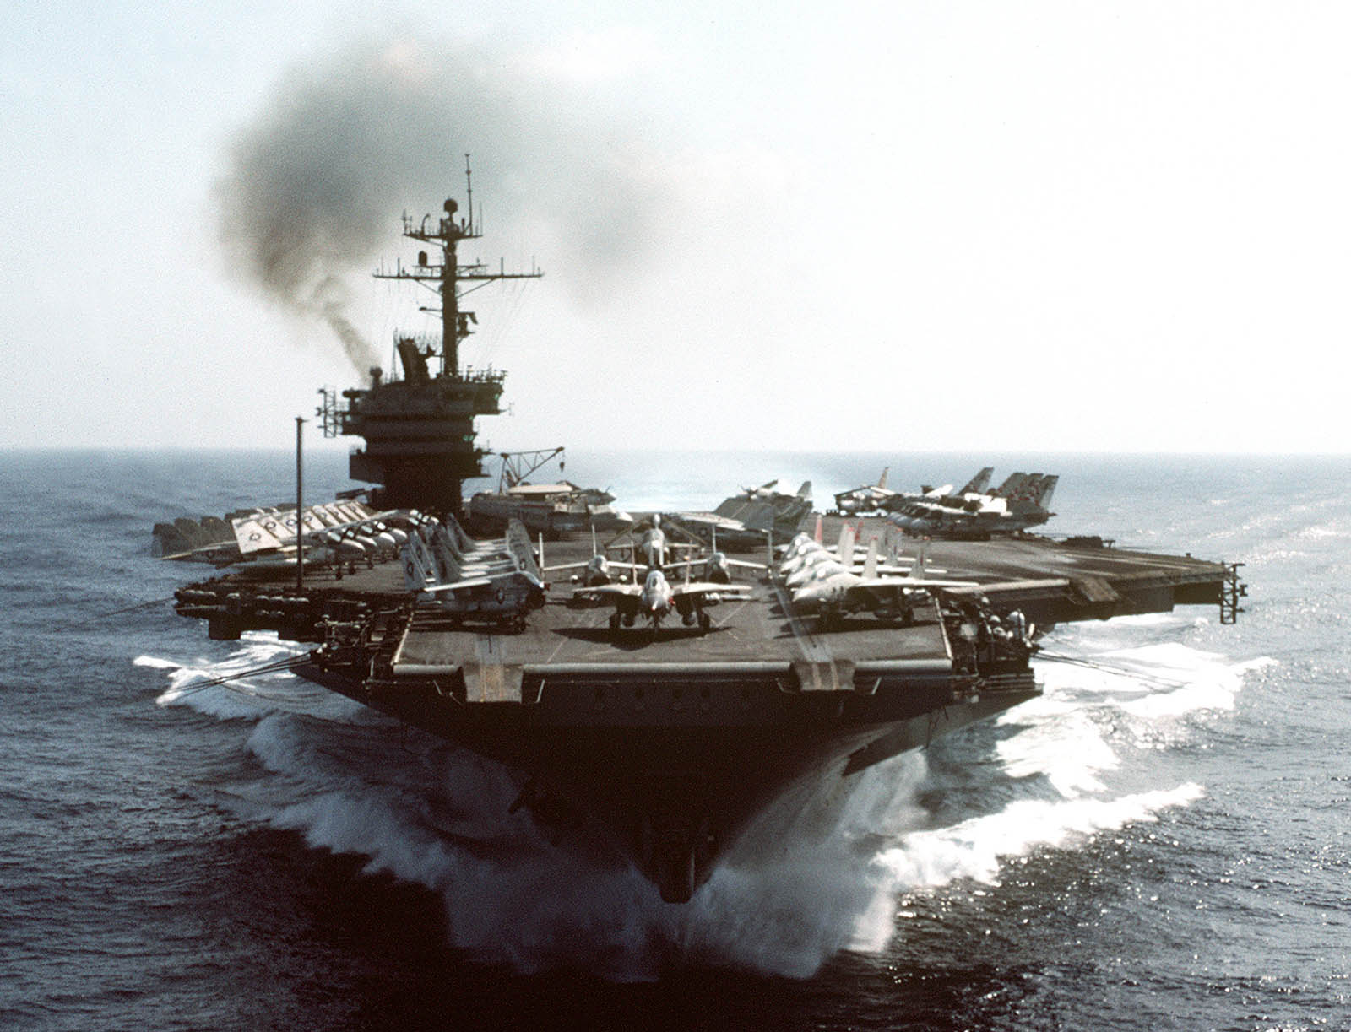

The short Caribbean series represent events running parallel to the early days of Northern Fury. The Soviet Foreign Service has been actively instigating trouble in America’s back yard. U.S. domestic difficulties and a global ‘Post-Cold War’ malaise made western response to the evolving issues fragmented, conflicting and generally ineffective.

In Nicaragua, American withdrawal of all support to the Contra’s after the Iran-Contra fiasco, allowed the Sandinista’s breathing space; however, when the anti-Sandinista ‘Chamorro’ government won the election in 1990 the revolutionary movement immediately restarted ending in a bloody coup in 92 with a Soviet leaning Sandinista Junta in control. A major funding proposal involves the planning and eventual building of a Nicaraguan Canal to compete with Panama, funding, construction and control of which would be from Moscow.

Although Honduras maintained a marginally effective government with significant US aid through the 80’s, the cessation of funding and support of the Contras’ in Nicaragua left a power vacuum which the US trained army could not effectively fill. By 1989 the Cinchoneros Liberation movement, now with significant Soviet backing gained the upper hand and several Army and Air Force units turned to their cause. The televised execution of 37 American soldiers caused world outrage but was quickly eclipsed by events in Europe and elsewhere. US retaliatory cruise missile strikes at rebel targets were followed by a raft of hostage taking incidents, piracy against civilian shipping and a general withdraw of the expatriate community. The coup in May of 91 was widely anticipated but a forgone conclusion with the former President and family already living at their palatial residence near Portland Oregon.

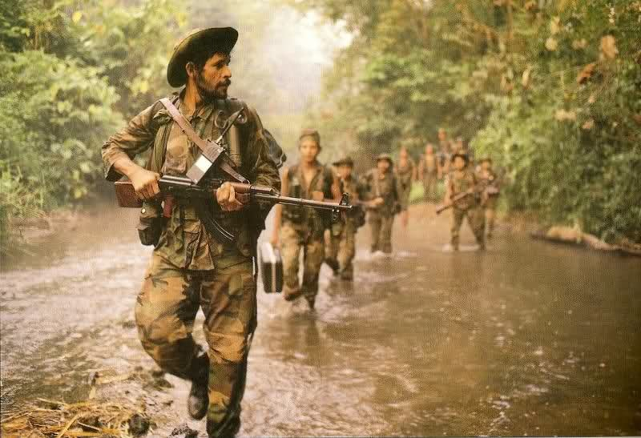

Following the coups’ in Honduras and Nicaragua, a militaristic anti-American movement gained momentum and these new governments started rearming with cast off Algerian and Libyan equipment (as these two countries rearm themselves, mostly with Polish and former East German equipment – see Mediterranean Fury) aided by Soviet deception, training, transport and financial resources.

An attempted coup in Guatemala failed due to US clandestine activities, but there remains a solid anti-Western sentiment, including significant numbers of displaced jungle fighters who have now taken on the cause of freeing Belize of British rule. Costa Rica has remained stable as has Panama, although attempts in both countries to overthrow western supporting governments have been made, they failed miserably. The El Salvadoran Civil war rages on with both the US backed government and the FNLN precipitating atrocities which get more shocking every year.

Colombia has remained staunchly pro-western, and billions of US dollars ensure they remain so. The leftist guerrilla movements, primarily FARC but there are others, that started in the 60’s have gained strength but are relatively well contained. The drug cartels however have significant and expanding power, outspending the government on technology and now using safe havens in Honduras and Nicaragua to ease their transport risk.

Mexico is showing signs of emerging out of economic and political distress. It is relying heavily on the newly signed North American Free Trade Agreement and the population are expecting great things. So is the world, with the evolving revolt in the Chiapas region causing new concern! With 12 F-5s and Gearing class destroyers, the US will undoubtedly be drawn into any conflict. Rebellion is in the wings should NAFTA fail to improve the Mexican economy.

Venezuela entered a new phase in its history with Hugo Chavez seizing power during his 2nd Coup attempt in 1992 and the death of President Perez while enroute to his impeachment hearings. Sitting on vast oil reserves and solidly linking itself to the new Soviet Government, Venezuela is quickly evolving as a regional power. By exerting political and financial energy and at times the threat of military involvement, neighboring countries are falling into line with Chavez’s vision of a resurgent Caribbean trading block to control international trade into the Central and South American region. Local U.S., British, Spanish, Dutch, French and other interests have all been negatively affected.

US efforts in Haiti and the continuing support of the Dominican Republic continue along historical lines, as does the evolution of the Eastern Caribbean islands.

Cuba, as always is the most interesting of the Caribbean countries. With a resurgence of Soviet interest the Cuban military and air force in particular has been experiencing a period of revival not seen since the late 50’s. It is suspected that most of the older SAM systems have been replaced by newer and much more capable ones, probably SA-10’s, and that the older MiG 17’s & 21’s have been replaced by MiG-23’s and 29’s. It is rumoured that a Kilo class submarine is now on the inventory. Two weeks ago, three RORO ships unloaded under cover of darkness, heavy security and some obvious deception measures. All of this was monitored by U.S. security agencies but it is unclear what was unloaded, indications are that it was not missiles, but probably aircraft, munitions and support equipment of various types.

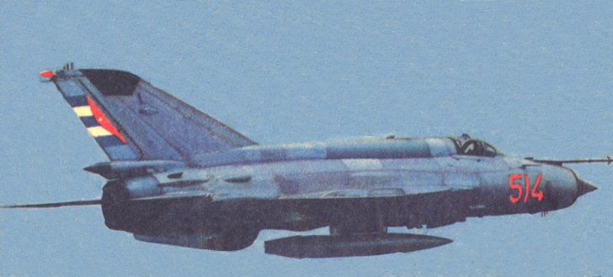

**US Reaction**: In response to the increased tension in the region the US military has stationed about 20 ships including the aircraft carrier *USS John F. Kennedy (CV-67)* and its Battle Group in the area. The Carrier is temporarily based at Gulfport Mississippi while many of the other ships are based in Mayport Florida and Corpus Christy Texas. Additionally, forces and activities in Panama, Guantanamo Bay and other areas of the Gulf and Caribbean are at higher than normal levels.

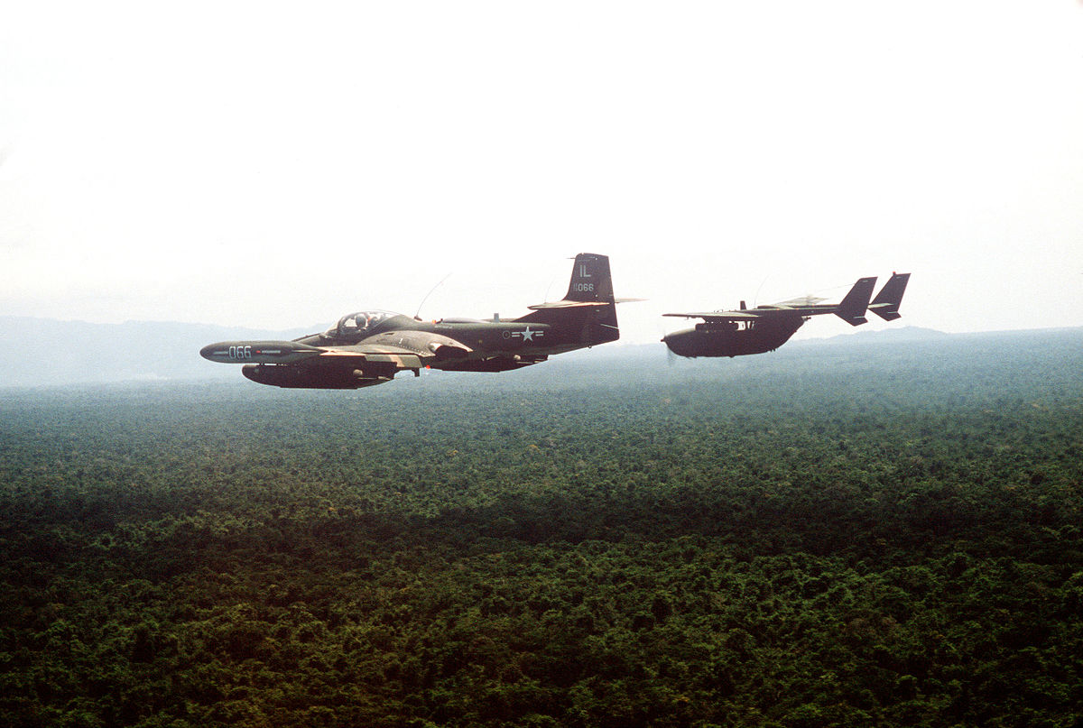

**Security Assessments:**

|  |  |  |  |  |  |  |
| --- | --- | --- | --- | --- | --- | --- |
| Country | Leaning | Concerns | Air Force | Naval Force | Land Force | Dependency |
| Cuba | Soviet | Aggressive | 12x MiG-29  60x MiG-23  48x MiG-21  ASW, MPA, EW  Multiple SAM Bdes | 3x Koni FF  2x Grisha FFL  3 Tarantul FFL  18-20x OSA II FAC  12-15x Ptl Boats  2-3x Foxtrot SS  ?1x Kilo SS? | 140K:  3 Armd Div  3 Mech Div  12 Inf Div  1 Arty Div  ABn Bde | USSR |
| Nicaragua | Soviet | Re-arming | 24x MiG-23BN  24x MiG-21bis  12x Mirage 5D  12x Mirage 5DE | Patrol craft | 80K, COIN | Libya |
| Honduras | Soviet | Re-arming | 12x MiG-23B  12x F-5F  10x A-37B | Patrol craft | 50K, COIN | USSR |
| Venezuela | N/A | Independent | 23x F16 Bl 15 | Venezuela | N/A | Independent |
| El Salvador | Divided | Civil War | 20-30x A-37  12x UH-1 | 3 patrol craft | 14K, COIN | Govt – US  Rebels - Cuba |
| Mexico | Western | Economic | 12x F-5 | 2x Ex Gearing DD  2x Ex Bronstein FF | 70K, 7x Bdes | US |
| Haiti | Western | Insurrection  Mil dissolved in 1995 | Util, Tg | None | Internal security | US/UN |
| Guatemala | Western | Insurgency | None | Patrol craft | 39K, COIN | US |
| Belize | Western | Insurgency | Tpt/Trg | None | 1.5K, 3x Bn | UK |
| Costa Rica | Western | Insurgency | Utility | None | Para Mil guard | US |
| Panama | Western | Insurgency | Utility/Trg | None | Para Mil guard | US |
| Columbia | Western | Drugs/insurg | 16x A-37  12x Kfir C2  Recon, EW, MPA, Tanker, Tpt, Trg, Util | 4x Padilla FFL  1x Dealey DE  2x Type 209 SS  2x CG Cutters  Patrol craft | 250K, 8x Div | US |
| Aruba, Bonair, Curacao (ABC) | Western | Proximity to Venezuela | None | None | None | Netherlands |
| Trinidad & Tobago | Western | Proximity to Venezuela | Util, MPA | Patrol boats | 3K, 4 Bns | UK |
| Grenada | Western | None | None | Patrol boats | Police | US |
| Barbados | Western | None | Util | Patrol boats | 1K, 1 Bn | UK |
| St Vincent & Grenadines | Western | None | None | None | Police | UK/US |
| St Lucia | Western | None | None | None | Police | UK/US |
| Martinique | Western | None | None | None | Police | France |
| Dominica | Western | None | None | None | Police | UK/US |
| Guadeloupe | Western | None | None | None | Police | Dept of France |
| Montserrat | Western | None | None | None | Police | British Overseas Territory |
| Antigua and Barbuda | Western | World’s Smallest military | None | Patrol boats | 245 in military | UK |
| Anguilla | Western | None | None | None | Police | British protectorate |
| British Virgin Islands | Western | None | None | None | Police | British protectorate |
| US Virgin Islands | Western | None | None | None | Police | US protectorate |
| Dominican Republic | Western | None | 40 Util | ~25 Patrol boats | 56K, 6 Bdes | US |
| Jamaica | Western | None | Util, SAR, Trg | Patrol boats | 3 Bns | UK |
| Turks & Caicos | Western | None | None | None | Police | British protectorate |
| The Bahamas | Western | None | None | Patrol boats | Police | British protectorate |
| Cayman Islands | Western | None | None | Patrol boats | Police | British protectorate |

|  |  |  |  |  |
| --- | --- | --- | --- | --- |
| Scen | Date | Title | Description | Remarks |
| 1 | 13 Feb | Hot Tamale’s | USS Kennedy CVBG vs Cuba | Final |
| 2 | 15 Feb | Retribution | Reduction of Cuban military capability. SOF snatch and grab from Havana area | Final |
| 3 | 17 Feb | Rumble in the Jungle | Counter strikes throughout Central America to eliminate opposition.  Retake Big Creek Belize |  |
| 4 | 19 Feb | Show of Force | Strike into Venezuela to destroy Sov base while not bringing them into the war |  |
| 5 | TBC | TBC | TBC |  |