In [*Northern Fury*](https://www.amazon.com/dp/B07R7BVQ31?ref_=pe_3052080_276849420)we write about a world in which the Cold War did not end in 1991, but we live and work in a world in which it did. I sometimes wonder which future the average person from 1991 would have considered more believable: our scenario in which the Cold War went hot, or the reality, where NATO peacefully absorbed much of the Eastern alliance it once faced?

Interestingly, while the world has changed drastically since 1991, much of the equipment [fielded](http://northernfury.us/warsaw/) by the former Eastern bloc armies has not. I’ve had the opportunity to train alongside several of these armies over the past few months, and this has produced some surreal moments for me.

One such moment occurred when my battalion trained with a Romanian unit. At one point I was directing the maneuver of a company composed of American Bradley Fighting Vehicles, Romanian tanks (locally produced TR-85s, essentially T-55 knockoffs), and TAB-77s (BTR-70 knockoffs), with modern Italian Eurofighter Typhoons providing close air support. Soviet 1960s, let me introduce you to the American 1990s, and the European 2010s!

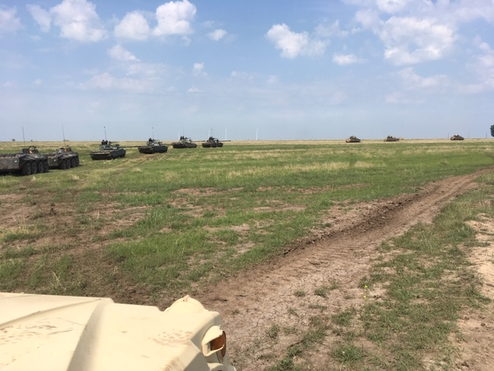

*American Bradleys lead Romanian tanks and PCs into the attack. Photo by Joel Radunzel.*

A couple of weeks later I was crossing our Abrams and Bradleys over the Danube River on a Romanian ribbon bridge, while Polish IFVs simulated suppressing the far bank, all under the direction of a Canadian officer. Talk about multi-national! Having grown up in a Europe that was firmly divided between West and East by the Iron Curtain, I’ve had ample opportunity to feel that the world I’m living in is perhaps stranger than the one we write about.

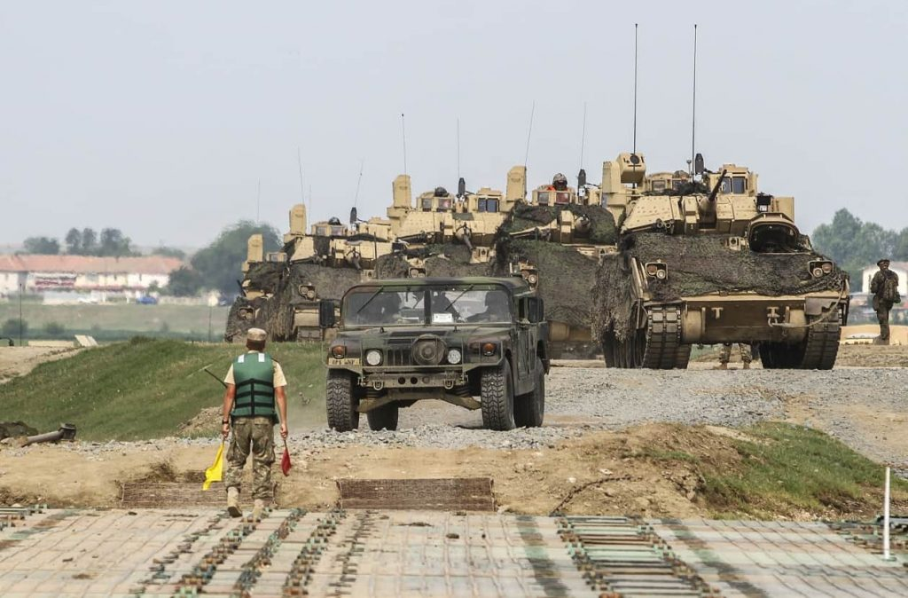

*American armor, Romanian bridge.*

Another surreal moment occurred as I was driving through an airbase where some of my unit is currently stationed. This particular airbase features in Bart’s CMANO scenario, [Mediterranean Fury 1: The Road to Byzantium](http://www.matrixgames.com/forums/tm.asp?m=4576183). Tucked away in the weeds and rushes along an access road, I found an aircraft graveyard that contained the very jets one gets to control in that scenario; there, MiG-23s and MiG-29s sit rusting away in the grass, while a few hundred meters away Italian Eurofighters rocket into the sky to police the skies over the Black Sea (interestingly, the older, simpler MiG-21s are still active and flying). In the scenario, these aircraft form a powerful fist with which the player must subdue the Turks and their NATO allies. Today, the whole airbase is a major NATO outpost.

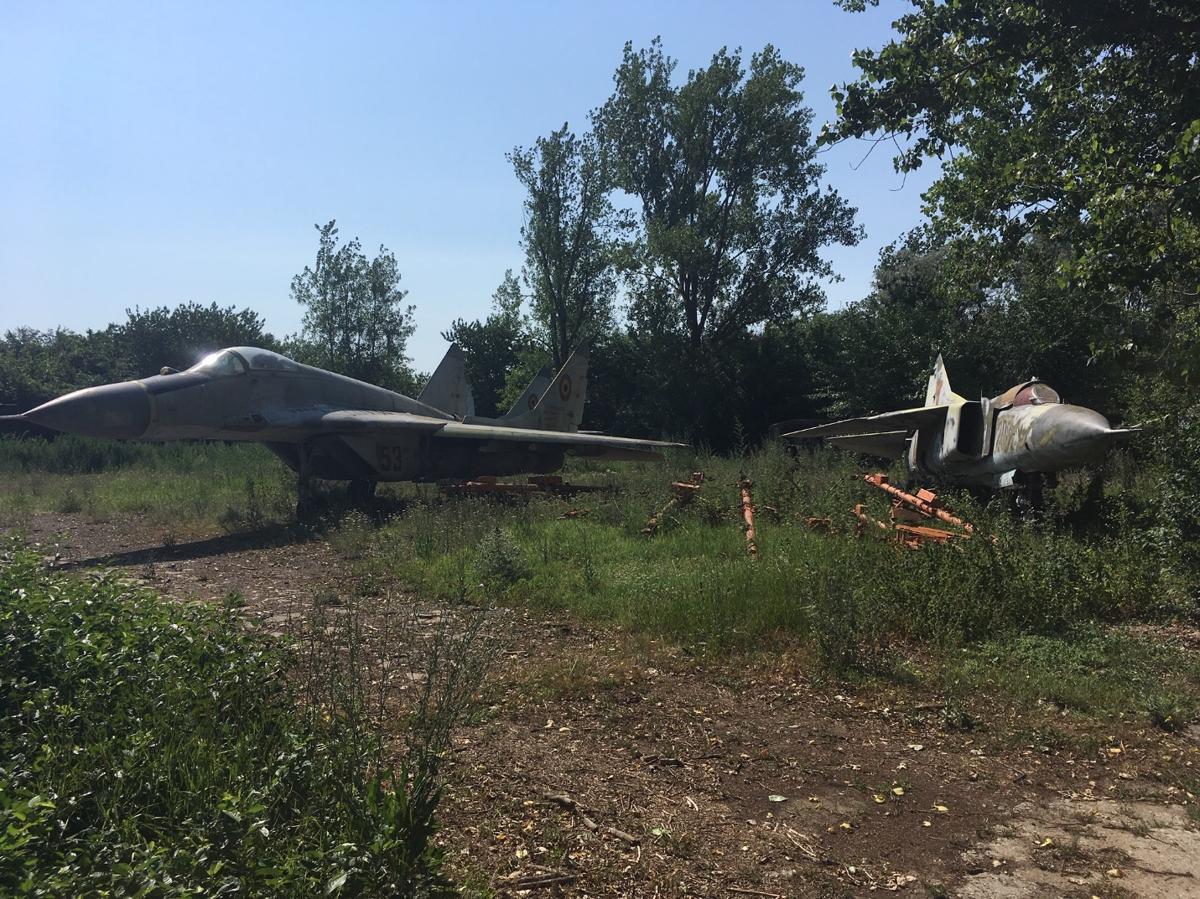

*A derelict MiG-29 and MiG-23 in their final resting place. Photo by Joel Radunzel.*

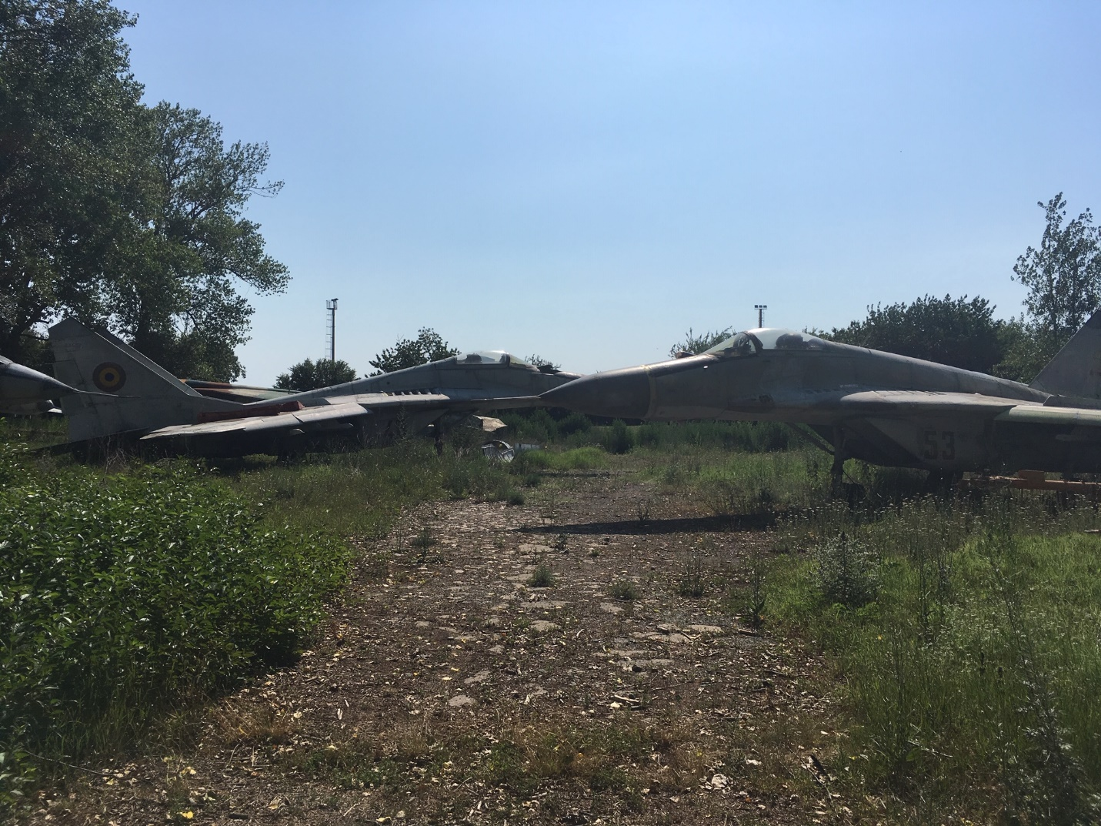

*MiGs that have seen better days. Photo by Joel Radunzel.*

All this to say, the time that I’ve spent in Eastern Europe has brought home to me how strange the outcomes of history can actually be. It’s been fun to explore one possible outcome in our novel and scenarios, and fun as well to explore the real (and strange) future that actually played out!

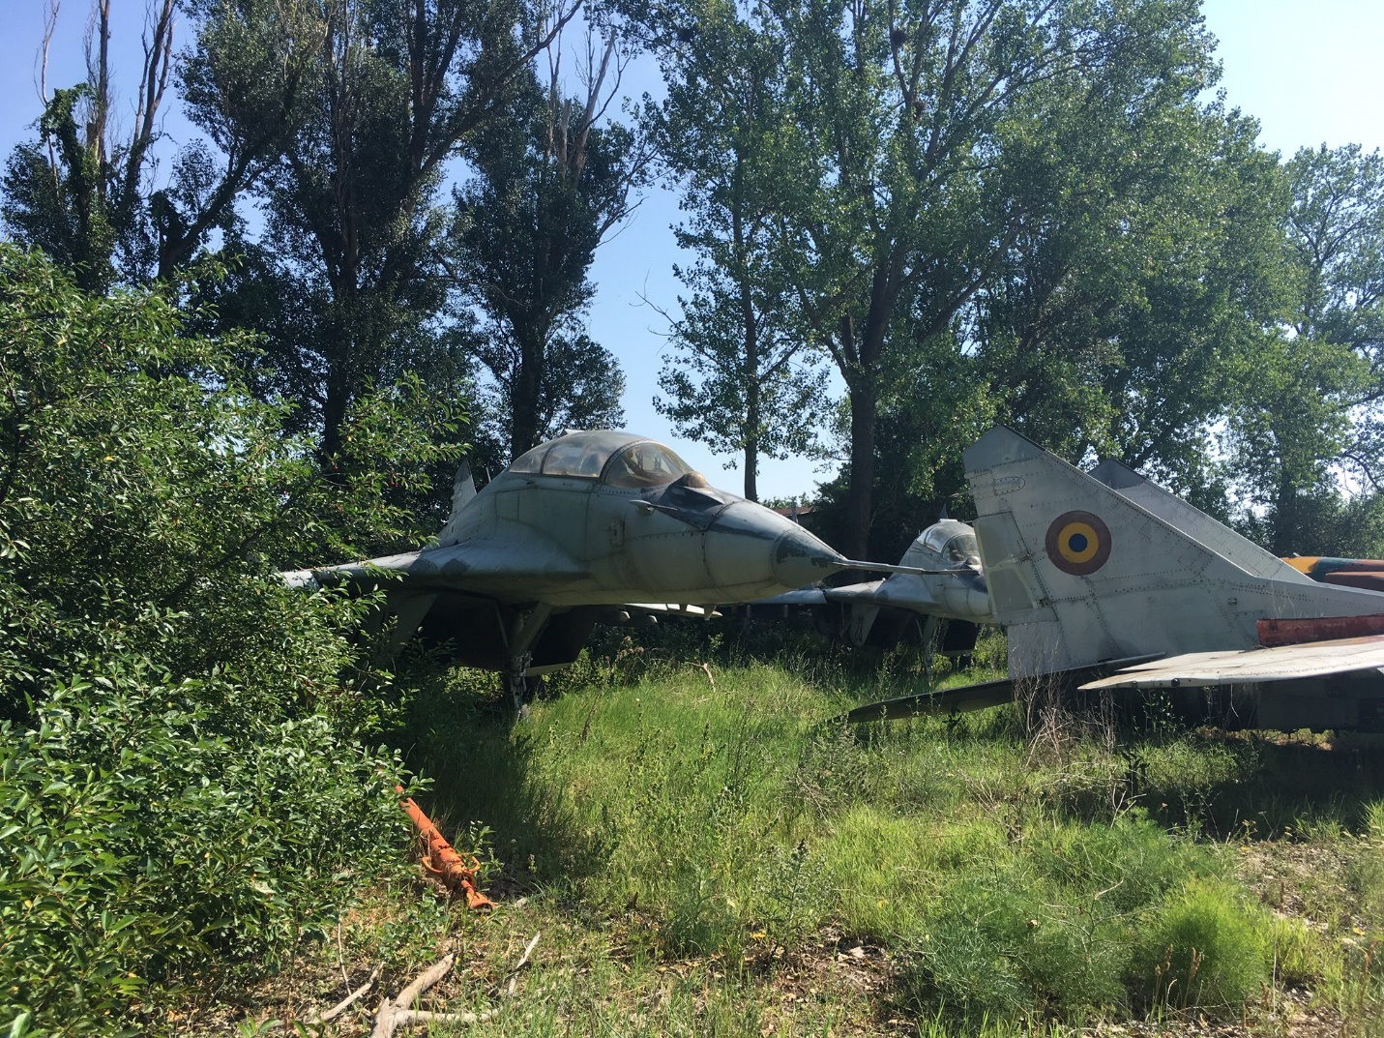

*Twin-seat MiG-29UB peeking through the bushes. Can you spot them in Med Fury 1? Photo by Joel Radunzel.*