**Background information for Indian Ocean Fury**

The information that follows is aimed at helping to understand the Northern Fury world as it pertains to the Indian Ocean region. The area holds three ‘Hotspots’ that we in the west have come to know quite well over the past few decades; The Persian Gulf, Somalia and the Somali coast and Yemen. Another flashpoint, arguably the most important, is India and Pakistan, but little attention is thrown that way, at least in North America. Although there’s been a fascination with the area since the Iranian revolution in 1979, its been since the Gulf War - coinciding with the end of the Cold War - where the region has been constantly in focus throughout the west. Interestingly, when designing this series, it’s often struck me that if a real war, a big war, were to occur - we wouldn’t be focusing our attention or our militaries here. The Indian Ocean region would quickly become a backwater as vital forces are pulled into the major fighting in the north Atlantic and north Pacific areas.

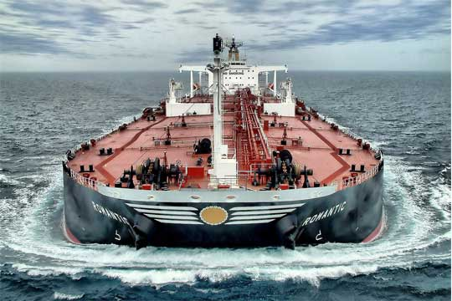

Therefore, the region is fertile ground for developing interesting situations where resources of all types are at a premium. The Soviet Union, well aware of the west’s fascination with the Persian Gulf, its oil and its dictators, will undoubtedly attempt to keep the focus here and therefore tie down forces that might make the difference elsewhere. The west, primarily the US, with the UK and France playing a large role, will be trying to establish a balance; minimizing forces committed here while ensuring that they maintain freedom of navigation and a reliable flow of commerce - particularly oil.

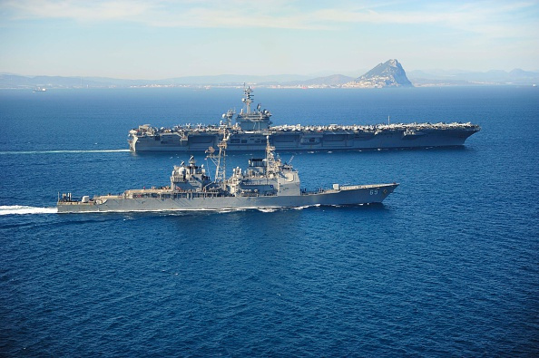

Geographically the Indian Ocean is massive, representing 20% of the world’s ocean surface. While not as large as the Atlantic or Pacific – it’s remoteness from the East-West interchange of the northern hemisphere make it difficult to support militarily. Nations, or more accurately continents bordering on the Indian Ocean, with the notable exception of Australia, tend to be less developed (in 1994) and much less ‘modern’. Local militaries are smaller and tend to use older technology and tactics.

The ‘Northern Fury’ story is consistent with actual history until about 1989, when it begins to diverge. The five years between 1989 and 1994 were very active in this region and that is not very different in our alternate history. Below is a summary of key events occurring and any diversions from that reality:

|  |  |  |  |  |
| --- | --- | --- | --- | --- |
| Timeframe | Event | Actual results | Northern Fury results | Remarks |
| 3 Jun, 1989 | Ayatollah Khomeini dies in Iran | Replaced by moderate | Replaced by radical | Shift not readily apparent in the west |
| 22 Oct, 1989 | Saudi Arabia, endorses a Charter of National Reconciliation | Balanced Cabinet and reduced Presidential power | Balanced Cabinet but Presidential power retained. | Some protest in the West |
| 1989 | Somali Civil War | Continued until ‘91 | Same | Same |
| 1989 | Muslim Insurgency in the Kashmir, India | Festers | Becomes a real problem for India | Fueled by Pakistan in both realities |
| 28 May, 1990 | Iraq makes dangerous pronouncements at the Arab League Summit | Threatens Israel with weapons of mass destruction | No change | No change |
| 24 Jul, 1990 | Iraq & Kuwait | Iraq accused Kuwait of economic conspiracy. Masses troops | No change | No change |
| 2 Aug, 1990 | Iraq invades Kuwait | Seized in 1 day | No change | No change |
| 7 Aug, 1990 | Operation Desert Shield | Coalition deploys | No change | No change |
| Oct, 1990 | Syria occupies Beirut | Nothing really | No change. Syrian forces still occupy Lebanon in 94 | No change |
| 1990 | US Sanction against Pakistan due to possible Nuclear weapons | Sale of F-16s halted. NZ leases them instead | The F-16s were never offered. USAF is absorbing all F-16 production. Sanctions are still tabled but much weaker. Limited effect. The 45x F-16AM and 12x F-16 ADF sold to PAK in 83 still occurred and they are maintained. | US very concerned with Indian action in Kashmir and heightened tension with Iran. Wants to keep Pakistan as ally in region. Assisted in Pak purchase of 40x Mirage 2000 |
| 1990 | Military build up Op Desert Shield | Coalition and events as historical | No change | No Change |
| 17 Jan 1991 | Desert Storm | Coalition and events as historical | No change | No Change |
| 27 Feb 1991 | Gulf War ends | Coalition and events as historical | No change | No Change |
| 21 May, 1991 | Rajiv Gandhi, assassinated |  | The assassination was linked to Pakistani based operatives causing a major diplomatic crisis |  |
| 31 July, 1991 | START I Treaty signed | Bush and Gorbachev | No change | Both sides claim they will hold to the treaty even after the coup in Aug ‘91 |
| 19 Aug, 1991 | Russian Coup | Gorbachev toppled | Start of Northern Fury spinning into Hard line reactions | The world changes ☺ |
| 19 Oct, 1991 | Earthquake Northern India | ~2000 people died | Although Kashmir only minimally affected, this turns into a diplomatic spat between India and Pakistan. | Several cross border incidents. India claiming the west is ignoring its disaster. Pakistan’s offer to help denied etc. |
| 24 Nov, 1991 | Freddie Mercury dies | Had to slip this one in | Doesn’t happen ‘Queen’ is touring the world with another massive hit album ☺ |  |
| 25 Dec, 1991 | Dissolution of the Soviet Union |  | This also does not happen. Soviet Union increased grip on power. A very bloody period of consolidation |  |
| Dec, 1992 | Operation Restore Hope in Somalia | Coalition and events as historical | By Dec 93 only a few hundred US Marines remain in Somalia | Somali piracy starts early and is having some effect by the end of 93 fueled by a bounty offered covertly by the Soviet Union. (historically this grew in 2002 onward) |
| Oct, 1993 | Battle of Mogadishu | Black Hawk Down | No real change, precipitated the hasty withdraw of coalition and US forces by the end of 93 |  |

So, based on the above and some other factors the key points that impact the Indian Ocean region are:

* Gulf War happened as it did historically, Iraq is neutered and unable to exert too much influence. Operation Southern and Northern Watch are ongoing with deployment of Coalition forces continuing roughly in line with historic deployments.
* Hard(er) line government in Iran. Evidence of Soviet funding and refurbishment of equipment
* Saudi Arabia is less ‘in bed’ with the west due to continued western support of Egypt and other Gulf states, and a desire to keep Soviet benevolence as an option
* Conflict in Somalia, the civil war, UN mission, battle of Mogadishu and withdraw of forces happened as they did in reality.
* Eastern Africa is unsettled; the continued influence of the Soviet Union is in direct conflict with China’s attempt to make inroads into African politics. Compounded by a general lack of interest in the West, this ongoing friction is leaving opportunities for exploitation by an aggressive Soviet foreign policy.
* Apparent sponsorship of piracy is starting to gain momentum. The going rates in this history for 1994 is ~ $10/Ton, so a bounty of ~2-3 Million USD is not uncommon. The ships are run aground, the crews freed and the cargo is sometimes sold as a bonus, or just looted locally. CTF 150 is patrolling off of Somalia but so far it’s a losing battle.
* CTF 151 is established in the Gulf of Aden in an effort to curb Piracy there, but also out of concern for a deteriorating situation in Yemen
* CTF 149 in the Northern Persian Gulf continues as it historically did.
* NATO establishes a standing Mine Countermeasures group at Djibouti to counter the persistent appearance of mines in the Bab-el Mandeb (BEM) (SNMCMG 3).
* The US establishes 5th Fleet HQ in Bahrain in Dec 1993, about 18 months earlier than it did historically.
* The French have reinforced their position in Djibouti somewhat.
* Tensions between India and Pakistan are very high

**Sub-Regions:** The following is a quick roundup of the situation by nation, running roughly clockwise around the region.

**South East Africa:** Ongoing friction sponsored by both the USSR and China have caused continued unrest in this area.

**South Africa** is just coming out of the Apartheid era and has resoundingly elected the ANC in a remarkably free and fair election (held in Jan vice Apr 94). The new South African Government is torn between severing ties with its colonial past and bolstering its defences against regional instability. The long ignored military is suffering from a significant technology gap.

**Mozambique,** after 15 years of civil war the country will attempt to hold an election in March 94. The Soviet backed FRELIMO who seized power after independence from Portugal and held the upper hand for most of the civil war is expected to win easily. Many factions are already calling the upcoming elections a hoax and a cover for a Communist backed dictatorship. A significant amount of Soviet support has been funneled into the county over the past 3 years.

**Madagascar** has spiraled into authoritarian rule since the President of the ‘Second Republic’ Vice Admiral Ratsiraka took a hard line after his bodyguard shot unarmed protesters in 1991. He was able to tighten his grip on power with financial and military aid provided by Bulgaria, Romania and the USSR.

**The Comoros**, gained its independence from France in 1975 and has had a turbulent succession of governance since then (30 Coups or attempts between 1975 and 2008). There is no military to speak of but the French Foreign Legion barracks remains on the Island of Mayotte.

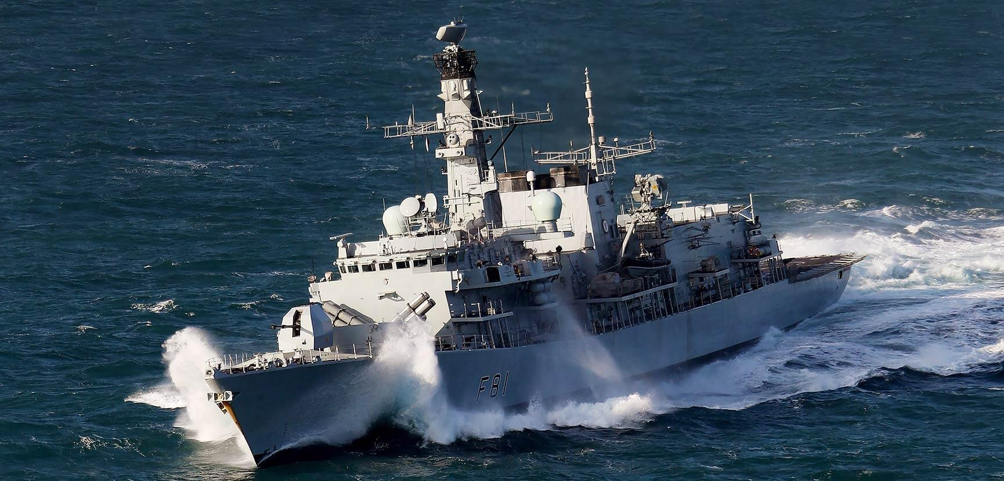

**East Central Africa:** Instability fueled by Soviet Foreign Policy.

**Tanzania,** is a single party socialist republic, attempts by dissident leaders in 1992 to change to a multi party state were ruthlessly put down. Ongoing support from the USSR propped up the corrupt dictatorship which has become quite aggressive towards neighboring Kenya.

**Uganda**, after the fall of Idi Amin in 1979, the Tanzania sponsored government was toppled in 1986 and replaced by a short lived progressive president. In 1990 another coup, probably sponsored by Tanzania gained power. Since 1990 Uganda has followed Tanzania’s lead in most issues, including receiving second hand military hardware from Eastern European countries.

**Kenya**, one of the most stable countries in Africa. Led by President Moi since 1978 who has won 4 elections, including in 1992, one which allowed for opposition parties to run for the first time. Kenya is pro west and still very British in its attitudes toward external policies. Although the west has to look the other way when domestic issues get ugly, such as the massacre of thousands of ethnic Somalis.

**Horn of Africa**: You really can’t make this stuff up!

**Somalia**, as a country is in a very bad way. The corruption and despotism of the 80’s lead to the Civil war which still rages. The failed US led coalition ‘United Task Force’ (UNTAF) to support delivery of humanitarian aid collapsed at the end of 1993 and has withdrawn. Remaining elements of the UN (UNOSOM II) and humanitarian organizations are in disarray. In Northern Fury, Somalia is even more fragmented than in the historic world (if that is possible!), Soviet funding has spurred on piracy and sponsored fractious groups which thrive on instability. Somali military forces have virtually ceased to exist, weapons, soldiers and even formed units have found their way into several warring factions. The government has no control over any effective military force, particularly air or naval elements which, by 1991 were completely ineffective anyway.

**Ethiopia**, continues to be supported by the Soviet Union. Attempts at forming a Democratic Republic faltered early in the process when Soviet funds started flowing into the economy again. The ‘Derg era’ a Soviet backed Marxist-Leninist military dictatorship continued. As expected the Military - large in 91, grew slightly but most importantly, became more competent as internal strife was extinguished and flair-ups on the border with Somalia became common.

**Djibouti**, although there is an ongoing, low level civil war (that won’t be settled until 2000), Djibouti is considered ‘stable’ in this region. Staunch allies with both its former colonial patriarch France, and its financial patriarch the US, means it is good business for all sides to keep a lid on domestic problems. Militarily, the most important element is basing rights for both France and the US. Proximity to the Bab-el-Mandeb (BEM) straits makes this a very strategic location and both France and the US are eager to ensure freedom of navigation through the Red Sea by keeping the BEM secure. The new NATO SNMCMG 3 has just set up its base of operations here.

**Eritrea**, gained independence from Ethiopia in 1991 after a 30 year war of independence (or civil war from Ethiopia’s point of view). In 1993 the UN sponsored a referendum which voted overwhelmingly for independence. Following this vote the EPLF (Eritrean People’s Liberation Front) seized power, established a single party socialist government and firmly gripped all organs of power (They are still in power and there have been no elections to date -2018). The military is not large but is staunchly loyal, and is Soviet equipped and trained.

**Sudan**, (not technically part of the Horn of Africa but put here for convenience) - Now since reality and fiction cross - this is a direct lift from Wiki:

*On 30 June 1989, Colonel Omar al-Bashir led a bloodless military coup. The new military government suspended political parties and introduced an Islamic legal code on the national level. Later al-Bashir carried out purges and executions in the upper ranks of the army, the banning of associations, political parties, and independent newspapers, and the imprisonment of leading political figures and journalists. On 16 October 1993, al-Bashir appointed himself "President" and disbanded the Revolutionary Command Council. The executive and legislative powers of the council were taken by al-Bashir.*

The only thing to add from a Northern Fury perspective - Bashir is on the Soviet funding list and is keeping his military up to date.

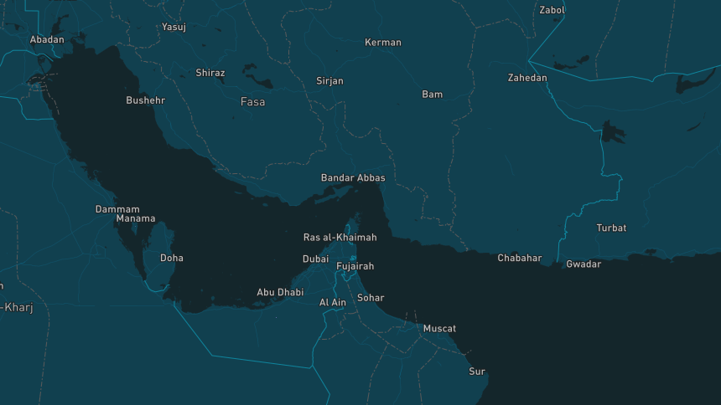

**Arabian Peninsula/Gulf States**: Rich and getting richer.

**Saudi Arabia,** a staunch ally of the US and the west but quite reluctant to involve itself with Cold War conflict. Ties with the Soviet Union are not nearly as strong as those with the west but they do exist and there is a faction within the politically powerful that resent the west’s and in particularly US interference and demands. The long standing hatred of Iran is tempered by the west’s support for Saudi Arabia’s other arch rival - Egypt. With the exception of Yemen, relations with other neighbors are good - the neighbors have no choice. Yemen is another situation entirely.

**Yemen,** appeared to be moving along the road to recovery with unification in 1990 and an elected government, until the Gulf War. When Yemen opposed non-Arab states from expelling Iraq from Kuwait, voting against several UN Security Council resolutions, the US was furious - and Saudi Arabia was livid! Saudi Arabia expelled 800,000 Yemenis, increasing the population by about 8-9% and precipitating food shortages, riots and a downward spiral into civil war by late 93 (historically the civil war started in May 94). The Soviet Union found the situation quite convenient and offered economic and military assistance.

**Oman,** the Sultanate of Muscat and Oman is one of the more stable countries in the region. A founding member of Gulf Cooperation Council, Oman is friendly to the west. Considering itself progressive, women have been allowed to vote since 1991 and the upcoming election later in 1994 will see female candidates in the general election for the first time - a first amongst the Arab countries in the Gulf.

**UAE,** very rich and pro west, the United Arab Emirates was also a founding member of the Gulf Cooperation Council. The UAE supported the coalition against Iraq in 1991 and is in the process of negotiating military defence agreements with the US and France.

**Qatar,** another rich and progressive (to a point) nation that is very friendly with the US and the west. Qatar fought in the coalition against Iraq and was heavily engaged in the battle of Khafji. Qatar is also a founding member of the Gulf Cooperation Council.

**Bahrain,** is the financial hub of the Arab world, replacing Beirut in this role during the Lebanese Civil War. Banking combined with oil make Bahrain’s economy more diverse than other Gulf States, but there is unrest among Shia fundamentalists evidenced by a failed coup in 1991. The government is very friendly with the west and provides naval basing to the US and UK. 5th Fleet HQ is located in Manama.

**Kuwait,** the focus of the 1991 Gulf war when Iraq invaded and the US led coalition assembled then expelled them. [Kuwait is still recovering](http://countrystudies.us/persian-gulf-states/33.htm) from the war, although the 700 oil well fires were extinguished within a year, the environmental and economic damage was immense. Interestingly Kuwait's population is now about half of what it was prior to the invasion, not due to casualties, but because the government is far more reluctant to allow non-Kuwaitis to enter. Rebuilding the oil industry and infrastructure has gone relatively quickly, reaching 50% of pre-invasion levels within 18 months - although there is still much to do and Billions to spend before it regains its pre-invasion status.

**Iraq,** the post Gulf War Iraq is an economic basket case. The Hussein government refused to disarm after the war and it is widely rumoured to maintain significant stocks of chemical weapons which it used, at least once, against its Kurdish population since the end of the war. The resultant international sanctions and the no-fly zone imposed by UN Security Council Resolutions have left the country crippled. The Iraqi military is in very bad shape with few workable aircraft or ships and very questionable fighting quality within the army.

**Iran,** the hard line anti-western government in Tehran has become even more acerbic towards the US and Europe since starting to receive increased military, economic and technical assistance from the Soviets, about the time of the start of the Gulf war. Little access is available in Iran but it’s now clear that the post-Khomeini regime is even more hard line than before. Although forced to a truce in the Iran-Iraq war, most in Iran considered it a clear win - that is certainly what they were told. Very little is known within Iran about the 1991 Gulf War and the destruction of the Iraqi armed forces, but it is certain that those in the Iranian government who do know, are ecstatic about the defeat of their hated enemy, but cautious about the combat capability of their other hated enemy - the US; locally known as the Great Satan.

**Indian Sub-Continent**: Where hatred festers!

**Pakistan,** needs the economic support of the west, and the west needs Pakistan to be an ally in an area rife with Soviet influence. The 1990’s are not shaping up to be a good decade for Pakistan however. With the death of long-time (for Pakistan) President Zia in 1988, conflicting left and right wing ideologies started to rip the country apart and unearthed decades of corruption and internal cultural strife and oppression. The struggle with India is ever present, the three wars and constant skirmishing between them since independence in 1947 have left deep scars, no more so than the almost continuing conflict in the Kashmir. Pakistani development of nuclear weapons has attracted international attention and sanctions from the UN. The US is walking a fine line with Pakistan, needing its support in the region but not wanting another nuclear power and needing to be seen as hard line against proliferation.

**India,** has been a nuclear power since 1974 although it maintains a ‘no first use’ policy. India has been an ally of the Soviet Union for several decades, although the relationship is far from congenial. Military hardware is purchased from around the world but the preponderance originates from Soviet or Warsaw Pact. The Soviets meanwhile, are more concerned with having India as a counterbalance with China than anything else, however, friction with Pakistan often works in its favour.

**Islands**: Paradise without the dashboard lights.

**Maldives,** a former British territory has been independent since 1968 and ruled by the same man since 1978. Although there has been a series of coup attempts, all have failed. The last coup in 1988 was stopped by an Indian parachute battalion that was flown in to stabilize the regime. The country consists of 26 atolls and a few isolated island groups with a population of about 240,000. The Maldives National Defence Force consists of two helicopters, several Coast Guard Patrol Boats and a small ‘Rapid Reaction Force’ to provide internal security.

**Mauritius,** colonized first by the Dutch, then the French and finally the British, it became a Crown Colony in 1968 and then an independent republic in 1992. Consisting of the main island and several outlying islands the country is almost the size of Luxembourg and has a population of just over a half million. The military consists of a small Coast Guard with two fixed wing (a BN-2T Defender, and a Do228) and three helicopters (2x Alouette III and an AS355), 10 Patrol Craft (ex Indian) and a 270-man reaction force.

**Seychelles,** colonized by the French and then controlled by the British, this country consists of 115 islands and a population of less than 100,000. Militarily there is a Presidential Protection unit, seven patrol craft and four aircraft. This country is friendly to both India and the West.

**British Indian Ocean Territory,** consisting of seven atolls totaling an area of 60 square kilometers, the largest being Diego Garcia, jointly used as a base by the British and US. Local people were forced to depart in the 1960s to allow the construction of the base at Diego Garcia and the current population of 4000, consists of 2,200 transient military, 1,400 Filipino contract workers and about 300 Mauritians.

**French Southern and Antarctic Lands,** is a group of island groups. Governed from Paris it has a prefect with a headquarters on Reunion Island. Total population is about 150 which doubles in the summer.

**The Scenarios:**

This region probably has room for about forty different scenario situations, but only 10 will form the Indian Ocean Fury battle set.

|  |  |  |  |  |
| --- | --- | --- | --- | --- |
| Scen | Date | Title | Description | Remarks |
| 1 | 13-15 Feb | Persian Pounce | Desperate struggle to withstand initial attacks in the Persian Gulf and evacuate key units out through the Straits of Hormuz | Complete |
| 2 | 13-15 Feb | Mozambique Madness | HMS Ark Royal transits the Mozambique Channel north to Somalia sorting out several problems along the way | Complete |
| 3 | 15-18 Feb | Socotra Scramble | USS Nimitz assembles its BG and in sequence removes the threat in Socotra, BAM and Sudan as it transits North though the Red Sea | Complete |
| 4 | 18-20 Feb | Gate of Tears | Ark Royal passes the BEM, moves north, Amphib and air assault onto and around Socotra and the BAM by US & French forces | Complete |
| 5 | 18-22 Feb | Hormuz Hoedown | USS Saratoga conducts strikes to re-open the Straits of hormuz. Problems develop between India and Pakistan | Complete |
| 6 | 22-25 Feb | Back into the Breach | After replenishing USS Saratoga takes the fight back into the Persian Gulf |  |
| 7 | 26-27 Feb | Deep Strike | Major strikes to disable Iran’s nuclear infrastructure |  |
| 8 | 27 Feb | Red Sea Rumble | Convoy operations with hostile elements still active in the restricted waters of the Red Sea. |  |
| 9 | 28 Feb, 1 Mar | Spectator Sport | Saratoga moves south as the Indo/Pak problem heats up |  |
| 10 | TBC | TBC | TBC |  |