**Canadian Air Force**

The Canadian Air Force conducts a wide range of operations from Defence of North America under the NORAD (North American Air Defence) treaty and NATO tasks with a wing of CF-18s in Germany, to maritime patrol, Anti Submarine Warfare (ASW) and search and rescue working with the Canadian Navy, to providing the Army with its tactical aviation.

**CF-18**

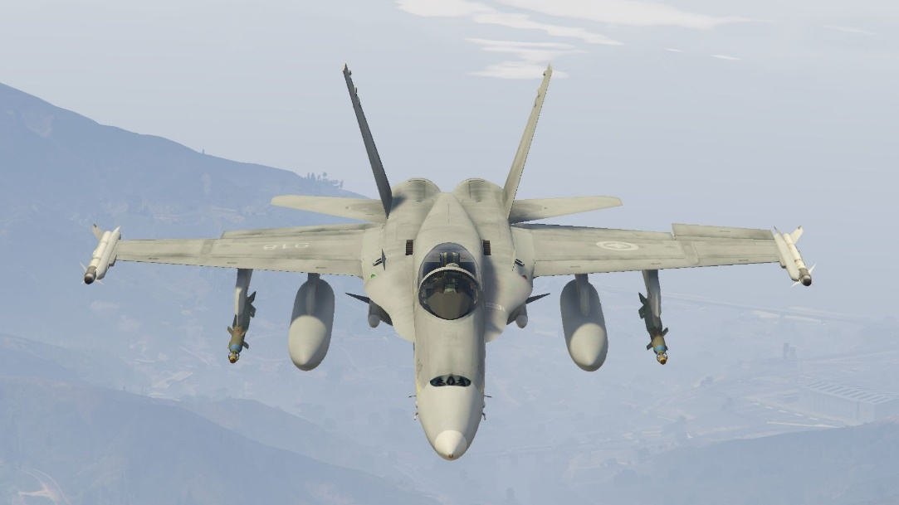In the 80’s Canada took delivery of all 138 CF-18’s (98 CF-18A and 40 twin seat CF-18B). The two main roles for these aircraft were NORAD patrols in Canada’s arctic and the standing NATO deployment in Baden Sollingen Germany.

1st Canadian Air Division (1 CAD) based in Baden Sollingen Germany consisted of two wings operated under control of Fourth Allied Tactical Air Force. 4 Wing was permanently established in Baden and consisted of three squadrons while 3 Wing was a ‘Flyover’ wing which was to deploy regularly or in periods of tension, consisting of two squadrons, one each from Cold Lake and Bagotville.

The NORAD Squadrons would be operating under the control of the Canadian NORAD Region (CANR) and would disperse to Arctic and bases on each coast in groups of six aircraft (6-Pack) each.

|  |  |  |  |  |  |  |  |  |
| --- | --- | --- | --- | --- | --- | --- | --- | --- |
| Formation | Wing | Sqn | Name | A/C | Type | Base | Deploy | Remarks |
| 1 CAD | 3 Wing | 416 | Lynx | 18 | CF-18 | Cold Lake | Lahr | 24 hrs |
|  |  | 433 | Porcupine | 18 | CF-18 | Bagotville | Lahr | 18 hrs |
|  | 4 Wing | 409 | Nighthawk | 18 | CF-18 | Baden |  |  |
|  |  | 421 | Red Indian | 18 | CF-18 | Baden |  |  |
|  |  | 439 | Sabre Toothed Tiger | 18 | CF-18 | Baden |  |  |
| CANR | 2 Wing | 425 | Alouette | 18 | CF-18 | Bagotville | East Coast | 2 hrs |
|  |  | 441 | Silver Fox | 18 | CF-18 | Cold Lake | West Coast | 2 hrs |
| Training | 2 Wing | 410 | Cougars | 10 | CF-18 | Cold Lake |  |  |

[**CF-5**](http://www.joebaugher.com/usaf_fighters/f5_21.html)

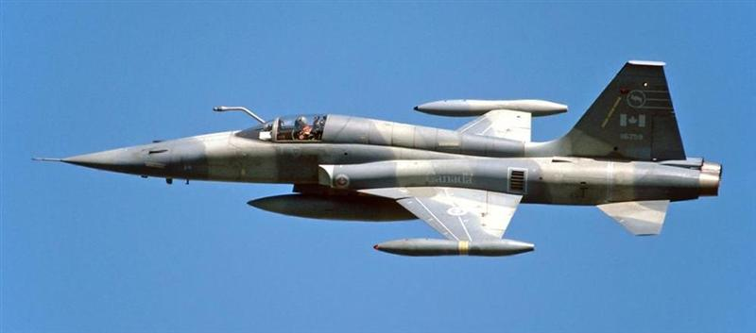Introduced in the late 60’s the CF-5 Freedom Fighter was due to be replaced by the CF-18. Only two squadrons remain even though 135 examples were initially built. In 1988 23x CF-5A and 33x CF-5D received a major upgrade and structural overhaul, and in 1990, a further Avionics Upgrade (AUP) was provided to 46 aircraft (13 CF-5A, 33 CF-5D). Historically this second upgrade was terminated after 37 aircraft were complete but in Northern Fury they were all completed. Both remaining squadrons (434 Sqn was historically disbanded in 89 but remains here) fly a multitude of missions: Advanced fighter training and lead-in training for CF-18 pilots; Close Air Support (CAS) for the Army, Dissimilar Air Combat Training (DACT) against the CF-18s and aggressor training against the Navy. Each squadron operates about 26 of the strengthened aircraft, more than half of them dual seat ‘D’ versions, mostly AUP versions.

|  |  |  |  |  |
| --- | --- | --- | --- | --- |
| Sqn | Name | A/C | Type | Base |
| 419 | Moose | 26 | CF-5A/D/AUP | Cold Lake |
| 434 | Bluenose | 26 | CF-5A/D/AUP | Chatham NB |

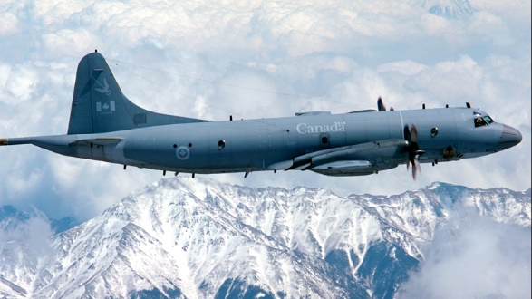

**CP-140 Aurora**

The Canadian version of the US P-3 which also mounts the electronics suite of the S-3 Viking to allow for a more varied mission set. 18 CP-140s were built plus 3 CP-140A Arcturus used primarily for training and fisheries patrols.

|  |  |  |  |  |  |
| --- | --- | --- | --- | --- | --- |
| Sqn | Name | A/C | Type | Base | Remarks |
| 404 | Buffalo | 5 | CP-140 | Greenwood NS | OTU |
| 405 | Eagle | 5 | CP-140 | Greenwood NS |  |
| 407 | Demon | 5 | CP-140 | Comox BC |  |
| 415 | Swordfish | 3  3 | CP-140  CP-140A | Greenwood NS | Testing & Eval |

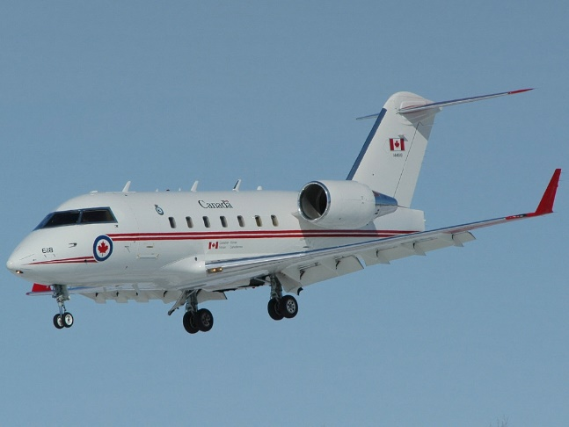**Transport**

The Canadian Air Force operates a wide variety of transport aircraft including about 60 CC-130 Hercules, 15 CC-115 Buffalo, 18 CC-144 Challenger, 5 CC-150 Airbus, and various other aircraft.

