**Denmark** 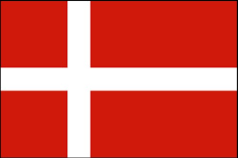

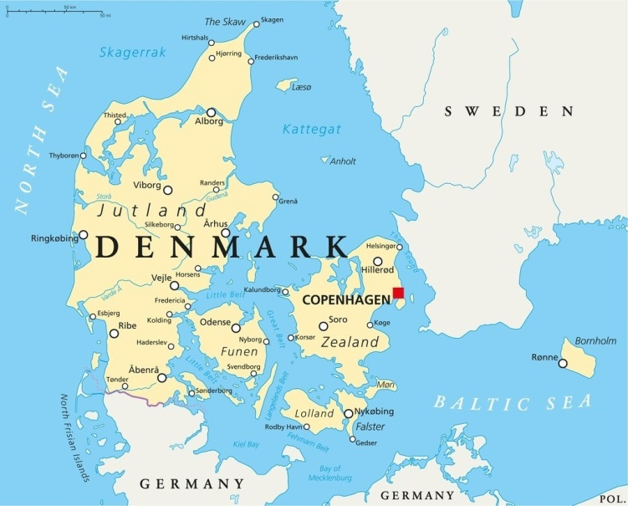

**Denmark:** The [Kingdom of Denmark](https://en.wikipedia.org/wiki/Denmark) is one of the original 12 NATO signatories and relies heavily on collective defence for its survival in conflict. Geographically small with a population of 5.2 million, Denmark has Trans-Atlantic responsibilities as it administers both the [Faroe Islands](https://en.wikipedia.org/wiki/Faroe_Islands) and [Greenland](https://en.wikipedia.org/wiki/Greenland). Bornholm Island is strategically critical, much closer to Poland than Copenhagen it was occupied by the Soviets in 1945 and is governed by an agreement with the Soviet Union which stipulates that no foreign troops will be stationed there.

The military forces of Denmark are relatively small but very integrated with the NATO force structure**.**