(Danish Submarines – to be added to the Danish Navy page)

**Submarines**

The Danish Navy operates two class of submarine, both of German design. Both designs are small, maneuverable and very well suited to operating in shallow, congested waters. All Danish submarines were based at Frederikshaven and two were kept at sea at all times with two more ready for immediate deployment.

[**Narhvalen Class**](https://en.wikipedia.org/wiki/Type_205_submarine): These two modified Type 205 submarines were acquired in 1970, they were very small and with a crew of only 21 personnel, were inexpensive to operate. They had a major drawback in that their torpedoes were only suitable for surface targets, and not other submarines, this was mitigated by operating them in coastal waters where they were supported by ASW helicopters.

|  |  |  |  |
| --- | --- | --- | --- |
| Pennant | Name | Status | Location |
| S 320 | Narhvalen | Active | In port |
| S 321 | Nordkaperen | Active | Patrolling off Bornholm Island |

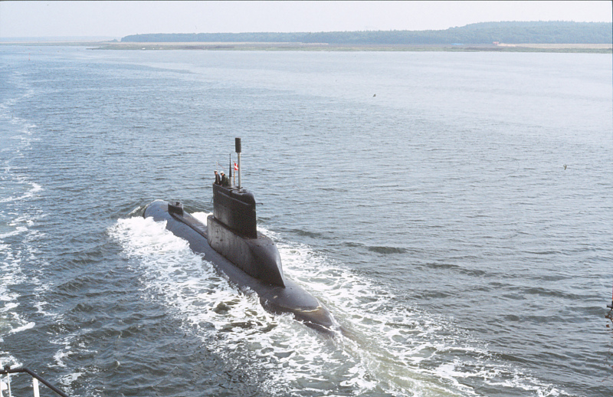

[**Tumleren class**](https://en.wikipedia.org/wiki/Kobben-class_submarine)**:** These three boats were purchased (along with a 4th used for spare parts) from Norway in 1989-91. This was the Norwegian Kobben class which were a customized version of the German Type 205 and designated the Type 207. Although very similar to the Narhvalen Class, they were slightly larger, had a much better maximum dive depth, better sensors, and were able to track and target other submarines.

|  |  |  |  |
| --- | --- | --- | --- |
| Pennant | Name | Status | Location |
| S322 | Tumleren | Active | In port |
| S333 | Saelen | Refit |  |
| S324 | Springeren | Active | Patrolling in the North Sea |

