**Spanish Air Force**

The Spanish Air Force (*Ejército del Aire, or Army of the Air)* has undergone significant transition since the death of Francisco Franco in 1975, the transition to democracy and joining NATO in 1982. Initially equipped with F-4 Phantoms, F-5 Freedom Fighters, and Mirage aircraft, the investment in the EF-18 has propelled the Spanish Air Force into the modern era.

**EF-18 Hornet:**

The fighting core of the Spanish Airforce is the EF-18A, with four operational Squadrons and a training squadron in two wings. Spain obtained 60 ‘A+’ and 12 ‘B+ versions of the aircraft, prefixed as EF these aircraft are very close to the ‘C/D’ standard allowing them to employ a modern suite of precision munitions, however they are limited to the Aim-7F Sparrow missile for air to air combat. An attempt (historically successful) to acquire a further 24 ex-US Navy Hornets has been thwarted by US requirements to expand its inventory of F/A-18s.

|  |  |  |  |  |  |  |
| --- | --- | --- | --- | --- | --- | --- |
| Wing | Squadron | Name | Base | # of AC | Type | Role |
| Gr.12 | Esc 121 | Aces | Torrejon | 12  2 | EF-18A  EF -18B | CAS/Mar |
| Gr.12 | Esc 122 | Black Cats | Torrejon | 12  2 | EF -18A  EF -18B | A2A |
| Gr.15 | Esc 151 | Bulls | Zaragoza | 12  2 | EF -18A  EF -18B | A2A |
| Gr.15 | Esc 152 | Mars | Zaragoza | 12  2 | EF -18A  EF -18B | SEAD |
| Gr.15 | Esc 153 |  | Zaragoza | 12  4 | EF -18A  EF -18B | Trg |

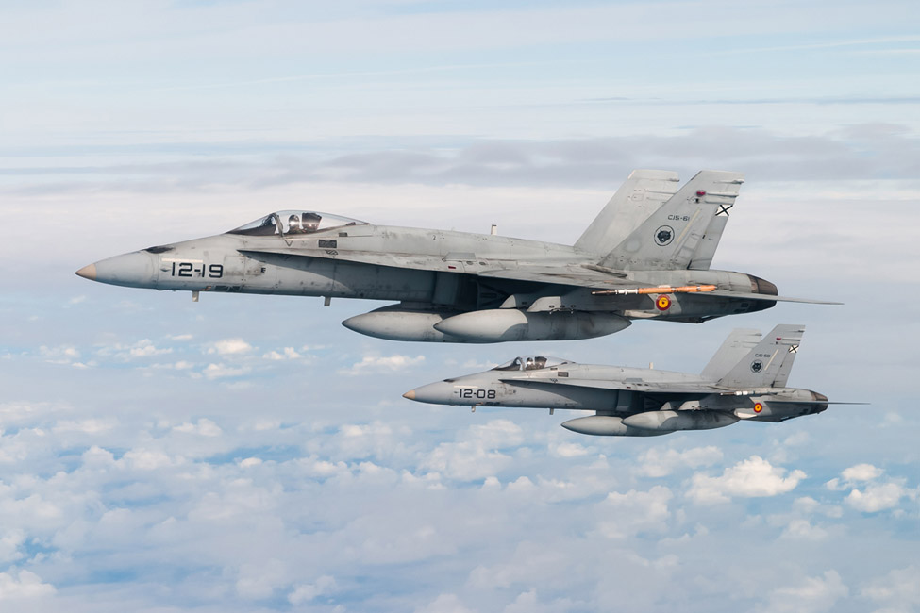

**Mirage F.1:**

Since 1975, one of the mainstays of the Spanish Air Force has been the Mirage F.1, many have been phased out but 48 of the original 91 airframes remain. Of these all have been upgraded to the ‘F.1M’ standard and half have been modified to the ‘EE’ interceptor role and the remainder are the ‘CE’ standard focusing on Close Air Support (CAS)

|  |  |  |  |  |  |  |
| --- | --- | --- | --- | --- | --- | --- |
| Wing | Squadron | Name | Base | # of AC | Type | Role |
| Ala.11 | Esc 111 | Wolves | Moron | 12 | Mirage F.1CE | CAS |
| Ala.11 | Esc 113 | Cocks | Moron | 12 | Mirage F.1EE | A2A |
| Ala.14 | Esc 141 | Bulldogs | Llanos | 12 | Mirage F.1CE | CAS |
| Ala.14 | Esc 142 | Tiger | Llanos | 12 | Mirage F.1EE | A2A |

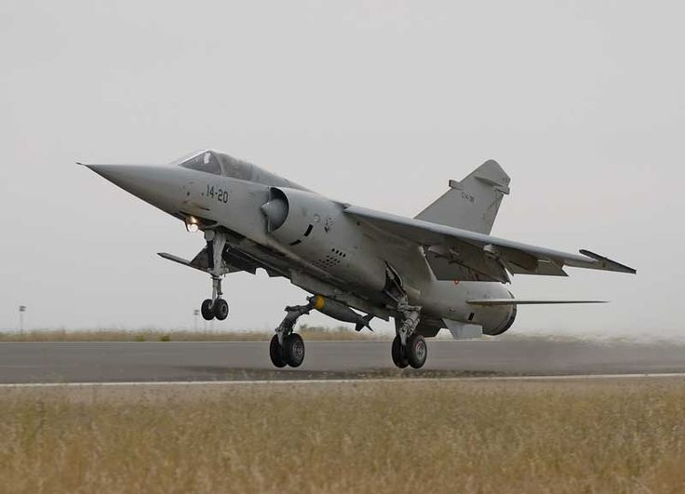

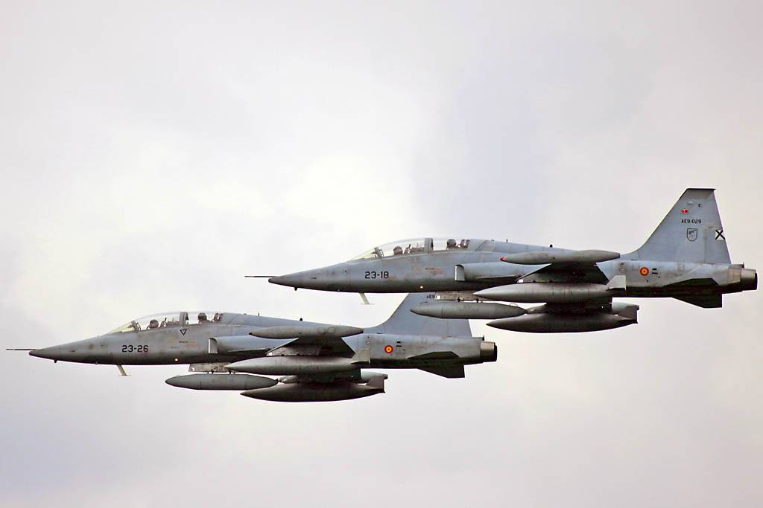**SF-5 Freedom Fighter**: Build in Europe and modified for the Spanish Airforce, the remaining versions are all upgraded ‘B’ model two seaters or the last single seat which are reconnaissance versions but upgraded from the fighter version and retaining the original gun. In addition to Close Air Support these aircraft provide training to future EF-18 pilots.

|  |  |  |  |  |  |  |
| --- | --- | --- | --- | --- | --- | --- |
| Wing | Squadron | Name | Base | # of AC | Type | Role |
| Ala.23 | Esc 231 | Talons | Talavera | 10 | SF-5B | Trg/CAS |
| Ala.23 | Esc 232 | Hawks | Talavera | 10  6 | SF-5B  SRF-5A | CAS/Recon |

**P-3B:** Spain purchased 5 P-3B’s from Norway in 1989 and operates them from Moron Air Base.

**CN-212 and CN-235:**  These home grown Spanish transport aircraft developed by CASA and IPTN before these two companies were purchased by Airbus. The CN-235 began production in 1986 began replacing the CN-212 the same year. Both have Electronic Warfare, Photo Reconnaissance, Search and Rescue, and Maritime Patrol variants but in 1994 these functions remained with the CN-212 while the CN-235 was quickly replacing the cargo variants.

**Falcon 20:** This French built executive jet serves the Portuguese, and many other European nations, as an Electronic warfare aircraft.

**C-130H**: The ubiquitous Hercules serves the Spanish Air Force as both a Tactical Transport (8) and an areal refueling tanker (5).

**Boing 707B**: The one example of the venerable 707 in the Spanish Air Force serves as a refueling tanker.

**F-27:** These three light twin engine turbo prop serves as a Search and Rescue aircraft.

|  |  |  |  |  |  |  |
| --- | --- | --- | --- | --- | --- | --- |
| Wing | Squadron | Name | Base | # of AC | Type | Role |
| Ala.22 | 221 | Poker | Moron | 5 | P-3B | ASW/MPA |
| Ala.31 | 331 | Jumbo | Zaragoza | 5 | KC-130H | Refueling |
| Ala.31 | 332 |  | Zaragoza | 8 | C-130 | Transport |
| Ala.35 | 351 |  | Getafe | 5 | C-295 | Transport |
| Ala.35 | 352 |  | Getafe | 5 | C-295 | Transport |
| Ala.35 | 353 |  | Getafe | 5 | C-295 | Transport |
| Ala.37 | 371 |  | Matacan | 5 | C-212 | Transport |
| Ala.37 | 372 |  | Matacan | 5 | C-212 | Transport |
|  | 403 |  | Madrid | 1 | C-212 | Photo Recon |
| Gr.47 | 471 |  | Torrejon | 1 | KC-707 | Refueling |
| Gr.47 | 472 |  | Torrejon | 1  2 | C-212 EW  Falcon 20 | EW |
| Gr.54 | 541 |  | Torrejon | 6 | C-212 SAR | SAR |
| Ala.46 | 802 |  | Las Palmas | 3 | F-27 | MPA |