NATO/France/Navy/Aircraft Carriers/CVG Foch

**FS Foch (R 99)**

The Foch is conducting trials using borrowed USN F/A-18A as a possible replacement for the much delayed and problematic Rafale which was encountering yet more problems in development. The Foch’s Battle Group escorts are somewhat dispersed at war start, either in port of conducting other tasks off the south coast of France.

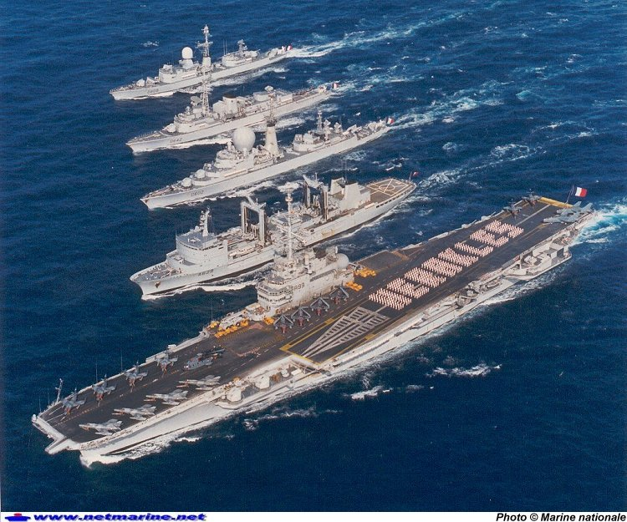

Battle Group on 13 Feb 1994

* + R 99 FS Foch
  + Aviation Wing
    - Flottille 13F – 15x Super Etendard Mod
    - Flottille 12F – 8x F/A-18A - on Loan from US for training
    - Flottille 4F – 8x BR.1050 Alize ALM
    - Flottille 32F – 2x SA.321G Super Frelon
    - Flottille 23S – 2x SA.365F Dauphin 2 and 1x SA.319B Alouette III
  + D 603 FS Duquesne (Departing Marcelles)
  + D 614 FS Cassard
  + D 641 FS Leygues Dupleix (Departing Toulon)
  + F 797 FS Commandant Bouan
  + A 629 FS Durance (off Toulon)
  + S 601 FS Rubis