**France** 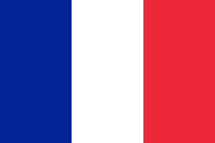

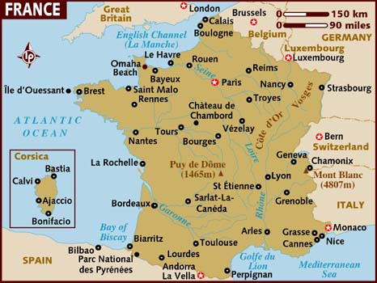

**France:** Although France left the NATO military command structure in 1966, it was one of the 12 founding members. In Northern Fury, France rejoins NATO within 7 hours of the war starting. France has several overseas territories and global commitments to maintain.

The significant military inventory fielded by France is hindered in several ways: The near 30 year absence from NATO means that interoperability with other nations has suffered; France's defence industry had fallen behind technologically in some areas leading to long development times (Rafale took 25 years from contract to fielding), excessive build times (12 years for the Aircraft Carrier Charles De Gaulle), neither of which are available for Northern Fury; Limited sales within NATO but significant sales to potential enemies (Dassault Mirage type fighters, Exocet SSMs, Crotale SAMs etc); Several unique but dated doctrinal anomalies remain within the French structure, (Light Armoured Divisions etc).