NATO/France/Navy/Aircraft Carriers/Naval Aviation

**French Naval Aviation**

The state of French Naval Aviation (Aviation Navale) in 1994 was quite desperate. The long awaited Rafale fighter was delayed once again, now over 20 (and eventually 25) years in development. This was only mitigated by the delays in building the new Aircraft Carrier ‘Charles De Gaulle’ which had finally been ordered in 1986, many years after it was needed, and was due to be launched later in 1994 (it would not be commissioned until 2001).

The aircraft available for the two existing aircraft carriers and one helicopter carrier were suffering from both material and doctrinal obsolescence.

**F-8P (FN) Crusader**

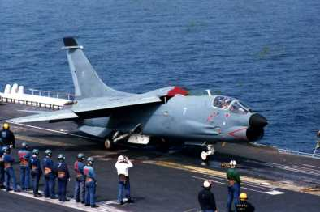As the American Navy was adopting the F-4 Phantom as its air superiority fighter, it was proven to be to large for the French aircraft carriers Clemenceau and Foch. Therefore, the last F-8’s coming off the production line were purchased, modified to fire the French Air to Air R.530 missile, and adopted to provide air superiority to the French Fleet. 42 were purchased and constantly upgraded until, by 1998 only 17 underwent a final life extension program. They operated in two Squadrons (*Flotille*) 12 & 14, each of 8 aircraft. *Flotille* 12 was conducting trials with USN F/A-18A at the start of the Northern Fury Campaign.

1 F-8P on FS Foch

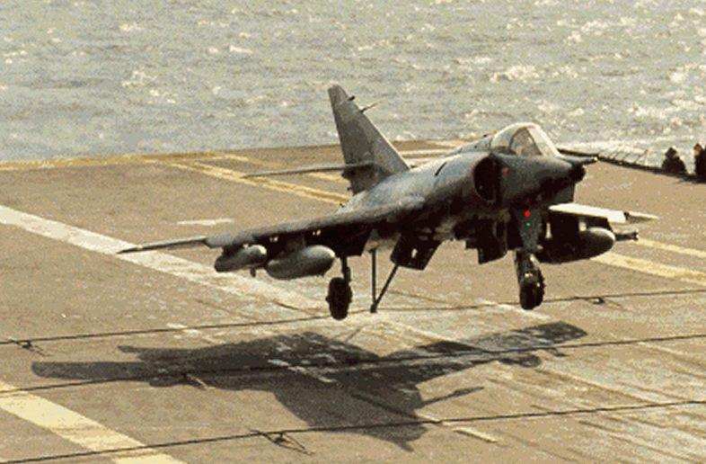**Super Étendard IVM**

2 Super Étendard

A total of 71 Super Étendards operated in Aviation Navale as the primary strike fighter in four squadrons, three operational and one training (11F, 13F, 15F, 17F). The normal complement in a carrier air wing was 16. Historically these started to retire in 1991 but they have been kept in service for Northern Fury.

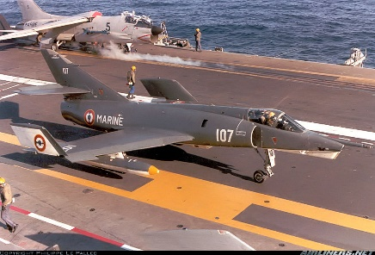**Étendard IVP**

3 Étendard IVP

The reconnaissance version of the original Étendard IV, the 22 examples went under a modernization program between 89 and 94 and would historically outlast the ‘Super’ versions by two decades. A standard air group has 4 of these on board. They operate from three Squadrons (16F, 18F, 20F).

**BR.1050 Alizé**

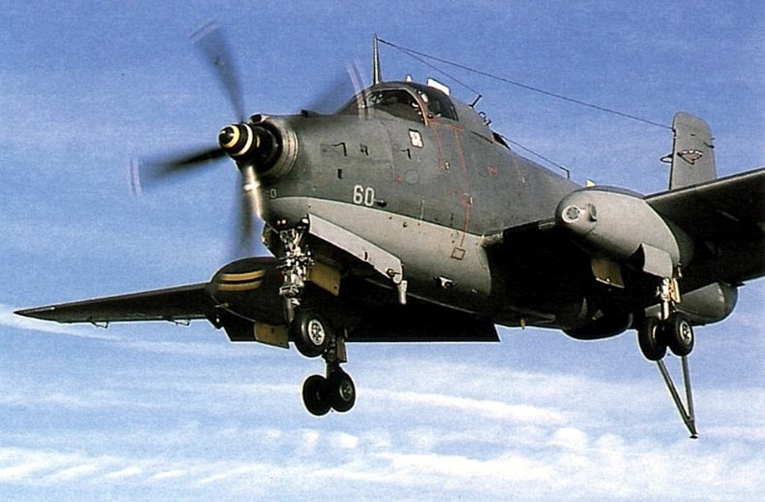Making the rest of the air group look modern was the Breguet Alizé! An ASW aircraft developed in the 1950’s. Although modernization in the 1980’s and again in the early 1990’s (which about half of the feet have undergone) improved the sensors somewhat, the final modernization removed all weapons to allow room for a better radar and reduce the weight load on the wings. Several squadrons operated these aircraft, initially numbered in the 1-10F range but as the weapons were removed and they became maritime patrol only they switched to the 21-30F range. Normal complement in and air group was eight.

4 Breguet BR.1050 Alizé

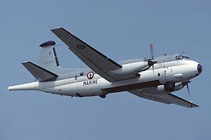**BR.1150 Atlantic 1 & 2**

The Atlantic is a shore based long range maritime patrol aircraft (MPA). These aircraft operate in the same role as the American P-3 and the British Nimrod, and by all accounts were equally capable in many respects. There were 40 **Atlantic 1’s** delivered in the 60’s and 28 of these were upgraded to **Atlantic 2’s**, a much more capable sensor platform in the 80’s. The 58 airframes remaining in 1994 operate in seven squadrons of mixed versions.

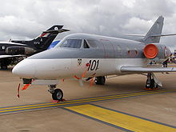**Falcon 200 Maritime Patrol, 50 ECM**

5 Falcon 200

Five of these converted executive jets are used for maritime patrol around French possessions in the Pacific Ocean. A similar number of Falcon 50 ECM variants are operating out of continental France.

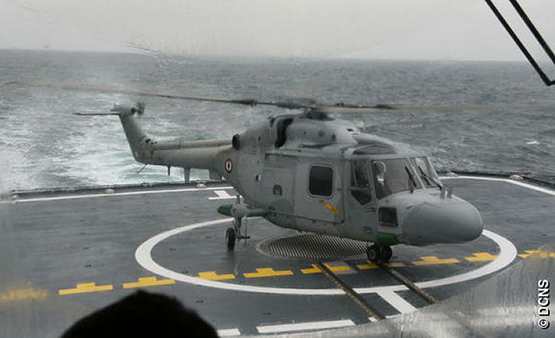**Naval Aviation**:

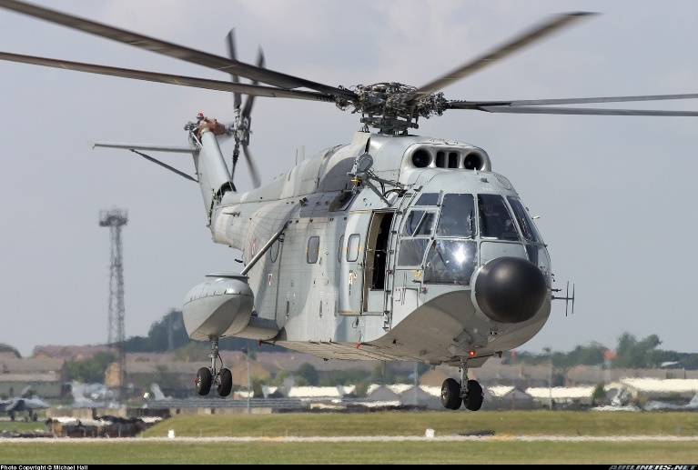The French Navy has a wide range of rotary wing craft conducting various tasks. The primary ship board ASW helicopter is the **Lynx Mk.4(FN).** Additionally, for carrier based ASW and sanitation of the exit routs for the SSBNs the **SA.321G Super Frelon** is used.

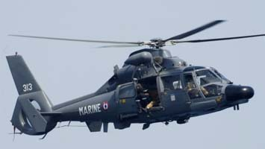

Ship board Search and Rescue (SAR) is conducted by the **SA.365F Dauphin 2.**