**Greek Air Force**

The Hellenic Air Force maintains a large but mixed inventory; some very capable modern aircraft are entering service but many less capable and border line obsolete aircraft remain.

**F-16**

Greece received 40x F-16 Block 30 (34 C & 6 D) airframes 1988/90 under the Peace Xenia I program, the last foreign sale of this type the US conducted within Northern Fury. Peace Xenia I was very closely linked with Peace Onyx I which was the sale of F-16s to Turkey. Initially concentrated at Néa Anghialos in 111th Combat Wing, a new squadron has just formed at Lárissa.

|  |  |  |  |  |  |  |
| --- | --- | --- | --- | --- | --- | --- |
| Sqn | Name | Wing | Location | AC | Type | Remarks |
| 330 Mira | Thunderbolt | Néa Anghialos | 111 PM | 16 | F-16C |  |
| 341 Mira | Arrows | Néa Anghialos | 111 PM | 14/2 | F-16C/D |  |
| 346 Mira | Jason | Lárissa | 110 PM | 6/4 | F-16C/D |  |

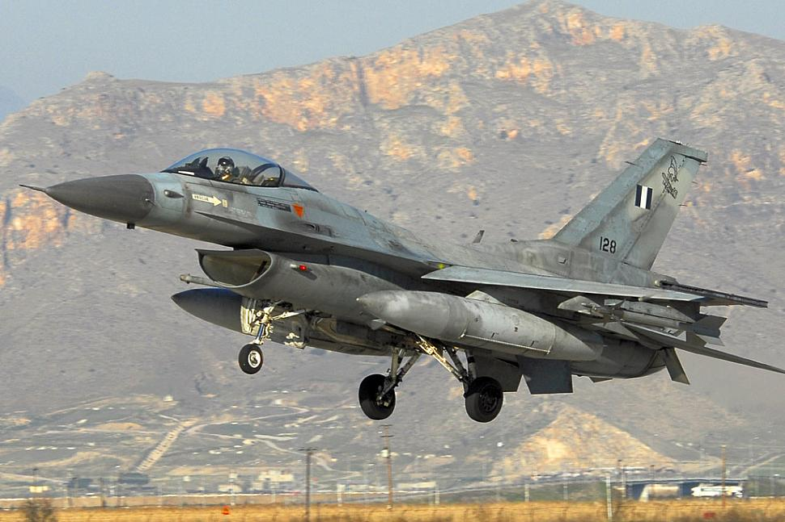

**Mirage 2000**

As part of the general modernization of the Greek air force in the 1980s 40 Mirage 2000Es (4 were two seat ‘BG’ trainers) were purchased. These were the first 4th generation aircraft employed by Greece and they were primarily meant for the air superiority role. They deployed to the 114th Combat Wing at Tanagra which was already operating the Mirage F.1CG.

|  |  |  |  |  |  |  |
| --- | --- | --- | --- | --- | --- | --- |
| Sqn | Name | Wing | Location | AC | Type | Remarks |
| 331 Mira |  | Tanagra | 114 PM | 18 | Mirage 2000EG |  |
| 332 Mira |  | Tanagra | 114 PM | 16/4 | Mirage 2000EG/BG |  |

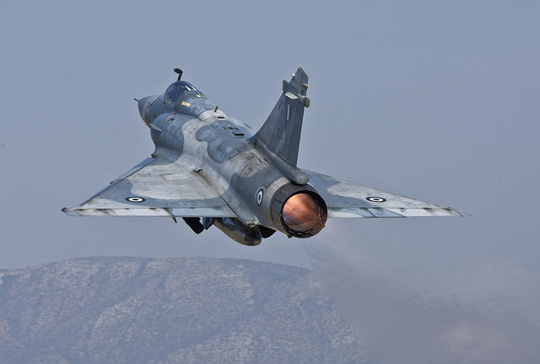

**Mirage F.1**

The Mirage F.1 was rushed into service in response to the Turkish invasion of Cyprus and the Greek withdrawal from NATO which quickly followed. France diverted some aircraft that were destined for its own air force in order to fill the requirement. No two seat trainers were acquired, only 40 F.1C modified to fire Sidewinder missiles (designated F.1CG), delivered from 1975-77. Although these were considered 3rd generation multi role aircraft, Greece was primarily interested in their Air to Air capability as they had A-7 Corsairs to focus on the bombing role.

|  |  |  |  |  |  |  |
| --- | --- | --- | --- | --- | --- | --- |
| Sqn | Name | Wing | Location | AC | Type | Remarks |
| 334 Mira |  | Tanagra | 114 PM | 18 | Mirage F1CG | 334 Mira |
| 342 Mira |  | Tanagra | 114 PM | 18 | Mirage F1CG | 342 Mira |

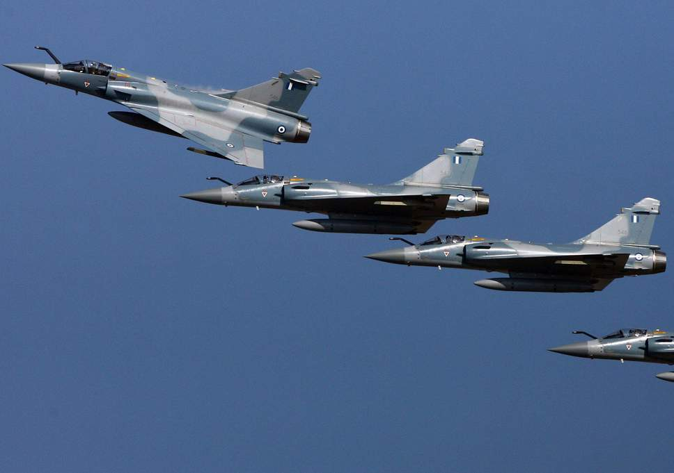

**F-4 Phantom**

The F-4 was another 3rd Generation multi role fighter which was acquired quickly in the early ‘70s, significantly modernizing the air force capability. Greece started receiving the first of 56 new build F-4E Phantom IIs in 1974, and then received 28 ex USAF F-4Es in 1991. In addition, the initial arrangement provided for six RF-4Es which were augmented by ex-Luftwaffe aircraft in 1993. In total four squadrons in two wings operate the F-4E and one squadron operates the RF-4E.

|  |  |  |  |  |  |  |
| --- | --- | --- | --- | --- | --- | --- |
| Sqn | Name | Wing | Location | AC | Type | Remarks |
| 337 Mira | Ghost | Lárissa | 110 PM | 18 | F-4E Phantom II |  |
| 338 Mira | Aris | Andrabida | 117 PM | 18 | F-4E Phantom II |  |
| 339 Mira | Aias | Andrabida | 117 PM | 18 | F-4E Phantom II |  |
| 348TRS | Eyes | Lárissa | 110 PM | 24 | RF-4E |  |
| 349 Mira | Kronos | Lárissa | 110 PM | 18 | F-4E Phantom II |  |

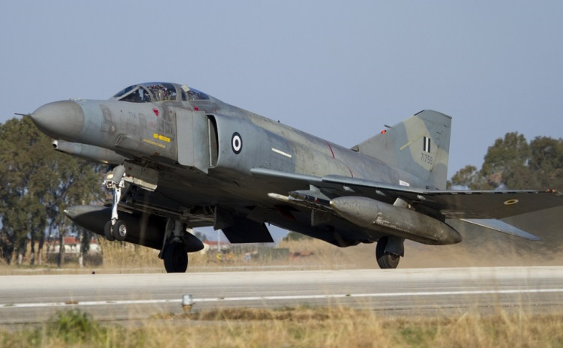

**F-5 Freedom Fighter**

Due for retirement and replacement by the F-16, some of these have been retained to counter the growing threat in Bulgaria. By 1994 about half of the F-5s originally operated by the Greek air force were still in operation.

|  |  |  |  |  |  |  |
| --- | --- | --- | --- | --- | --- | --- |
| Sqn | Name | Wing | Location | AC | Type | Remarks |
| 333 Mira |  | Micra | 113 PM | 18 | F-5 |  |
| 343 Mira | Asteri | Néa Anghialos | 111PM | 18 | F-5 |  |
| 344 Mira |  | Micra | 113 PM | 18 | F-5 |  |

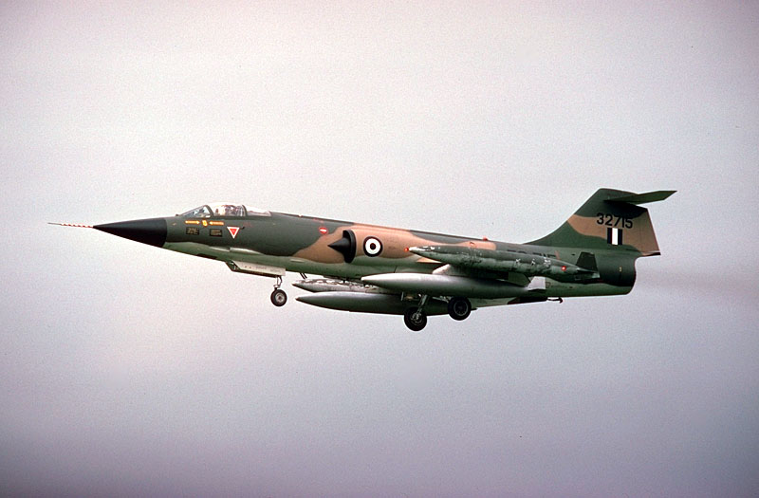

**F-104 Starfighter**

Another aircraft retained beyond its planned retirement date of 1993 was the F-104 Starfighter. As the Greek government tries to find solutions to the US reluctance to sell more F-16s, an upgrade program similar to the Italian F-104 ASM is being entertained.

|  |  |  |  |  |  |  |
| --- | --- | --- | --- | --- | --- | --- |
| Sqn | Name | Wing | Location | AC | Type | Remarks |
| 335 Mira | Tigers | Araxos | 116PM | 18 | F-104G |  |

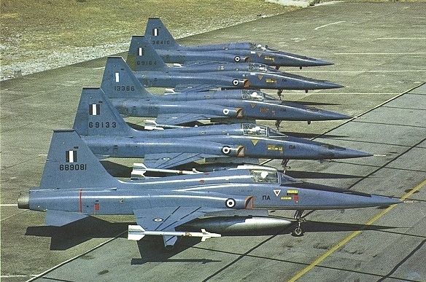

**A-7 Corsair II**

One veteran aircraft the Greek air force has no intention of retiring is the A-7H Corsair II. The SLUF (Short Little Ugly Fellow) is a venerable bomb truck with a massive range. Greece was the only country to receive new production Corsairs and the first foreign country to operate them in 1975. There were 60 newly built plus an additional 36 surplus A-7Es in the early ‘90s.

|  |  |  |  |  |  |  |
| --- | --- | --- | --- | --- | --- | --- |
| Sqn | Name | Wing | Location | AC | Type | Remarks |
| 336 Mira | Olympos | Araxos | 116PM | 18 | A-7E |  |
| 355 Mira | Hawks | Araxos | 116PM | 18 | A-7E |  |
| 340 Mira | Fox | Souda | 115 PM | 18 | A-7H |  |
| 345 Mira | Star | Souda | 115 PM | 18 | A-7H |  |
| 347 Mira | Perseus | Néa Anghialos | 111PM | 18 | A-7H |  |

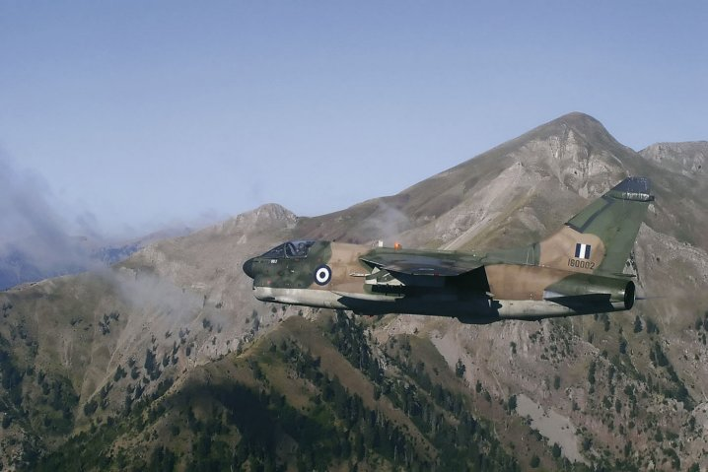

**Transport Aircraft**

Three different types of transport aircraft are in use, all operated by the 112th Combat Wing.

|  |  |  |  |  |  |  |
| --- | --- | --- | --- | --- | --- | --- |
| Sqn | Name | Wing | Location | AC | Type | Remarks |
| 352 VIP | Eagle | Elefsina | 112 PM | 2 | Gulfstream I |  |
| 355 TTS | Atlas | Elefsina | 112 PM | 12 | CL-215 |  |
| 336 TTS | Hurcules | Elefsina | 112 PM | 12 | C-130B/H |  |