**Greece** 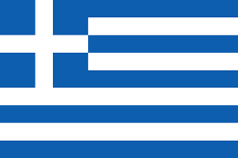

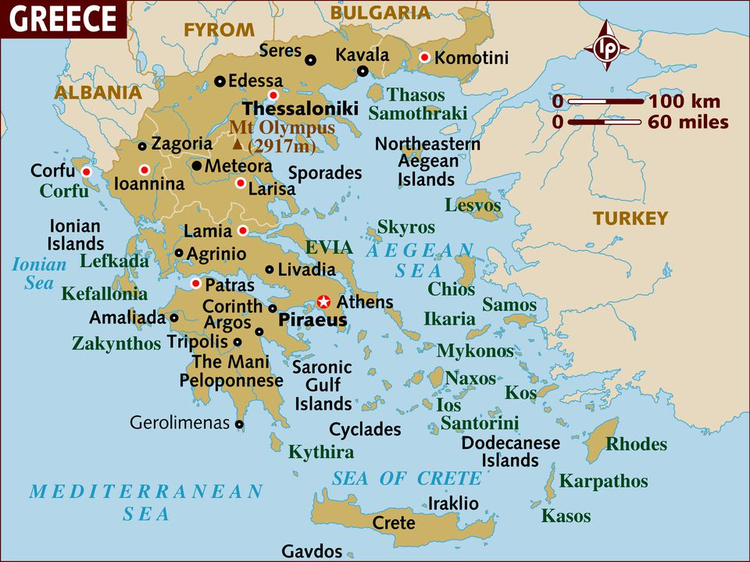

Greece has had a somewhat tumultuous relationship with NATO, joining in 1952 in conjunction with is geographic neighbor and long term rival Turkey. In 1974 when NATO refused to act against Turkey over the Turkish invasion of Cyprus, Greece withdrew from the alliance in protest, only rejoining again in 1980. Tensions between Greeks and Turks have been a significant issue within NATO but the threat of attack through Bulgaria towards the Aegean and from Soviet Crimea towards the Bosphorus is real enough that they work through their differences.

It is difficult to say how well the deep seated differences between Greeks and Turks would manifest under the pressures of conflict however the multi-national NATO command structure was not built to put eithers troops, ships or air elements under command of the other. Greece retaining command of its land forces as Allied Land Forces South Central Europe (LANDSOUTHCENT) headquartered in Larissa, and reporting directly to Allied Forces Southern Europe (AFSouth); Seventh Allied Tactical Air Force (7 ATAF) also in Larissa) and Commander Easter Mediterranean (COMEDEAST) in Athens. Turkey had equivalent commands all reporting to Naples.