**Italy **

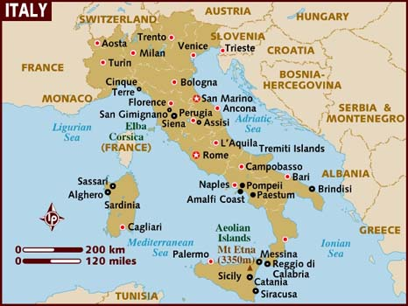

Italy is an original member of NATO as one of the 12 nations forming the alliance in 1949. Italy and NATO however had a complicated relationship; between 1946 and 1994 the government changed 61 times. Most of the turmoil however was internal to Italy and in that time only eight different presidents sat, they were mostly Right Wing. Internally however the tumultuous domestic political situation meant a decade of political tension where violent riots and bombings were an ever-present threat and strong Socialist and Communist parties.

The Italian military is relatively large, conscript based and focused entirely on NATOs Allied Forces South (AFSOUTH) headquartered in Naples.