**Italian DD/DDG’s**

Italy operates four destroyers and used them to provide air defence to the carriers, lead independent task forces or operate independently. They are potent and modern ships that exhibit excellent sea keeping characteristics

[**Audace** **Class**](http://www.military-today.com/navy/audace_class.htm): These two general purpose Destroyers were commissioned in 1972 but modernized between 1988 and 1991. In their current form they represent a hybrid of American and Italian systems with Aspide short range and Standard SM-1 missiles for medium range air defense. In addition to the 127mm gun, these ships use eight Italian designed Otomat Surface to Surface Missiles (SSM) for anti-ship targeting. These are good missiles with a 110 nautical mile range but suffer from needing mid-course guidance and are limited to ship launched systems only. Four OTO-Melara 76mm rapid fire guns augment both the air defense and anti-surface batteries. Two AB-212 Anti-Submarine Warfare (ASW) helicopters round out the armament making these very potent well rounded ships.

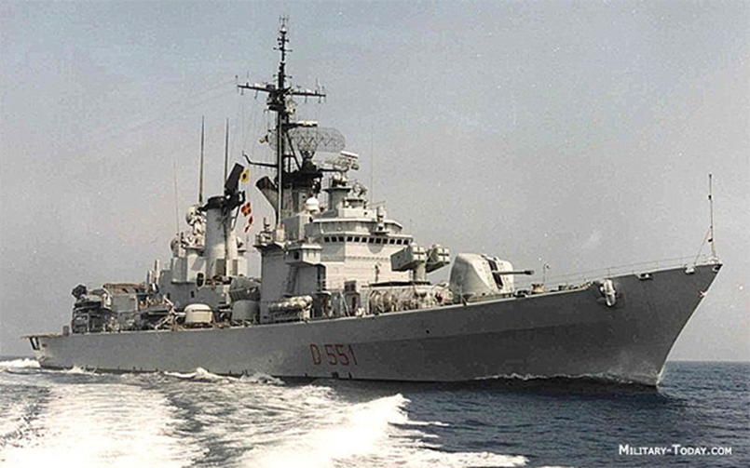

[**De la Penne Class**:](http://www.military-today.com/navy/de_la_penne_class.htm) Both of these brand new ships (launched in March and October 1993) are were designed to be improved versions of the very successful Audace class. They have essentially the same armament as the Audace class but with more modern sensors and control systems. One of the 76mm gun has been removed, leaving three. These are well rounded world class ships

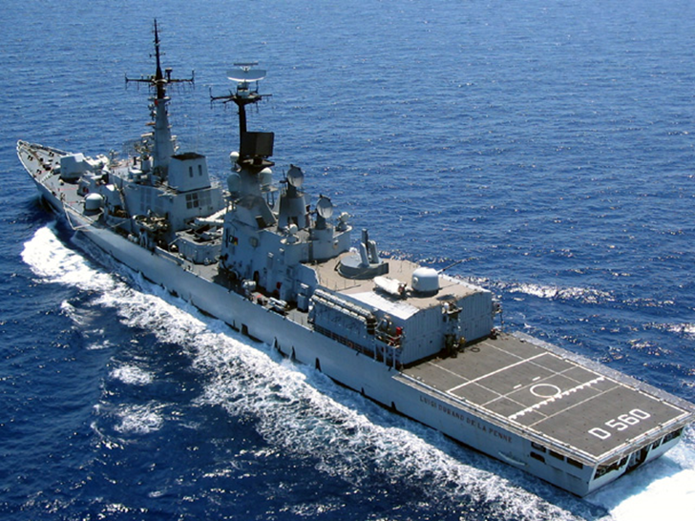

|  |  |  |  |  |
| --- | --- | --- | --- | --- |
| Class | Pennant | Name | Task | Remarks |
| Audace | D 550 | Ardito |  |  |
|  | D 551 | Audace | TG Garibaldi |  |
| De la Penne | D 560 | Durand de la Penne | TG Garibaldi |  |
|  | D 561 | Francesco Mimbeli | TG V Venito |  |