**Luxembourg **

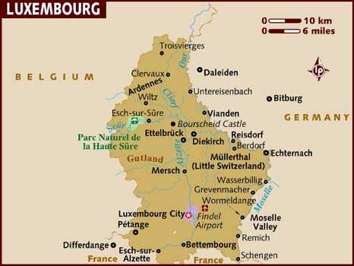

**Luxembourg:**

***Note: Add the bit above to the single Luxembourg page***

***Also check spelling of Luxembourg on page***