**Belgian Air Force**

Belgium maintained a powerful Air Force in the later Cold War era; however, they were quick to try and cash in on the ‘Peace Dividend’ when the Berlin Wall fell and most thought that the Cold war was ending. Luckily, the coup in Moscow reversed the trend in Brussels and although several squadrons were on the verge of standing down, they were kept, initially at a lower state of readiness but as tension with a resurgent Soviet Union heightened in 91/92, training increased and new weapons were purchased. The Belgian Air Force was committed to **2nd Allied Tactical Air Force (2 ATAF)** on the Central front over Germany.

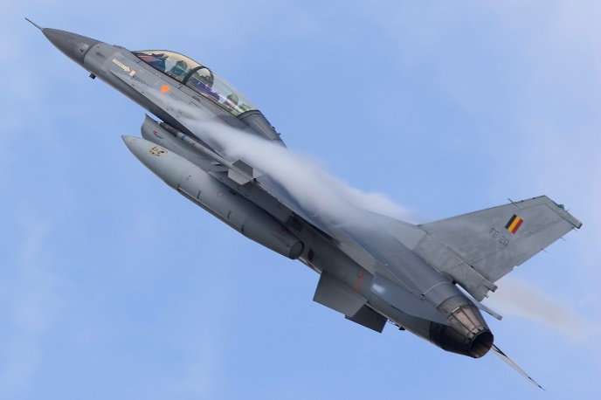

**F-16**

Belgium and the Netherlands formed a production consortium to build F-16s in Europe, eventually producing over 500 primarily for Norway, Denmark and themselves. By 1991 the second major purchase order had been completed with a total of 136 ‘A’ models and 24 ‘B’ models. The earlier production examples were rebuilt to the Block 10 standard, bringing the entire fleet to the Block 10/15 standard by 1992, with the final 40 being at the improved ‘OCU’ (Operational Capability Upgrade) standard.

Historically, Belgium obtained 72 Aim-120 AMRAAM and 12 AGM-65 missiles in 1995. Northern Fury has them acquiring these munitions in 1993, and the quantities increased to 140 AMRAAM and 36 Mavericks.

|  |  |  |  |  |
| --- | --- | --- | --- | --- |
| Sqn | Name | Location | A/C | Type |
| 1 | Stingers | Florennes | 20 | F-16A+ |
| 2 | Comet | Florennes | 20 | F-16A+ |
| 23 | Devils | Kleine Brogel | 24 | F-16A |
| 31 | Tigers | Kleine Brogel | 24 | F-16A |
| 349 | Mace | Beauvechain | 24 | F-16A |
| 350 | Ambiorix | Beauvechain | 24 | F-16A |
| OCU | Vulture | Beauvechain | 24 | F-16B |

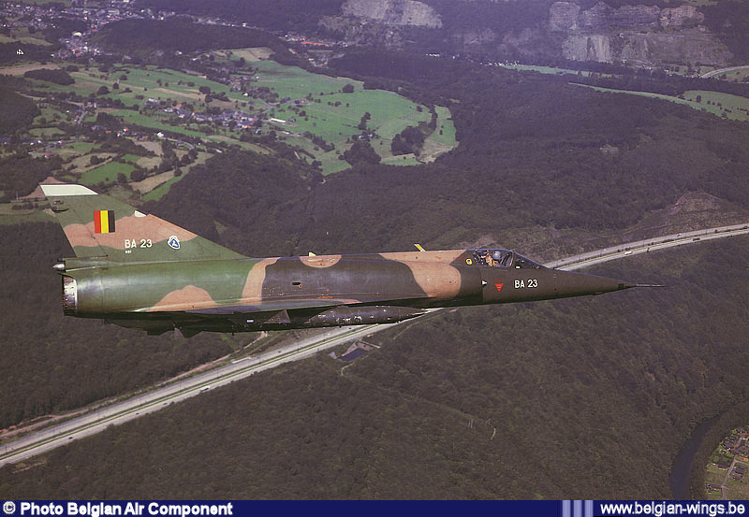

**Mirage 5**

Two squadrons of Dassault Mirage 5’s remain active in the Belgian Air Force, one in the attack role and the other focused on reconnaissance.

|  |  |  |  |  |
| --- | --- | --- | --- | --- |
| Sqn | Name | Location | A/C | Type |
| 8 | Blue Cocotte | Bierset | 36 | Mirage 5BA |
| 42 | Mephisto | Bierset | 22 | Mirage 5BR |
| OCU |  | Bierset | 16 | Mirage 5BD |

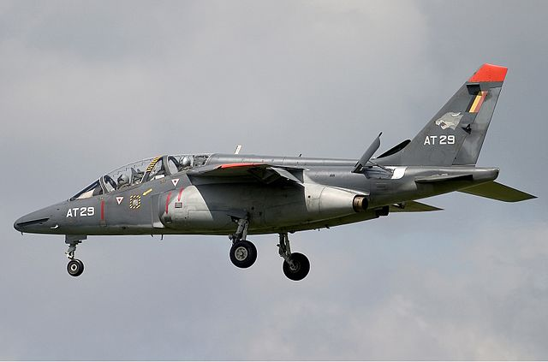

**Alpha Jet**

Initial operational training in both air-to-air and air-to-ground combat is conducted in the Alpha Jets of 7th and 33rd Squadrons. These units can also be put forward into combat if required.

|  |  |  |  |  |
| --- | --- | --- | --- | --- |
| Sqn | Name | Location | A/C | Type |
| 7 | Wolves | St Truiden | 16 | Alpha Jet |
| 33 | Bats | St Truiden | 16 | Alpha Jet |

**Transport**

The Belgian Air Force operates two transport Squadrons at Melsbroek Air Base: 20th Squadron operates 12x C-130H Hercules, while 21st Squadron operates a mixed fleet of Boeing 727 (x2), Dassault Falcon 20E (x2), Swearingen Merlin (x6), and Hawker Siddeley HS 748s (x3).

**SAR**

40th Squadron operates five Sea King Mk.48 out of Koksijde Air Base in the Search and Rescue role.

