**Canada** 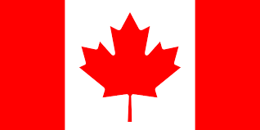

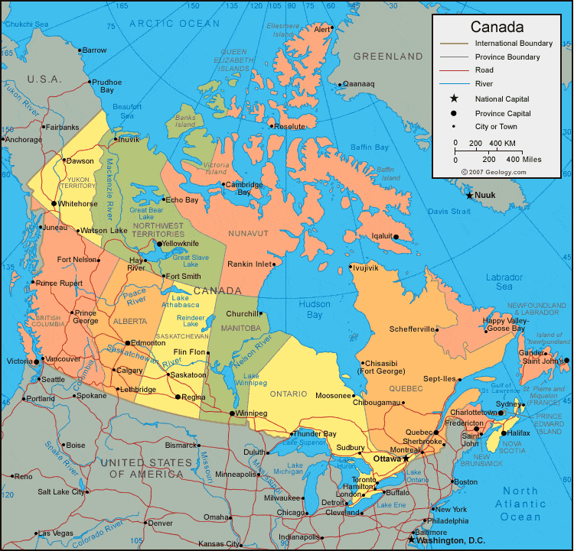

**Canada:** Canada was one of the original 12 NATO countries, geographically the largest in the alliance and one of the two North American partners. The Canadian Armed forces are small and committed on two fronts; Defence of North America through **NORAD** and domestic responsibilities, and the defence of Europe through **NATO**.