**Canadian Navy**

Canada’s Navy was primarily focused on ASW work in the North Atlantic, although a Squadron was always available in the Pacific to patrol the west coast and work with the US 7th Fleet and Asian allies.

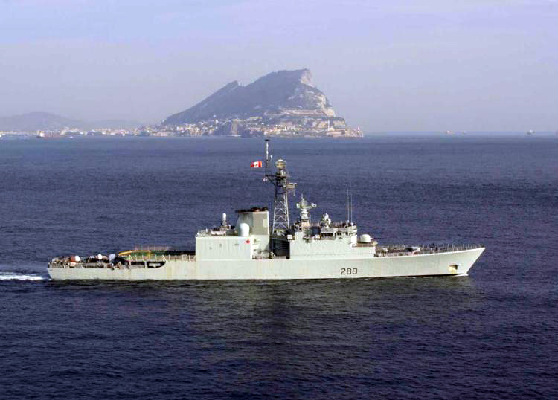**Tribal Class Destroyers**: These four ships had just finished a mid-life modernization program (TRUMP - Tribal Update and Modernization Project), making them quite capable. They routinely operated as a flagship for ASW task groups or within the ASW escort of a US CVBG.

| **Pennant** | **Ship** | **Status** | **Location** | **Task** |
| --- | --- | --- | --- | --- |
| DDH 280 | Iroquois | Active | Atlantic | STANAVFORLANT |
| DDH 281 | Huron | Active | Pacific |  |
| DDH 282 | Athabaskan | Active | Atlantic |  |
| DDH 283 | Algonquin | Active | Atlantic | Standing TG |

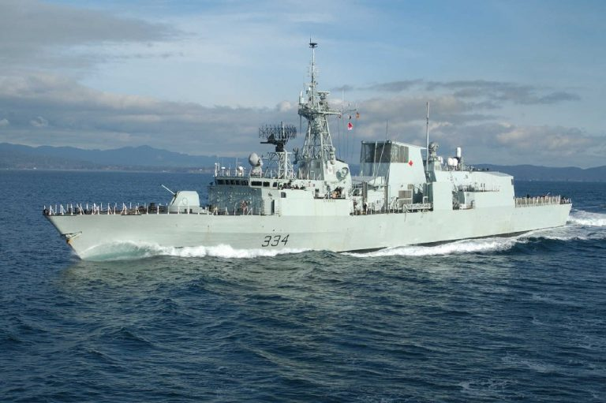

**Halifax (City) Class Frigates** represented a long awaited infusion of modern capabilities into the RCN. In Northern Fury, four (of 12) members of this class are available, with three more being commissioned three months early and arriving for operations during the campaign. The remaining five will be commissioned beyond the scope of Northern Fury.

| **Pennant** | **Ship** | **Status** | **Location** | **Available** |
| --- | --- | --- | --- | --- |
| FFH 330 | Halifax | Active | Atlantic |  |
| FFH 331 | Vancouver | Active | Pacific |  |
| FFH 332 | Ville de Québec | Commissioning | Atlantic | Apr-94 |
| FFH 333 | Toronto | Active | Atlantic |  |
| FFH 334 | Regina | Active | Pacific |  |
| FFH 335 | Calgary | Building | Jul-95 |  |
| FFH 336 | Montréal | Commissioning | Atlantic | Apr-94 |
| FFH 337 | Fredericton | Commissioning | Atlantic | May-94 |
| FFH 338 | Winnipeg | Building | Jun-96 |  |
| FFH 339 | Charlottetown | Building | Sep-95 |  |
| FFH 340 | St. John‘s | Building | Jun-96 |  |
| FFH 341 | Ottawa | Building | Sep-96 |  |

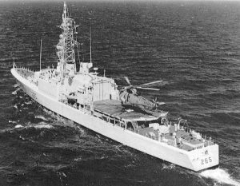

Annapolis Class

**The Steamers:** The ships the Halifax class was replacing were all commissioned in the late ‘50s or early ‘60s and were of marginal capability at best. Representing four different classes these 14 ships were all due for retirement after over 30 years of hard use in the North Atlantic or North Pacific. Essentially they remained active as life support systems for very effective towed array variable depth sonars (VDS) and the Sea King Helicopter carried on Annapolis and St Laurent classes (6 Ships).

| **Pennant** | **Class** | **ship** | **Status** | **Location** |
| --- | --- | --- | --- | --- |
| DDH 265 | Annapolis | Annapolis | Active | Pacific |
| DDH 266 | Annapolis | Nipigon | Active | Atlantic |
| DDE 261 | Mackenzie | Mackenzie | Tied Up | Pacific |
| DDE 262 | Mackenzie | Saskatchewan | Tied Up | Pacific |
| DDE 263 | Mackenzie | Yukon | Tied Up | Pacific |
| DDE 264 | Mackenzie | Qu‘Appelle | Tied Up | Pacific |
| DDE 236 | Imp Restigouche | Gatineau | Active | Pacific |
| DDE 257 | Imp Restigouche | Restigouche | Active | Pacific |
| DDE 258 | Imp Restigouche | Kootenay | Active | Pacific |
| DDE 259 | Imp Restigouche | Terra Nova | Active | Pacific |
| DDH 207 | St Laurent | Skeena | Active | Atlantic |
| DDH 229 | St Laurent | Ottawa | Tied Up | Atlantic |
| DDH 230 | St Laurent | Margaree | Tied Up | Atlantic |
| DDH 233 | St Laurent | Fraser | Active | Atlantic |

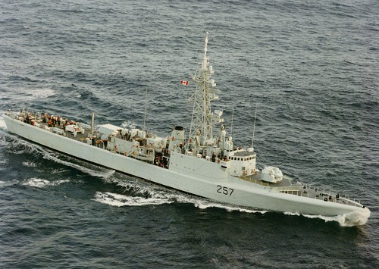

Improved Restigouche Class

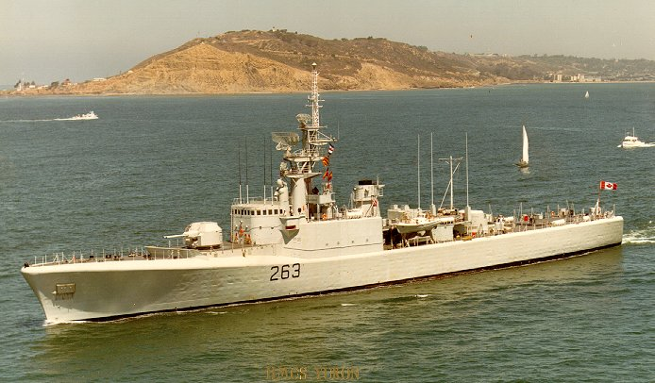

Mackenzie Class

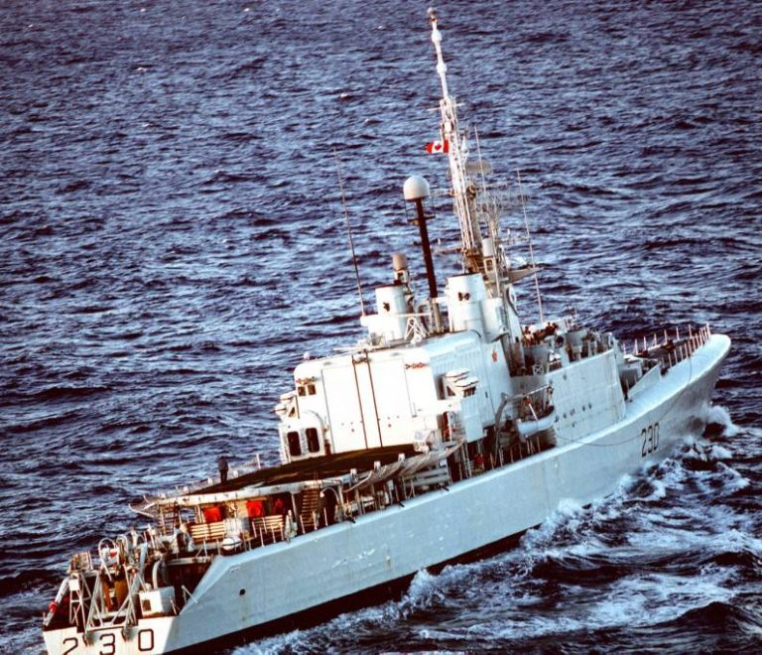

St Laurent Class

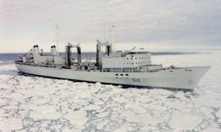

**Provider Class** The RCN also operated three replenishment oilers (AO), the Provider was the prototype for the other two which are larger and have improved systems, generally speaking there was one on each coast with the third on the Atlantic coast either undergoing refit or committed to NATO operations. These ships had strengthened hulls for operations in icy waters but they were not icebreakers, they also have accommodation for a Flag Officer and staff as well as an 8-bed hospital and facilities for 3x CH-124 Sea King helicopters (Provider has 2).

| **Pennant** | **Ship** | **Status** | **Location** | **Task** |
| --- | --- | --- | --- | --- |
| AOR 508 | [Provider](https://en.wikipedia.org/wiki/HMCS_Provider_(AOR_508)) | Active | Pacific |  |
| AOR 509 | [Protecteur](https://en.wikipedia.org/wiki/HMCS_Protecteur_(AOR_509)) | Active | Atlantic |  |
| AOR 510 | [Preserver](https://en.wikipedia.org/wiki/HMCS_Preserver_(AOR_510)) | Active | Atlantic |  |

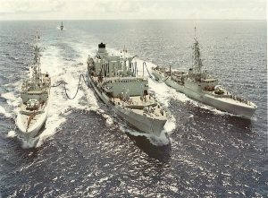

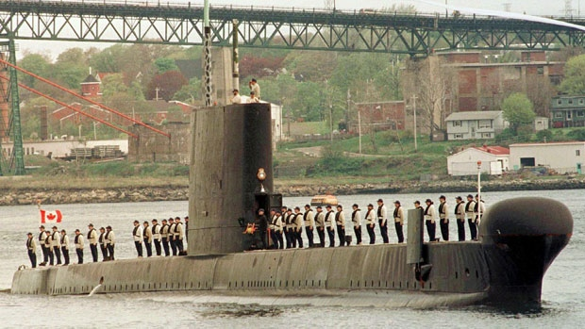**Submarines**

The RCN operated three Oberon Class submarines ‘[O-Boats](https://maritime.org/doc/oberon/index.htm)’. All had recently undergone an upgrade program (Submarine Operational Update Program (SOUP)) and were ready for another decade of service. Ojibwa was built to Royal Navy (RN) standards and modified before commissioning while the other two were built from the keel up as Canadian Boats. Historically two more O-Boats were acquired but not commissioned: HMS Olympus for training and HMS Osiris for spare parts. While the Olympus arrived in 1989, Osiris remains in service with the RN. All three active boats are based in Halifax.

| **Pennant** | **Ship** | **Status** | **Location** | **Task** |
| --- | --- | --- | --- | --- |
| S74 | Ojibwa | Active | Atlantic |  |
| S75 | Okanagan | Active | Atlantic |  |
| S76 | Onondaga | Active | Atlantic |  |