**Germany** 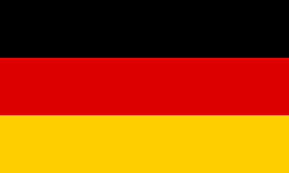

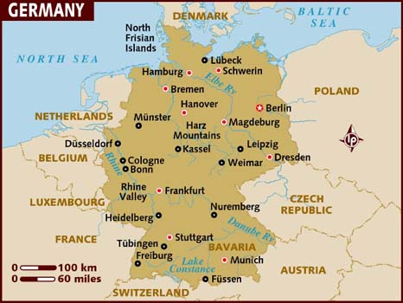

**Germany:** Although Germany reunified in 1990, all is not celebrations and roses in the Northern Fury world. With the Soviet Union in resurgence; economic pressures in Germany and a political movement to leave NATO has caused significant instability in Berlin and throughout Germany, the north and east in particular. Strong internal movements in Bavaria have been a counter to the left wing movements in the north causing further disunity.

Militarily, unification did little to boost Germany's capabilities. Historically most of the ships and aircraft were sold off or simply scrapped, but in Northern Fury most of these were transferred back to the Soviet Union or other Warsaw Pact countries. Germany retained seven patrol boats, an icebreaker, survey ship and several smaller craft plus a single squadron of MiG-29's. The Bundeswehr was significantly reduced to 370,000 personnel and the former East German National Volksarmee (NVA) was disbanded.