**Royal Danish Air Force**

The Royal Danish Air Force (RDAF) is primarily focused on defence of the Baltic Approaches and will be largely detached to under command of Allied Air Forces Baltic Approaches (AIRBALTAP) in times of war. The two main roles envisioned by this force are to defend the airspace to allow reinforcement squadrons to arrive from the UK and US and to prevent Warsaw Pact surface forces access to the North Sea. To do this the bulk of the RDAF is focused on four squadrons of F-16s and two squadrons of F-35 Drakan’s.

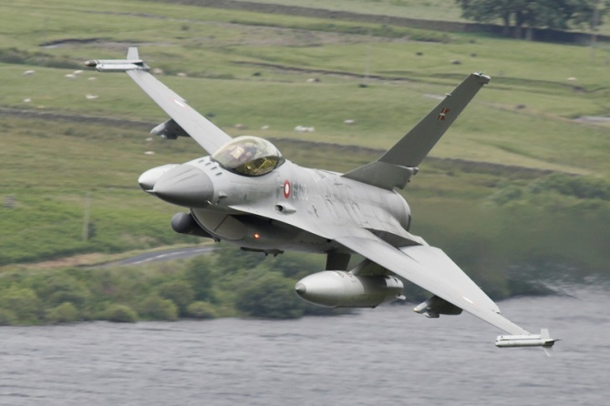

[**F-16**](http://www.f-16.net/f-16_users_article3.html)

Denmark is one of four European nations to participate in the production of F-16s in Belgium and the Netherlands. In total the Danes acquired 70 examples, (54 F-16As and 16 F-16Bs) all are of the Block 10/15 standard with a Danish built chaff dispenser system. They are organized in four squadrons and reside in two bases, 723 Squadron has the added role of conducting initial and continuation training.

|  |  |  |  |  |
| --- | --- | --- | --- | --- |
| Sqn | Name | Location | AC | Type |
| 723 | Horntail | Aalborg | 6/16 | F-16A/B |
| 726 | Phantom | Aalborg | 16 | F-16A |
| 727 | Craven | Skrydstrup | 16 | F-16A |
| 730 | Birdsong | Skrydstrup | 16 | F-16A |

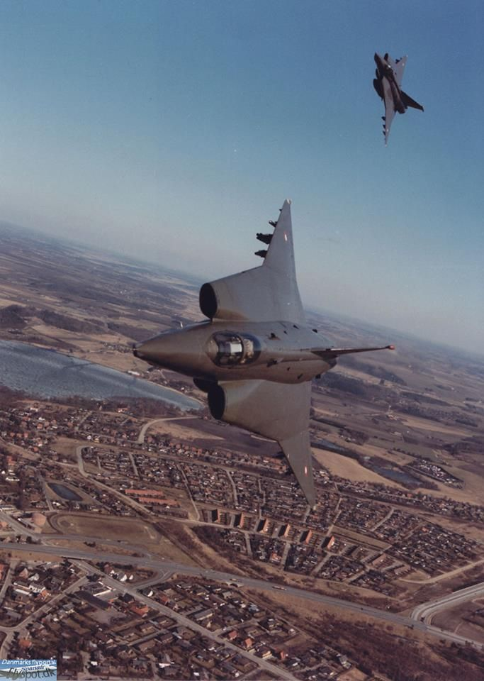

[**F-35 Draken**](https://en.wikipedia.org/wiki/Saab_35_Draken)

To fulfill the surface strike role, Denmark purchased a heavily modified version of the Swedish SAAB 35 Draken. The SAAB 35 XD or to Denmark the F-35, converted the original interceptor design into a strike fighter able to carry a large bomb load and Bullpup missiles. Of the 51 purchased, 20 were the baseline strike aircraft (F-35), a further 20 were a reconnaissance version RF-35 and 11 were a two seat training version TF-35. In addition to their front line aircraft, each of the two squadrons maintained five of the TF-35 twin seat versions for training. Both squadrons were projected to operate into the late 90’s but were disbanded in 1992 due to the end of the Cold War – they remain for Northern Fury.

|  |  |  |  |  |
| --- | --- | --- | --- | --- |
| Sqn | Name | Location | AC | Type |
| 725 | Dragon | Karup | 20 | F-35 |
| 729 | Eagle | Karup | 20 | RF-35 |

**Transport/SAR/AD**

Other elements of the RDAF include 721 ‘Buffalo’ Squadron flying 3x C-130H Hercules, 722 ‘Sea Lions’ Search and Rescue Squadron flying 8x S-61A helicopters, and eight ‘I-HAWK’ surface to air missile batteries divided into East and West commands.

