**Danish Army**

The Danish army is roughly two divisions in size split into two distinct regions. The Jutland Division in the west being dedicated to the NATO Command of LANDJUT, the commander responsible for the defence of Schleswig-Holstein Germany and the Jutland peninsula of Denmark. In the east, largely on Zealand, the Corps level HQ becomes NATO’s LANDZEALAND command defending the islands in the Baltic including Zealand, Fyn, Bornholm and many others.

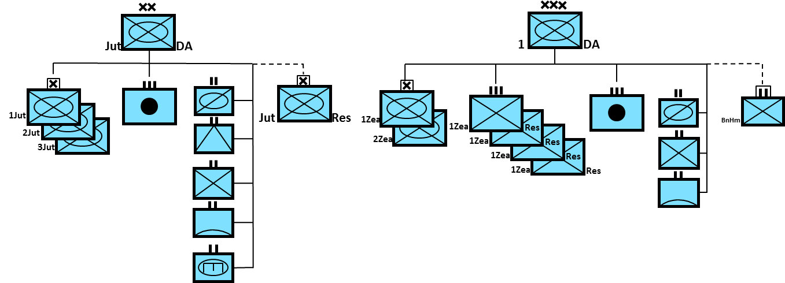

**Leopard 1DK**

Denmark initially acquired 120 Leopard 1A3 in the 70’s and upgraded them to the ‘A5’ level as well as purchasing a further 110 to replace its aging Centurions in 1992. Historically the second order was filled from surplus German Army stock as that force downsized – in Northern Fury these were still required and not available from surplus so they are new build tanks.

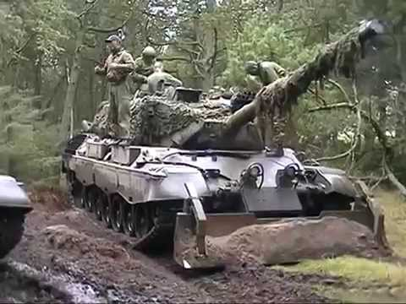

**M41 DK**

Denmark was the last European country to still be using this post World War Two light tank, with 41 examples providing armored support for the ‘Bornholm’ Battle Group. Although modernized and equipped with improved fire control, a laser range finder and thermal site, better ammunition, fire suppression system and defence against Nuclear, Biological, and Chemical (NBC) threats; it was still an old tank. However, in theory the only armed force these tanks would face if this isolated island was invaded, would be the Soviet ‘PT-76’ light tank or perhaps airborne BMD or amphibious BMP Infantry Fighting Vehicles, so the 76mm high velocity gun and light armour would suffice.

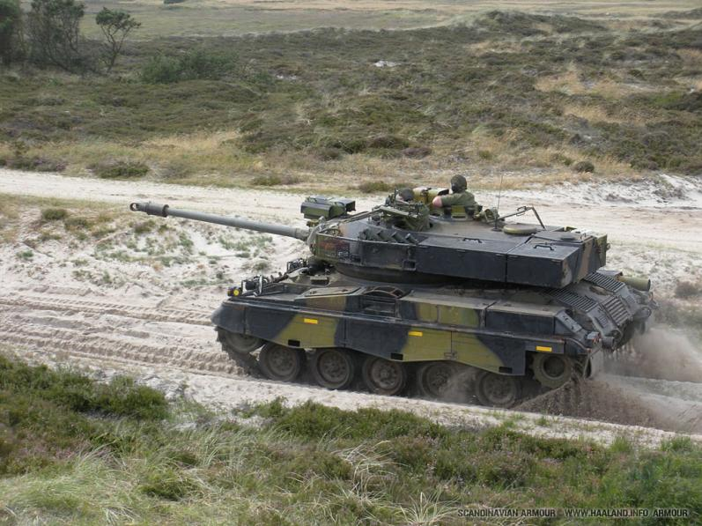

**M113**

The venerable M113 equipped the Danish mechanized Infantry force. Of the 636 in the force, approximately 530 were the standard Armoured Personnel Carrier (APC) version, 50 of these were the new A2 DK version with a 25mm gun, a further 56 were the Anti-Tank variant with TOW missiles and the remainder a mix of many other derivatives.

