**Spanish Air Force**

The Spanish Air Force (*Ejército del Aire, or Army of the Air)* has undergone significant transition since the death of Francisco Franco in 1975, the shift to democracy and joining NATO in 1982. Always depending on the west for equipment Spain replaced its F-86 and T-33 with F-4 Phantoms, F-5 Freedom Fighters, and Mirage in the 1960s and now the investment in the EF-18 has propelled the Spanish Air Force into the modern era. Because of past difficulties with obtaining aircraft or replacement parts from the US, Spain maintains a policy of ensuring that it holds both European (primarily French) as well as US fighters at all times.

[**EF-18 Hornet**](https://www.plane-encyclopedia.com/modern/ef-18-hornet-in-spanish-service/)

The fighting core of the Spanish Airforce is the EF-18A, with four operational Squadrons plus a training group. Spain obtained 60 ‘A+’ and 12 ‘B+’ versions of the aircraft, prefixed as EF these aircraft are very close to the ‘C/D’ standard allowing them to employ a modern suite of precision ground attack munitions, however they are limited to the Aim-7F Sparrow missile for air to air combat. An attempt (historically successful) to acquire a further 24 ex-US Navy Hornets has been thwarted by US requirements to expand its inventory of F/A-18s. Each Squadron operates at least two EF-18B in addition to its single seat fighters.

|  |  |  |  |  |  |  |
| --- | --- | --- | --- | --- | --- | --- |
| Wing | Squadron | Name | Base | # of AC | Type | Role |
| Gr.12 | Esc 121 | Aces | Torrejon | 14 | EF 18 | CAS/Mar |
| Gr.12 | Esc 122 | Black Cats | Torrejon | 14 | EF 18 | A2A |
| Gr.15 | Esc 151 | Bulls | Zaragoza | 14 | EF 18 | A2A |
| Gr.15 | Esc 152 | Mars | Zaragoza | 14 | EF 18 | SEAD |
| Gr.15 | Esc 153 |  | Zaragoza | 16 | EF 18 | Training |

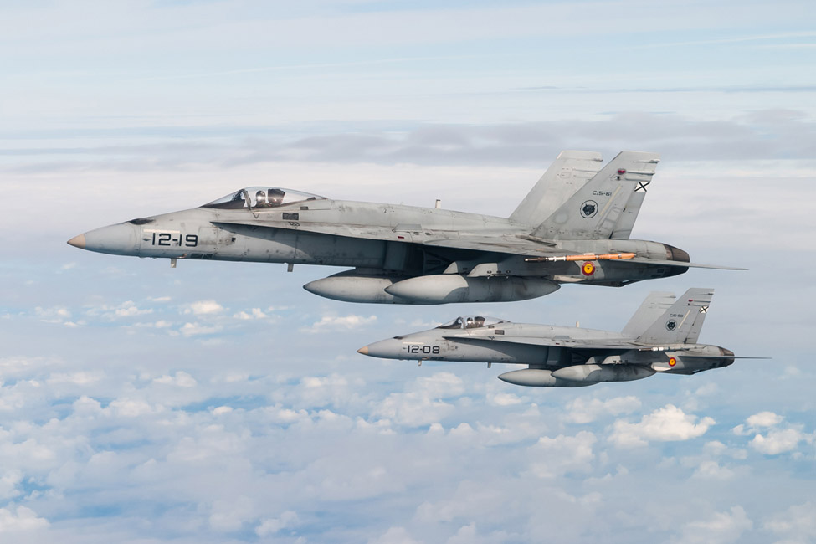

[**Mirage F.1**](https://en.wikipedia.org/wiki/Dassault_Mirage_F1)

Since 1975, one of the mainstays of the Spanish Air Force has been the Mirage F.1. Of the original 91 airframes, 48 remain in service. All of these have been upgraded to the ‘F.1M’ standard; half have been modified to the ‘EE’ interceptor role, and the remainder are the ‘CE’ standard focusing on Close Air Support (CAS)

|  |  |  |  |  |  |  |
| --- | --- | --- | --- | --- | --- | --- |
| Wing | Squadron | Name | Base | # of AC | Type | Role |
| Ala.11 | Esc 111 | Wolves | Moron | 12 | F.1CE | CAS |
| Ala.11 | Esc 113 | Cocks | Moron | 12 | F.1EE | A2A |
| Ala.14 | Esc 141 | Bulldogs | Llanos | 12 | F.1CE | CAS |
| Ala.14 | Esc 142 | Tiger | Llanos | 12 | F.1EE | A2A |

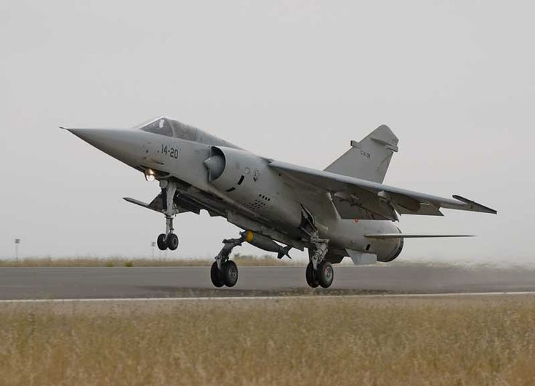

[**SF-5 Freedom Fighter**](http://www.joebaugher.com/usaf_fighters/f5_24.html)

These Freedom Fighters are built in Europe and modified for the Spanish Airforce, the 20 remaining strike versions are all upgraded ‘B’ model two seaters while the last single seat reconnaissance versions are upgraded from the fighter version and retaining the original gun. In addition to Close Air Support these aircraft provide training to future EF-18 pilots.

|  |  |  |  |  |  |  |
| --- | --- | --- | --- | --- | --- | --- |
| Wing | Squadron | Name | Base | # of AC | Type | Role |
| Ala.23 | Esc 231 | Talons | Talavera | 10 | SF-5B | Trg/CAS |
| Ala.23 | Esc 232 | Hawks | Talavera | 10  6 | SF-5B  SRF-5A | CAS/Recon |

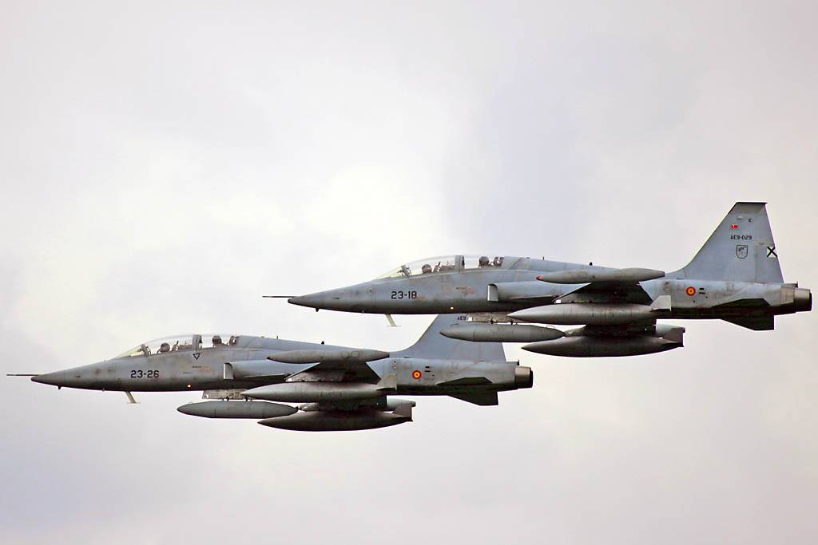

**P-3B**

Spain purchased 5 P-3B’s from Norway in 1989 and 221 Squadron operates them from Moron Air Base.

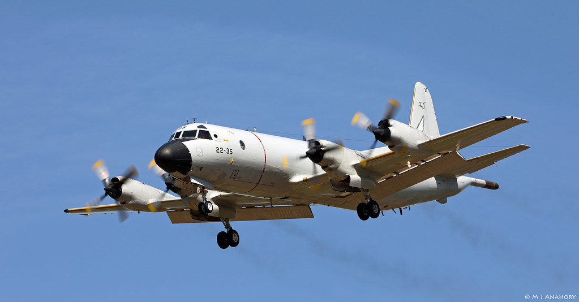

**CN-212 and CN-235**

These are home grown Spanish transport aircraft developed by CASA and IPTN before these two companies were purchased by Airbus. The CN-235 entered production in 1986 began replacing the CN-212 the same year. Both have Electronic Warfare, Photo Reconnaissance, Search and Rescue, and Maritime Patrol variants but in 1994 these functions remained with the CN-212 while the CN-235 was quickly replacing the cargo variants.

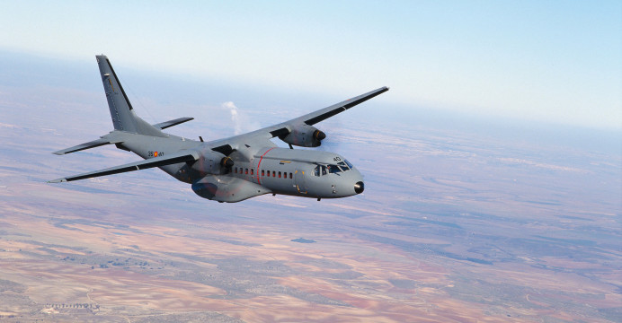

**Falcon 20**

This French built executive jet serves the Portuguese, and many other European nations, as an Electronic warfare aircraft.

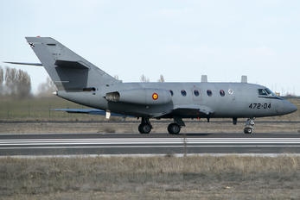

**C-130H**

The ubiquitous Hercules serves the Spanish Air Force as both a Tactical Transport (8) and an areal refueling tanker (5).

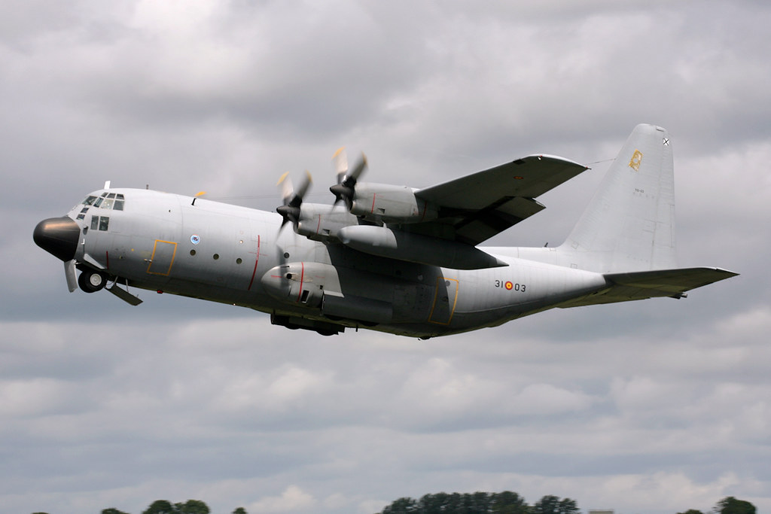

**Boing 707B**: The one example of the venerable 707 in the Spanish Air Force serves as a refueling tanker.

**F-27:** These three light twin engine turbo prop serves as a Search and Rescue aircraft.

|  |  |  |  |  |  |  |
| --- | --- | --- | --- | --- | --- | --- |
| Wing | Squadron | Name | Base | # of AC | Type | Role |
| Ala.22 | 221 | Poker | Moron | 5 | P-3B | ASW/MPA |
| Ala.31 | 331 | Jumbo | Zaragoza | 5 | KC-130H | Refueling |
| Ala.31 | 332 |  | Zaragoza | 8 | C-130 | Transport |
| Ala.35 | 351 |  | Getafe | 5 | C-295 | Transport |
| Ala.35 | 352 |  | Getafe | 5 | C-295 | Transport |
| Ala.35 | 353 |  | Getafe | 5 | C-295 | Transport |
| Ala.37 | 371 |  | Matacan | 5 | C-212 | Transport |
| Ala.37 | 372 |  | Matacan | 5 | C-212 | Transport |
|  | 403 |  | Madrid | 1 | C-212 | Photo Recon |
| Gr.47 | 471 |  | Torrejon | 1 | KC-707 | Refueling |
| Gr.47 | 472 |  | Torrejon | 1  2 | C-212 EW  Falcon 20 | EW |
| Gr.54 | 541 |  | Torrejon | 6 | C-212 SAR | SAR |
| Ala.46 | 802 |  | Las Palmas | 3 | F-27 | MPA |