**Spanish Navy**

The Spanish Navy is relatively small but well rounded. The addition of the *Príncipe de Asturias* aircraft carrier in the late 80s opened a new and more prominent phase for the navy which had concentrated on blue water Anti-Submarine Warfare (ASW) work in the eastern Atlantic since joining NATO.

[**R-11 Príncipe de Asturias**](https://www.militaryfactory.com/ships/detail.asp?ship_id=Principe-de-Asturias-R11)

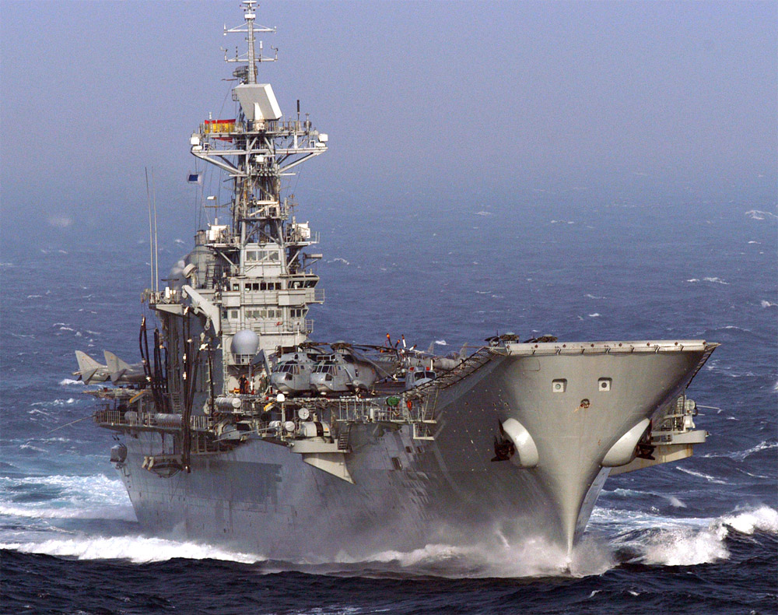

Launched in 1988 and modernized with new radars in 1990 this ship, the flagship of the Spanish Navy, is very modern and capable. She carries 8 AV-8B Harrier II, 8 Sea Kings, 4 AB-212 and 2 Sea King AEW. At war start she is conducting a port visit to Rio de Janeiro as part of a 4 month tour aimed at training and validating the use of the Spanish Navy’s new AOR (A-14 Patiño).

[**Santa María-class frigate**](http://www.seaforces.org/marint/Spanish-Navy/Frigate/Santa-Maria-class.htm)

The six ships of this class are based on the US Oliver Hazard Perry with a wider beam and a different close in weapons suite. These ships are all less than 10 years old and the final batch were purchased earlier in Northern Fury so all are available by the end of 1993, although F86 Canarias is still undergoing sea trials.

|  |  |  |
| --- | --- | --- |
| F 81 | Santa Maria | Persian Gulf |
| F 82 | Victoria | Tied Up |
| F 83 | Numancia | USS Eisenhower Gp |
| F 84 | Reina Sofia | P de Asturias Gp |
| F 85 | Navarra | Western Med |
| F 86 | Canarias | Workups Rota |

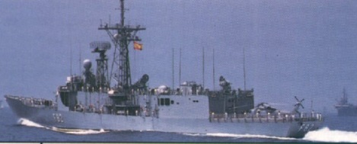

[**Baleares Class Frigate**](https://en.wikipedia.org/wiki/Baleares-class_frigate)

These five ships are based on the US Knox class but much improved with ‘Standard’ air defence missiles and improved sonar, unfortunately all this was at the cost of helicopter facilities.

|  |  |  |
| --- | --- | --- |
| F 71 | Baleares | Off Gibraltar |
| F 72 | Andalucia | Western Med |
| F 73 | Cataluna | CTF 150 Somalia |
| F 74 | Asturias | P de Asturias Gp |
| F 75 | Extremadura | Tied Up |

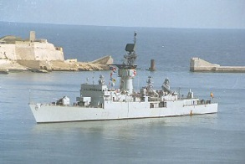

[**Descubierta-class Corvette**](https://en.wikipedia.org/wiki/Descubierta-class_corvette)

The six 1500 ton corvettes or Patrol Frigates of the Descubierta class primarily focus on surface warfare, with only limited short range air defence and ASW capability. These ships are a cost effective expedient to patrol Spain’s long coastline or show the flag on occasional international missions.

|  |  |  |
| --- | --- | --- |
| F 31 | Decubierta | Off Gibraltar |
| F 32 | Diana | Caribbean |
| F 33 | Infanta Elena | Tied Up |
| F 34 | Infanta Cristina | Coruna |
| F 35 | Cazadora | Eastern Med |
| F 36 | Vencedora | Refit |

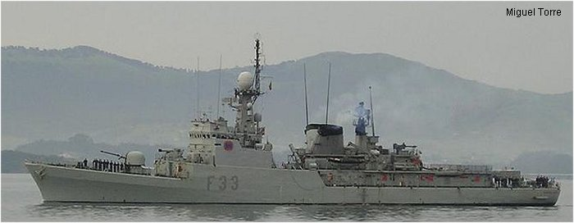

[**Serviola-class patrol boat**](https://en.wikipedia.org/wiki/Serviola-class_patrol_boat)

The four ships in this class were all commissioned in 91 and 92. They are designed for offshore patrol and are able to maintain operations in heavy seas. They can operate a helicopter although none are normally embarked but they do normally deploy with two RHIBs.

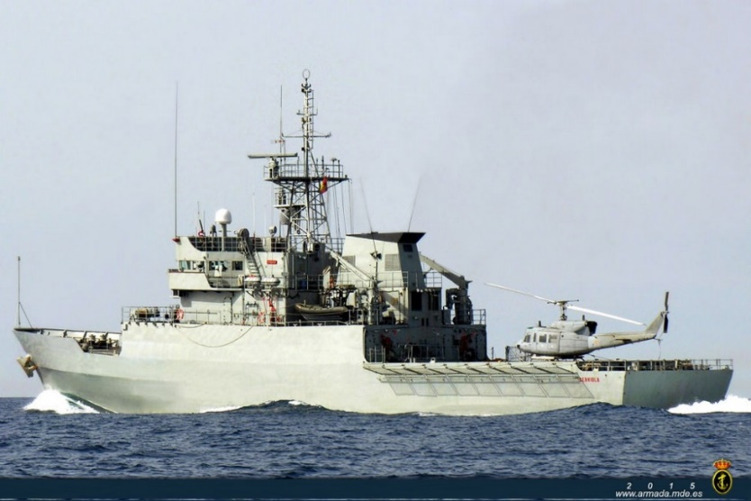

|  |  |  |
| --- | --- | --- |
| P 71 | Serviola | Bay of Biscay |
| P 72 | Centinela | Tied Up |
| P 73 | Vigia | Off Vigo |
| P 74 | Atalaya | Tied Up |

**Amphibious forces**

The Spanish Navy has a small Marine Brigade (Tercio de Armada) of two battalions, two artillery batteries, a tank company with M48 Patton tanks, amphibious tractors and various other elements. Unfortunately, there is very little in the way of amphibious landing capability; two Dock Landing Ships are being designed, and the two ‘Newport’ class LSTs destined for Spain were retained by the US. Spain has the following amphibious ships, all based at Rota:

* 2x 1950’s era Attack Transports of WW2 design
* 3x 1950s era LSTs of WW2 design
* 2x LCU 1466
* 3x K class LCT
* Various landing craft

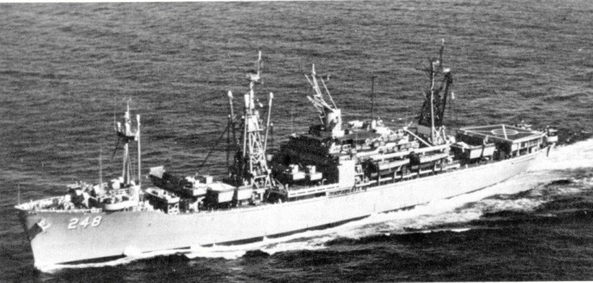

USS Paul Revere (APA-248), sold to Spain in 1980 as L-21 Castilla (L-21)

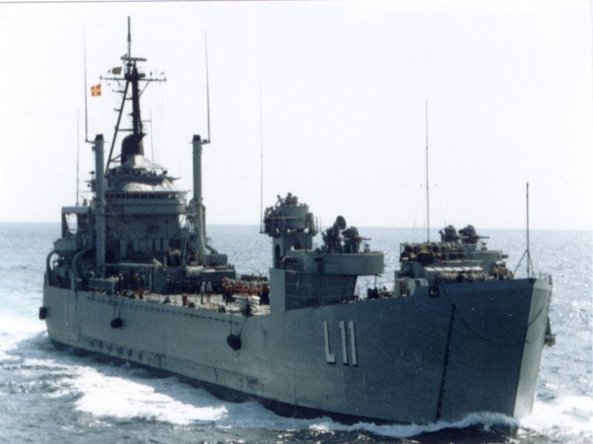

L11 Velasco ex US LST-1156 Terrebonne Parish

**Submarines**

[**Agosta Class**](http://www.military-today.com/navy/agosta_class.htm)

These four French designed Submarines are very capable SSK or conventionally powered attack submarines. These boats have the endurance for long journeys and routinely patrol thorough the Mediterranean and beyond.

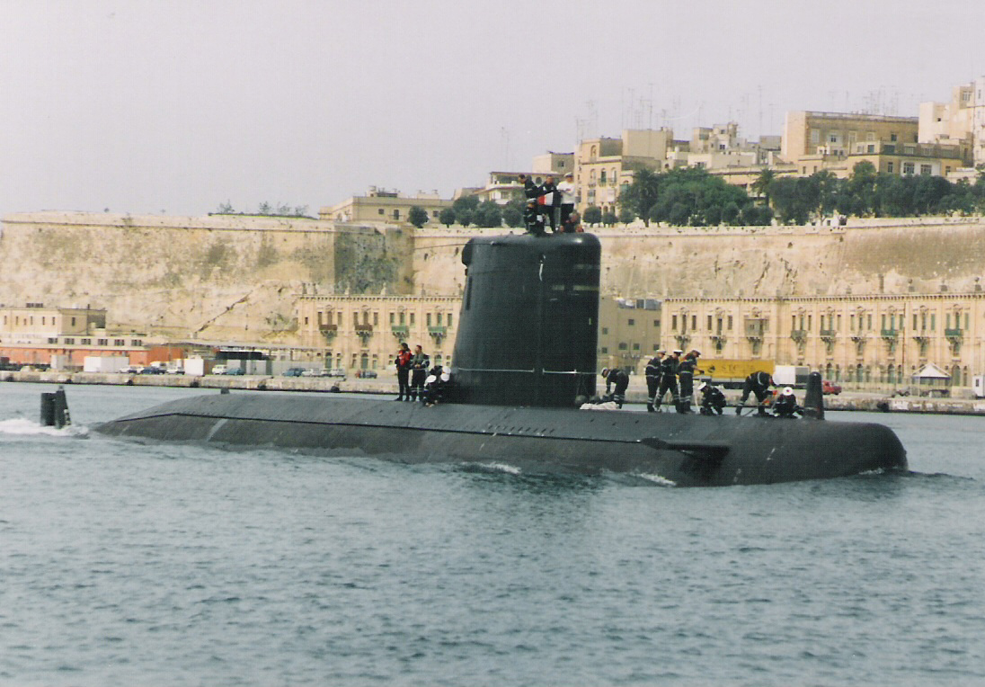

|  |  |  |
| --- | --- | --- |
| S 71 | Galerna | Tied Up |
| S 72 | Siroco | Off Gibraltar |
| S 73 | Mistral | Off Syria |
| S 74 | Tramontana | Tied Up |

[**Daphné-class**](http://www.military-today.com/navy/daphne_class.htm)

The four Daphne class submarines are older and smaller than the Agosta’s but their 8 forward and 4 stern firing torpedo tubes make for an impressive first strike on a group of targets. Used primarily for costal patrolling on both the Mediterranean and the Atlantic coast of Spain.

|  |  |  |
| --- | --- | --- |
| S 61 | Delfin | Bay of Biscay |
| S 62 | Tonina | Tied Up |
| S 63 | Marsopa | Off Gibraltar |
| S 64 | Narval | Tied Up |

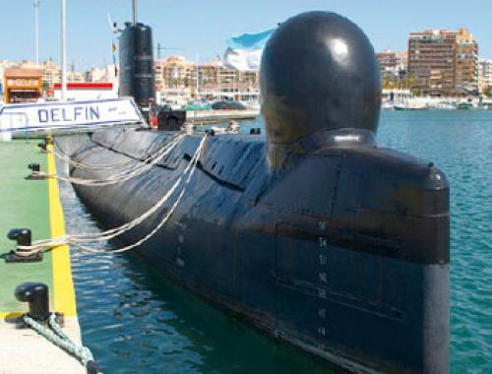

**Service Ships**

**AOR A-14 Patiño**

A new ship, and new type for the Spanish Fleet is the Fast Replenishment Oiler (AOR) Patiño. Designed specifically to provide mission support to the Príncipe de Asturias aircraft carrier and its escort, allowing them to venture globally rather than being confined to the Mediterranean and Eastern Atlantic or relying on allies. This ship was historically commissioned in 1995 but in Northern Fury with funds freed up by not purchasing American amphibious ships, she was laid down a year earlier and commissioned 18 months earlier than in the real world. A sister ship, the Cantabria (A15) is planned but not yet ordered.

