**Spanish Naval Aviation**

The primary focus of Spanish Naval Aviation is providing aircraft for operations on board ships, both the *Príncipe de Asturias*and other ships in the fleet. The Spanish Air Force operates the fleet of P-3Bs and other Maritime Patrol Aircraft (MPA) and Sea Air Rescue (SAR) assets. All assets are based at NAS Rota.

[**EAV-8S Matador**](https://en.wikipedia.org/wiki/Hawker_Siddeley_Harrier)

Spain’s 9th Escuadrilla operates 12 AV-8B Harrier II’s, called the EAV-8S Matador, as the *Príncipe de Asturias’* main strike element. A 13th aircraft is available for shore based training, maintenance training and emergency replacement at Rota. These are the ‘Day Only’ Aim-9 equipped versions, however an order has been placed to upgrade them to the ‘+’ standard. Unfortunately, this will not happen during Northern Fury.

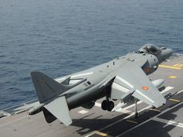

[**SH-70B-1 Seahawk**](https://www.naval-technology.com/projects/s70b-seahawk/)

These 12 new Anti-Submarine Warfare (ASW) helicopters operating off of the six Santa María-class frigates are provided by the 10th Escuadrilla. Essentially the same as the American SH-60B, these aircraft work with the Oliver Hazard Perry based Frigates and provide a powerful ASW system to protect the aircraft carrier or on independent patrol.

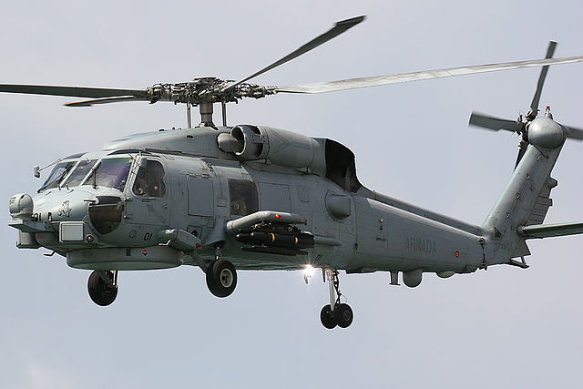

[**Sea King**](http://www.armada.mde.es/ArmadaPortal/page/Portal/ArmadaEspannola/buquesaeronaves/prefLang-en/02flotilla-aeronaves-helicopteros--025-escuadrilla-aeronaves-sh-3-d-w-sea-king)

The Spanish Navy operates three different versions of Sea King. The initial purchase was for 18x SH-3D, and between that time and 1994, six of these were written off. Eight of the remaining 12 were upgraded to the SH-3H (HS.9) standard, to carry on ASW work, while the last four were converted to SH-3G utility/transport versions. Further, in 1985, three were converted to SH-3W for Airborne Early Warning (AEW). All are operated by 5th Escuadrilla and the ‘H’ and ‘W’ variants operate off the Principe de Asturias.

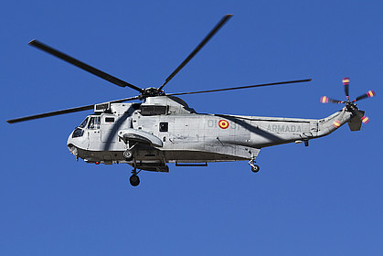

**AB212**

3rd Escuadrilla operate two versions of this versatile helicopter. Of the original 8 obtained for ASW work, four remain in that task, while the four others were converted to Electronic Warfare (EW). These aircraft would work either off of the aircraft carrier or on special missions as none of the other Frigates were able to house a helicopter.

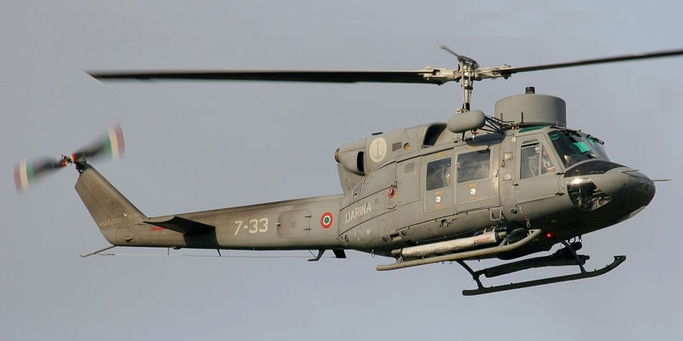

**Hughes 500ASW Defender**

Used for local ASW tasks or for short journeys on the Serviola-class patrol boat, 6th Escuadrilla operated six of these small aircraft.

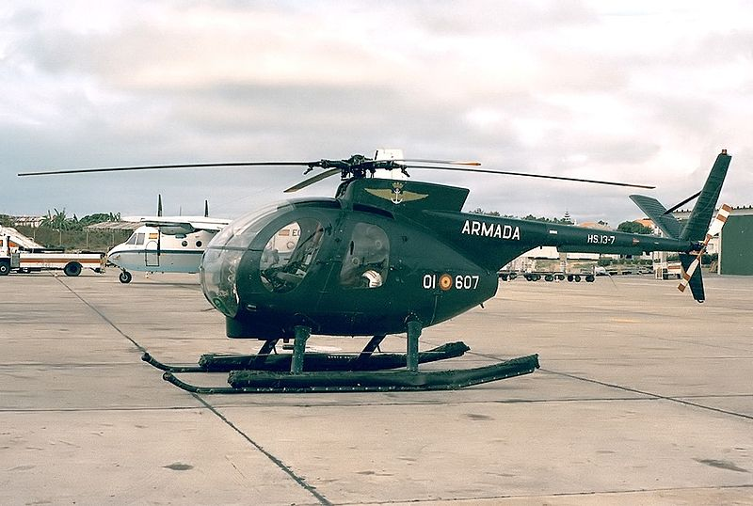

**Cessna Citation II**

4th Escuadrilla operates four of these executive jets as well as several other small transport aircraft for general transport tasks.