**French Air Force (Armée de l'air or Air Army)**

The French Air Force is one of the largest in Europe with 93,000 personnel and over 70000 reserves. Maintaining over 450 combat aircraft, a strategic and a tactical nuclear capability and significant support and transport elements, the French Air Force is critical to the defence of Europe. The Air Force is divided into four major commands: Strategic Air Force (CoFAS) operating IRBMs (Intermediate Range Ballistic Missiles), bombers and refueling aircraft; Tactical Air Force (FATac) operates most of the strike aircraft; Aid Defense Command (CAFDA) operating Fighter Interceptors; and Air Transport Command (CoTAM) operating transport and helicopter squadrons. Centrally controlled are 4 E-3F AWACS.

**Strategic Air Force (CoFAS)**

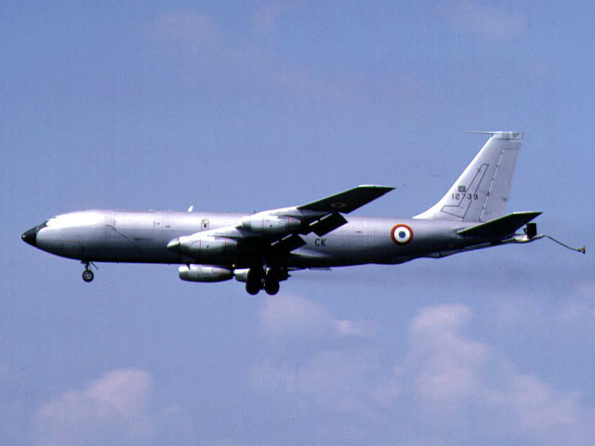

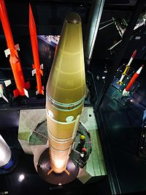

CoFAS operates the 91st bombardment wing with two squadrons of Mirage IV-P (18) nuclear bombers and one squadron of Mirage IV-R (12) in the reconnaissance role, the 94th bombardment wing providing training and conversion with Mirage IV-A (12) and IV-P(4), and an IRBM wing of two squadrons (18 silos). Supporting the Mirage IV-P was an air refueling wing of 3 KC-135F Squadrons (12 total).

**Mirage IV**

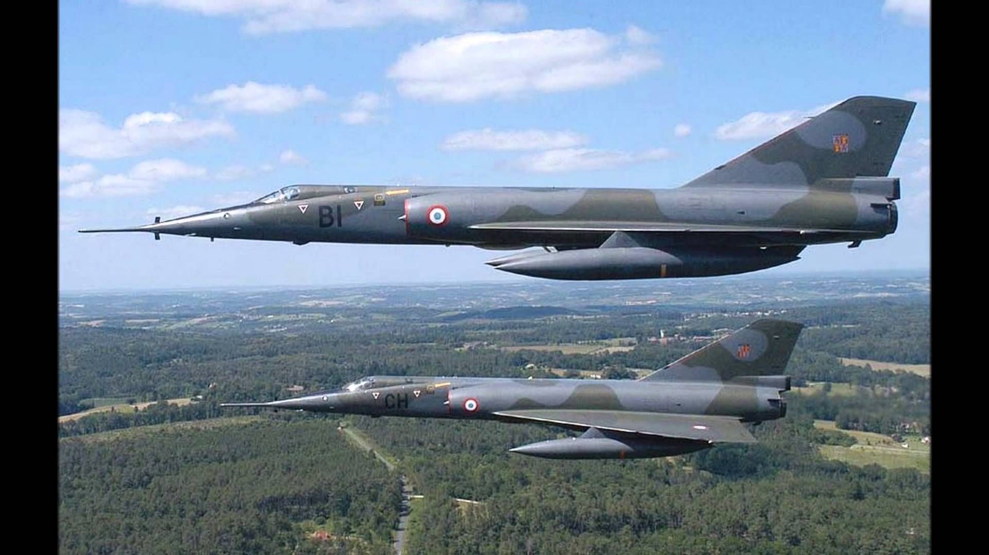

The Mirage IV was twice the weight and 1.5 times the length of its predecessor the Mirage III (more later), which allowed for massive fuel tanks. Even though this aircraft was a bomber – all ordinance was attached externally, that and the extra fuel storage allowed for high speed and long range.

|  |  |  |  |  |  |
| --- | --- | --- | --- | --- | --- |
| Sqn | Name | Location | Group | No. | Type |
| EB 1/91 | Gascogne | Mont-de-Marsan | CoFAS | 9 | Mirage IV-P |
| EB 2/91 | Bretagne | Cazaux | CoFAS | 9 | Mirage IV-P |
| EB 3/91 | Beauvaisis | Creil | CoFAS | 12 | Mirage IV-R |
| EB 1/93 | Guyenne | Istres | CoFAS | 4 | KC-135F |
| EB 2/93 | Cevennes | Orange | CoFAS | 4 | KC-135F |
| EB 3/93 | Sambre | Cambrie | CoFAS | 4 | KC-135F |
| EB 1/94 | Bourbonnais | Avord | CoFAS | 6 | Mirage IVA |
| EB 2/94 | Marne | St Dizier | CoFAS | 6 | Mirage IVA |
| EB 3/94 | Arbois | Luxeuil | CoFAS | 4 | Mirage IVP |

**Aid Defense Command (CAFDA)**

CAFDA operates 4 wings of fighter interceptors focusing on the Air Defence and Air Superiority tasks. Comprising 13 squadrons (escadron de chasse, translated ‘Pursuit Squadron’ or EC) equipped with two versions of Dassault Mirage aircraft, this force also had expeditionary tasks to Djibouti and the Persian Gulf.

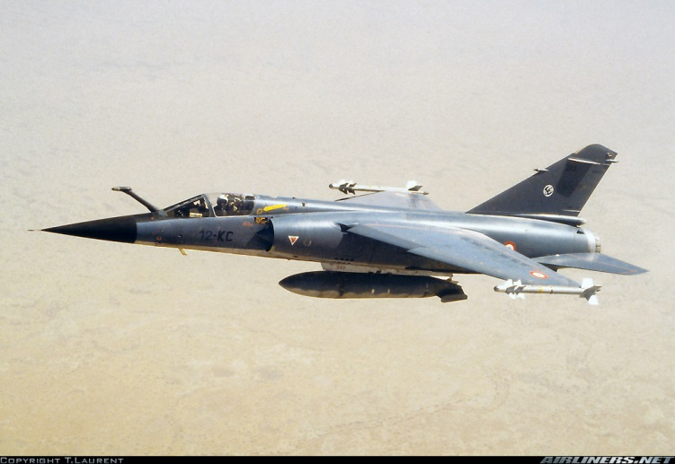

**Mirage F1C & F1C-200**

Of the 162 F1C’s that entered service with the French Airforce, half were equipped with a refueling capability (F1C-200) for expeditionary operations, and beginning in 1991, 55 were converted to the F1CT strike fighter and transferred to the FATac. In 1994 the 82 F1C’s and 25 remaining F1C-200’s formed the core of two interceptor wings, the 12th with four squadrons, and the 30th with three squadrons.

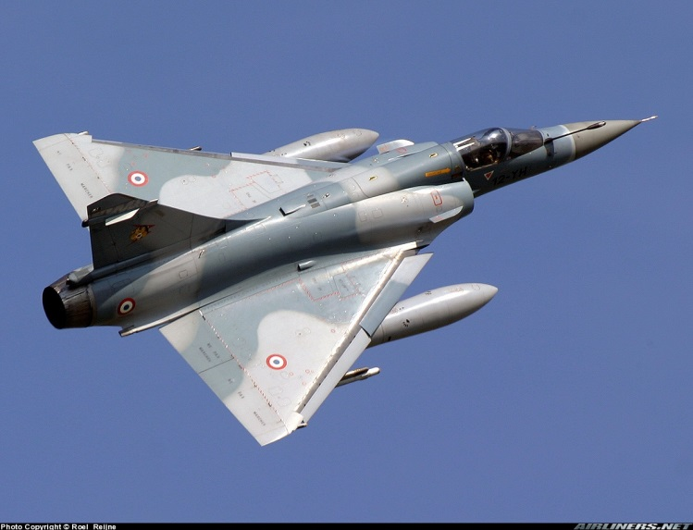

**Mirage 2000C**

5 Mirage 2000C

The Mirage 2000C was designed as a modern interceptor with a secondary strike role. This aircraft was meant to be the French answer to the F-16 and has certainly evolved into multiple variants and roles being exported to eight other countries; total production is about 600 compared to almost 5000 F-16’s. Two wings, the 2nd and 5th each have three squadrons of these aircraft.

|  |  |  |  |  |  |
| --- | --- | --- | --- | --- | --- |
| Sqn | Name | Location | Group | No. | Type |
| EC 1/2 | Cigognes | Dijon | CAFDA | 18 | Mirage 2000C |
| EC 2/2 | Cote d'or | Dijon | CAFDA | 18 | Mirage 2000C |
| EC 3/2 | Alsace | Dijon | CAFDA | 18 | Mirage 2000C |
| EC 1/5 | Ill de France | Orange | CAFDA | 18 | Mirage 2000C |
| EC 2/5 | Ill de France | Orange | CAFDA | 18 | Mirage 2000C |
| EC 3/5 | Ill de France | Orange | CAFDA | 18 | Mirage 2000C |
| EC 1/12 | Cambresis | Cambrie | CAFDA | 15 | Mirage F1C |
| EC 2/12 | Picardie | Cambrie | CAFDA | 15 | Mirage F1C |
| EC 3/12 | Comouaile | Cambrie | CAFDA | 15 | Mirage F1C |
| EC 4/12 | Balbuzard | Cambrie | CAFDA | 15 | Mirage F1C |
| EC 1/30 | Valois | Marsan | CAFDA | 15 | Mirage F1C |
| EC 2/30 | Normandie | Marsan | CAFDA | 15 | Mirage F1C |
| EC 3/30 | Lorraine | Marsan | CAFDA | 15 | Mirage F1C |

**Tactical Air Force (FATac)**

FATac comprises a large segment of the French Air Force, with 25 Squadrons there have been several variations from history in the Northern Fury world. The role of this group is to conduct both conventional and nuclear strike missions in a high threat environment. Thus, not only strike aircraft are required, but reconnaissance, and electronic warfare as well.

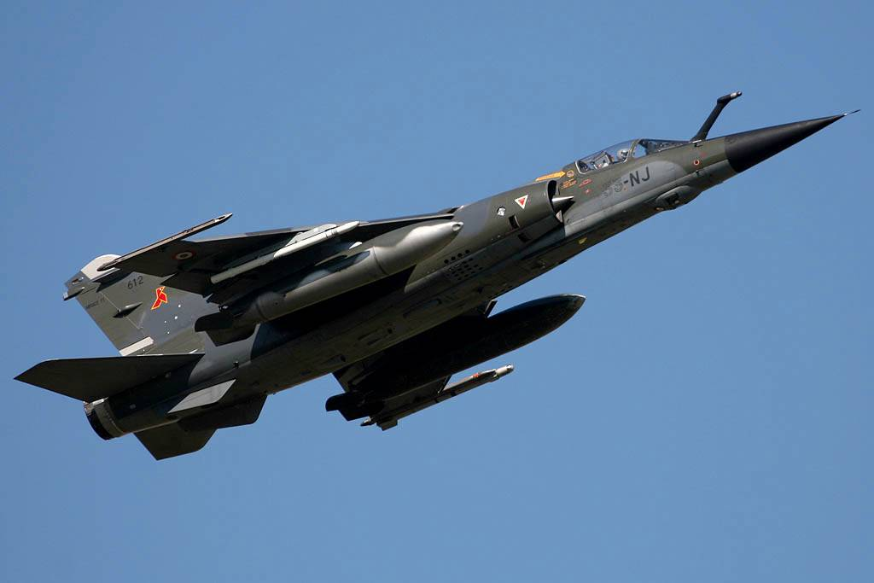

**Mirage F1CR**

A reconnaissance version of the baseline interceptor, this aircraft has a secondary ground attack role. 64 were built and they equipped three squadrons of the 33rd wing at Strasbourg.

**Mirage F1CT**

Yet another version of the Mirage F1; 55 of the CT or strike variants were converted from the F1C-200’s in 91-92. Historically they replaced a Jaguar wing but in Northern Fury they formed a new wing, the 6th which also took on the role of providing the contingent in Djibouti. These aircraft look identical to the reconnaissance version.

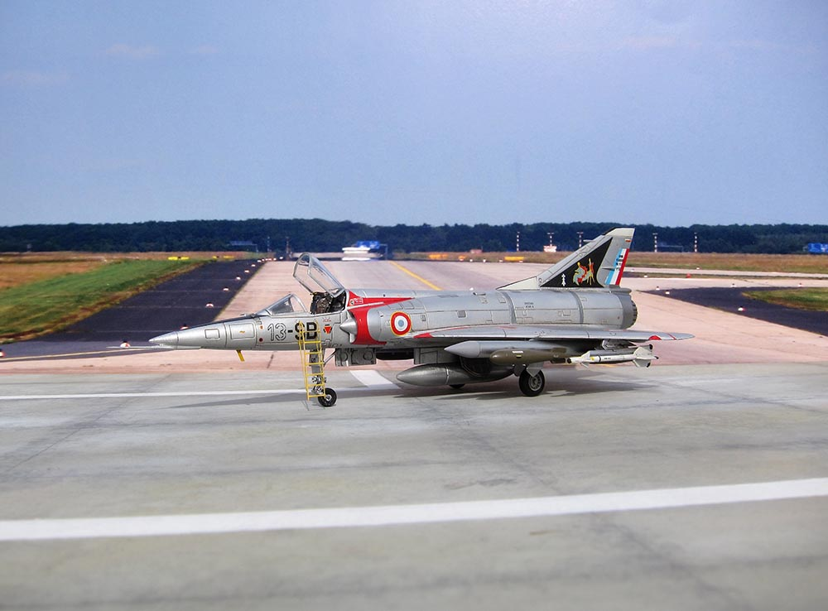

**Mirage 5F**

This aircraft, a derivative of the Mirage III was meant for export, in particular to Israel but do to political tension over the 1967 Arab/Israeli war, France embargoed the sale of these aircraft. Although Israel had paid for the jets, and several attempts to obtain them were made, the 50 aircraft were eventually adopted into the Armée de l'air as the Mirage 5F. They were designed for the clear weather ground attack role and were operated by the 13th wing at Colmar.

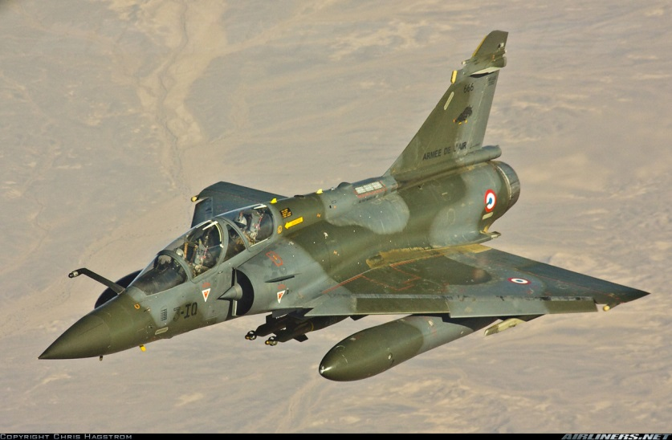

**Mirage 2000N**

A two seat version of the basic fighter which is designed specifically for tactical nuclear weapon delivery. Its wings are strengthened for low level flight, an electronic countermeasures suite is added, and it has a precision navigation system with terrain avoidance radar. 75 of this version were produced and operated by four squadrons of the 4th wing at Luxeuil

**Mirage 2000D**

This is the multi-role, two seat version of the basic Air Superiority design and very similar to the 2000N. This aircraft is designed for delivering conventional munitions and has been modernized from the 2000N with improved radar and a digital cockpit. Historically it entered service in 1994/95 but in Northern Fury it arrives three years earlier and 72 of a planned 96 have been built. Both wings equipped with this aircraft are housed at Nancy, the 3rd was historically the first wing converted and also a new wing, the 20th forming to allow yet another Jaguar wing to be retained.

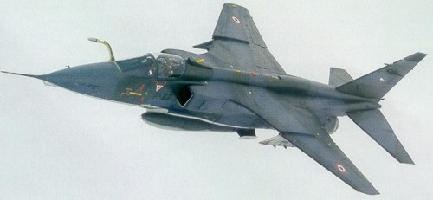

**SEPECAT Jaguar**

Unique in the Armée de l'air’s fighter aircraft, the Jaguar was not produced by Dessault! SEPECAT is a consortium of Breguet and British Aircraft Corporation (now BAE Systems). These very agile, rugged and versatile fighters equipped nine squadrons at one point but that has now been reduced to six. Until the introduction of Mirage 2000N, the Jaguar maintained the tactical nuclear role. Although largely retired by 1994 they have been retained in the Northern Fury world.

|  |  |  |  |  |  |
| --- | --- | --- | --- | --- | --- |
| Sqn | Name | Location | Group | No. | Type |
| EC 1/3 | Navarre | Nancy | FATac | 12 | Mirage 2000D |
| EC 2/3 | Champagne | Nancy | FATac | 12 | Mirage 2000D |
| EC 3/3 | Ardennes | Nancy | FATac | 12 | Mirage 2000D |
| EC 1/4 | Dauphine | Luxeuil | FATac | 18 | Mirage 2000N |
| EC 2/4 | Lafayette | Luxeuil | FATac | 18 | Mirage 2000N |
| EC 3/4 |  | Luxeuil | FATac | 18 | Mirage 2000N |
| EC 4/4 |  | Luxeuil | FATac | 18 | Mirage 2000N |
| EC 1/6 |  | Colmar | FATac | 16 | Mirage F1CT |
| EC 2/6 |  | Colmar | FATac | 16 | Mirage F1CT |
| EC 3/6 |  | Colmar | FATac | 12 | Mirage F1CT |
| EC 4/6 | Vexin | Djibouti | FATac | 8 | Mirage F1CT |
| EC 1/7 | Provence | St Dizier | FATac | 18 | Jaguar |
| EC 2/7 | Argonne | St Dizier | FATac | 18 | Jaguar |
| EC 3/7 | Languedoc | St Dizier | FATac | 18 | Jaguar |
| EC 1/11 | Roussillon | Toul | FATac | 18 | Jaguar |
| EC 2/11 | Vosges | Toul | FATac | 18 | Jaguar |
| EC 3/11 | Corse | Toul | FATac | 18 | Jaguar |
| EC 1/13 | Artois | Colmar | FATac | 15 | Mirage 5F |
| EC 2/13 | Alps | Colmar | FATac | 15 | Mirage 5F |
| EC 3/13 | Colmar | Colmar | FATac | 15 | Mirage 5F |
| EC 1/20 | Nementcha | Nancy | FATac | 12 | Mirage 2000D |
| EC 2/20 | Oranie | Nancy | FATac | 12 | Mirage 2000D |
| EC 3/20 | Ouarsenis | Nancy | FATac | 12 | Mirage 2000D |
| CR 1/33 | Belfort | Strasbourg | FATac | 16 | Mirage F.1CR |
| CR 2/33 | Savoie | Strasbourg | FATac | 16 | Mirage F.1CR |
| CR 3/33 | Mosell | Strasbourg | FATac | 16 | Mirage F.1CR |

**Air Transport Command (CoTAM)**

CoTAM is a large command with 28 squadrons: ten fixed wing; 12 rotary wing; six overseas based squadrons which were uniquely tailored to the requirements of the post; and a VIP transport element.

