**French Army**

Although France is not part of the NATO military alliance, its forces are earmarked to reinforce NATO, and although they are not integrated as other NATO counties are, there is an understanding of commitment. In Northern Fury, France Declares itself a full NATO partner within hours of the war starting and the Armed Forces of France come under the NATO military command structure.

The French Army is large, 296,000 active and over 400,000 reserve soldiers. It is however, organized quite differently from most NATO nations. Brigade HQs have been removed and units report directly to the Division HQ, also most divisions are about half the strength of their NATO counterparts and the ‘Light Armoured’ Divisions are about the size of a typical NATO Brigade. 1st French Army is assigned to deploy to Germany as part of CENTAG (Central Army Group) while the Force d’Action Rapide will deploy to NORTHAG (Northern Army Group). In addition to these deployable forces, there are six Territorial Defence Regions with assigned troops, the Gendarmerie (para military police force), the French Foreign Legion (mostly in central and northern Africa) and forces overseas in former colonies throughout Africa, Djbouti, Reunion Islands, the French Polynesia, New Caledonia, Caribbean and supporting Coalition operations in the Persian Gulf.

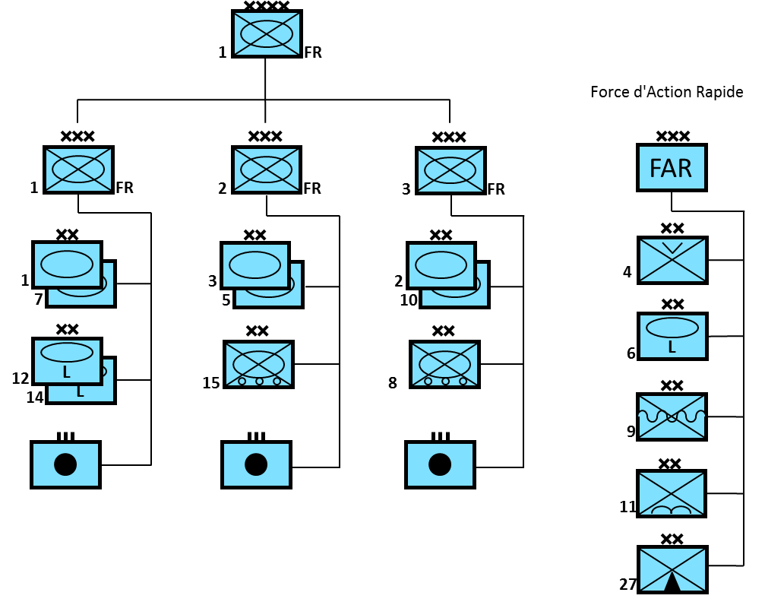

**Leclerc**

The French Army was in the initial stages of re-equipping its forces with this new Main Battle Tank (MBT) when Northern Fury occurs. This tank with very modern fire control, advanced armour and a 120mm gun was easily the equivalent of the M1A2 or the Leopard 2 in many respects, probably superior in some areas, and certainly a match for anything the Soviet forces had available at the time. Production commenced in 1992, with the first unit equipped by the end of 1993. Within 2e Régiment de Chasseurs, part of 10th Armoured Division is equipped with 80 of these new tanks, while further production continues at an increased pace.

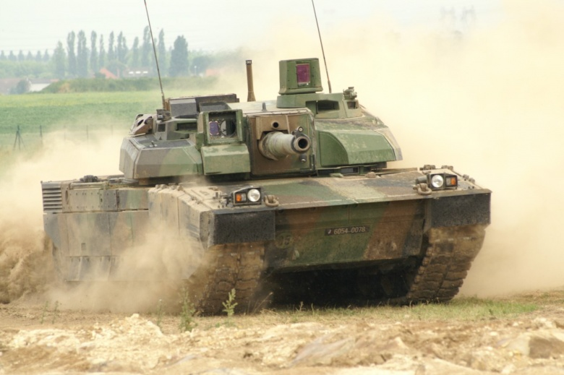

**AMX 30**

The standard MBT of the French Army, 1,355 of the original AMX 30 were accepted into service and in the 80’s and early 90’s the final 271 production tanks and 820 conversions (as originally planned and more than historic) were to the AMX 30 B2 standard with an improved fire control system, and a better engine. The non-stabilized 105mm gun puts this in an equivalent class to the American M60A1 or the Soviet T-62 – a good tank but not in the same league as the latest NATO or WP competitors. Many variants were produced, including an Air Defence version with Roland missiles, a Self Propelled Gun, engineering variants and even 44 ‘Pluton’ tactical nuclear missile launchers.

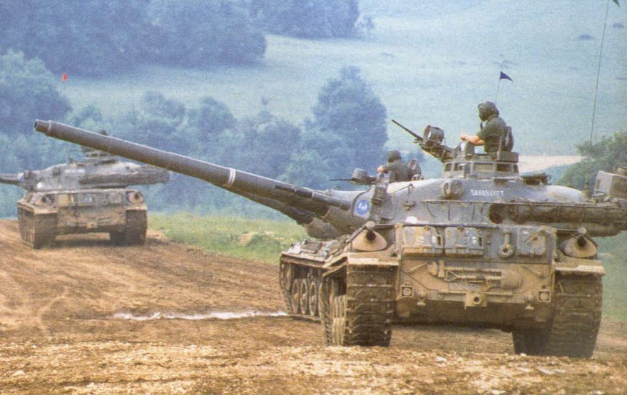

**Armoured Cars**

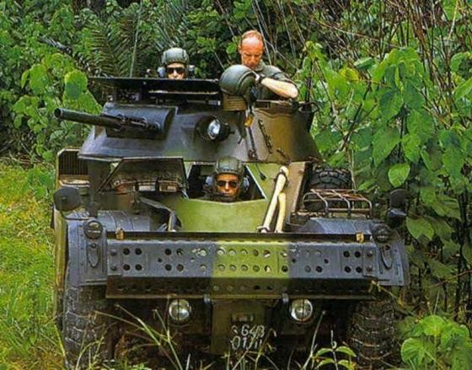

The French Army had various armoured cars for divers usage, mostly in the Light Armoured Divisions and reconnaissance roles. Over 425 AML-60 remained in service from an original procurement of over 3000, although there were several hundred in reserve. These are used in a reconnaissance role in most divisions and in the Foreign Legion but also provided the basis of a complete family of vehicles with many variations. The French Gendarmerie also use over one hundred examples of this vehicle.

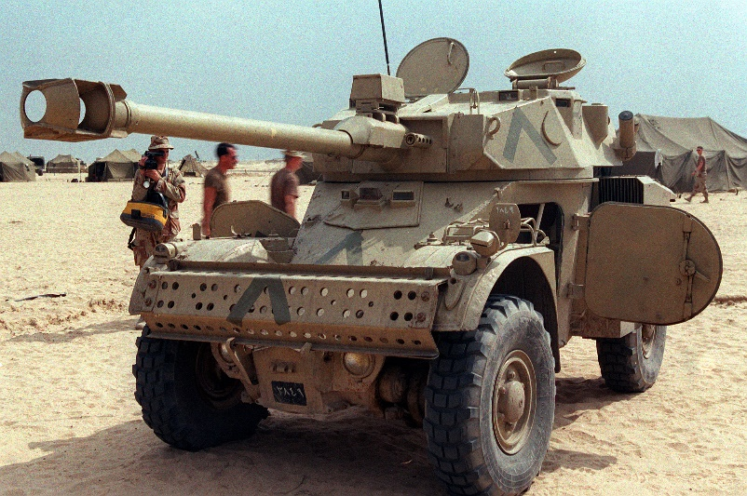

One of the more prolific variants of the AML was the AML-90 with a 90mm low velocity gun (short recoil). The Army uses 210 of these variants in the Light Armoured Divisions, reconnaissance units and for specialized units in other divisions. The Gendarmerie and Foreign Legion also uses this type.

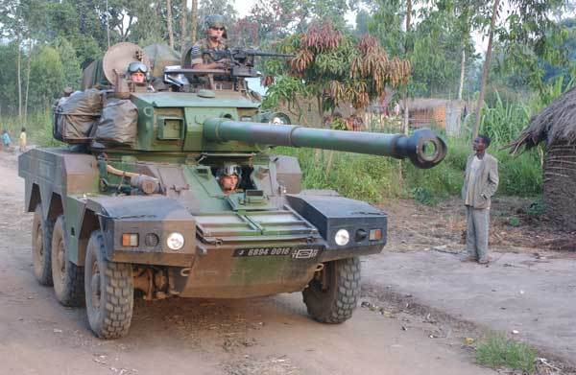

A more modern vehicle was needed to replace the AML-90 and in the early 80’s the ERC-90 was produced. Also with a 90mm gun but this was a smooth-bore cannon which allowed the firing of improved Armour-Piercing, Fin-Stabilized, discarding Sabot (APFSDS) ammunition. This improvement enabled a much better capacity to destroy older type Soviet tanks and other armoured vehicles out to a range of 2000 meters. Only 192 of these armoured cars entered service with the Marines, Airborne and Alpine divisions.

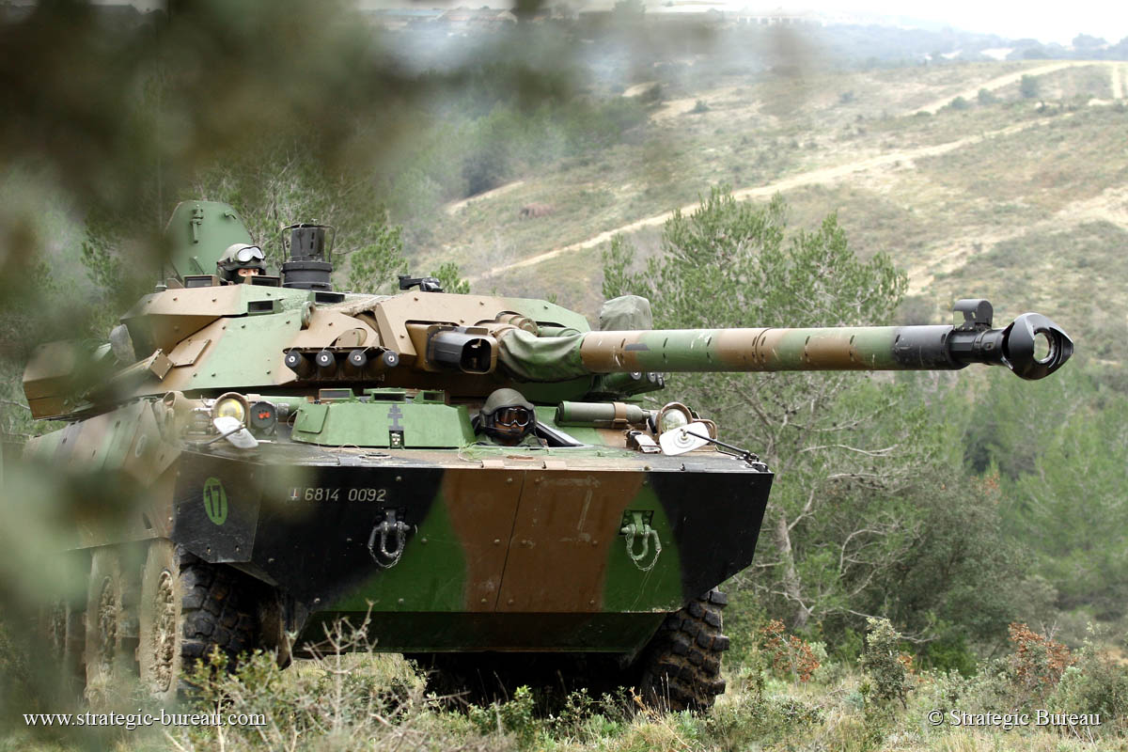

A more effective vehicle to support light forces is found in the AMX-10RC, which is a heavier 6-wheeled armoured car with a 105mm medium velocity gun. 284 of these vehicles can be round in the tank destroyer and reconnaissance roles in light armoured divisions, mechanized divisions, 9th Marine division and the Foreign Legion. The very capable gun is designed to be fired from light vehicles such as this and with specialized ammunition can penetrated the side of a Soviet MBT at 2000 meters. The hydropneumatic suspension is adaptive and allows for both high speeds and a low profile when needed.

**Armoured Personnel Carriers (APC)**

Like most French vehicles, their APCs were all French designed and built, with a mind for the export market. Also these vehicles were spawned many variations. The tracked APC (AMX-10P) had 15 different variants fielded while the wheeled APC (VAB) developed a staggering 35 variants from a riot control vehicle to Milan and HOT ATGM (Anti-Tank Guided Missile) launcher. All examples of these two vehicle families had NBC (Nuclear, Biological, Chemical) protection and were amphibious.

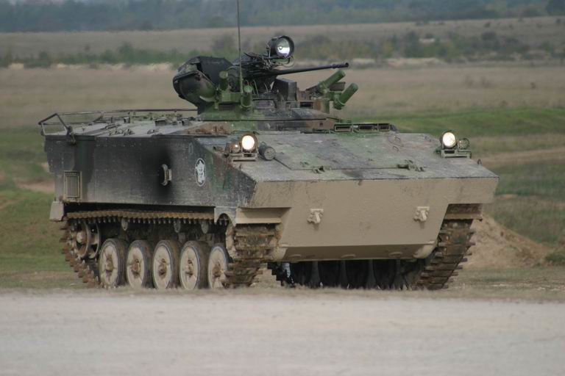

The tracked AMX-10P was used primarily in the mechanized infantry units of the heavy armoured divisions and their supporting artillery observers. Over 1500 of the base model with a 20mm autocannon were delivered as well as ambulance, recovery, ATGM, artillery observer, radar, mortar and mortar tractors, command, and cargo variants.

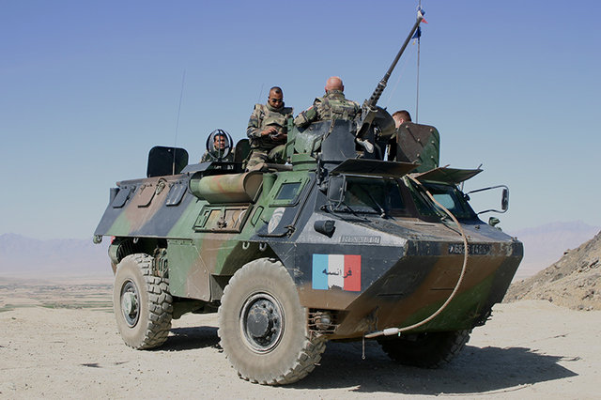

The wheeled counterpart to the AMX-10 is the VAB (Véhicule de l’Avant Blindé or Vanguard Armoured Vehicle). This was the most numerous APC in the French Army by a long margin with over 4000 in the inventory and over 1000 more produced for export. These are built in both a 4-wheel and 6-wheel configuration but the vast majority in French service are the 4-wheeled variety. This vehicle is amphibious, lightly armoured and armed and extremely versatile. Every division has at least one unit equipped with the VAB and dozens of variants are in use throughout the force.

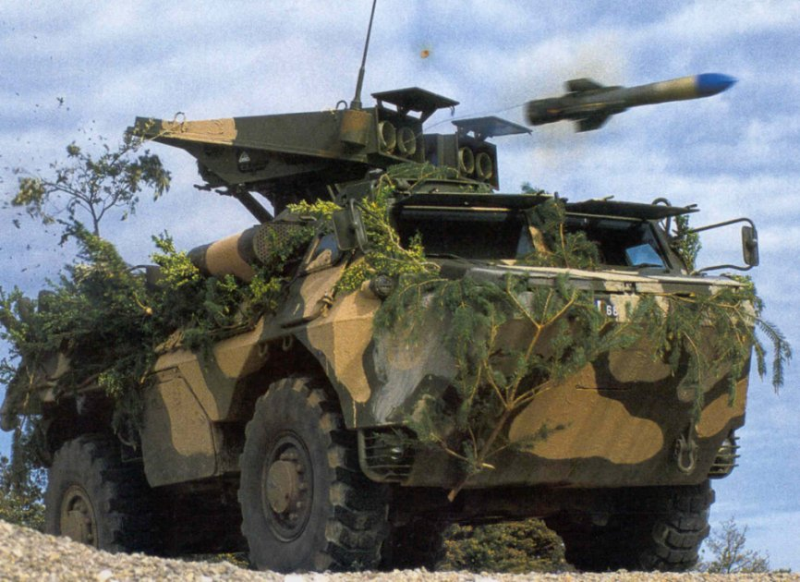

VAB firing a HOT Anti-Tank Guided Missile.

**Artillery**

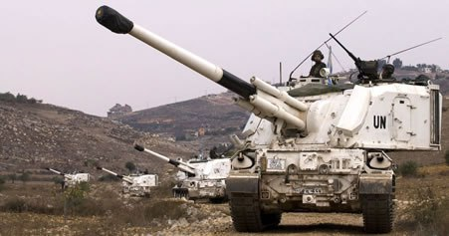

The French produced GCT was a 155mm howitzer built on an AMX 30 chassis. The gun provided NBC protection, and auto-loader enabling a rate of fire of 6-8 rounds per minute out to a range of 23,500 meters. Using rocket assisted projectiles the range increased to 28,000 meters. By 1994, 253 GCTs were in service, replacing most of the old and unprotected Mk3 guns produced in the 50’s.

Numerous older 155mm and 105mm artillery systems were in use in various roles within the French army.