**French Aircraft Carriers**

With the long and tortuous delays in building the Nuclear powered fleet carrier ***'Charles De Gaulle'***, France's existing Aircraft Carrier fleet has proceeded into obsolescence.

The two Clemenceau class carrier were commissioned in the early 60's and have already served 30 years. Less than half the size of American Aircraft Carriers, and with dated air wings, these ships are suitable for secondary roles only and are of limited value against a Soviet threat. Both were based at Toulon on the Mediterranean.

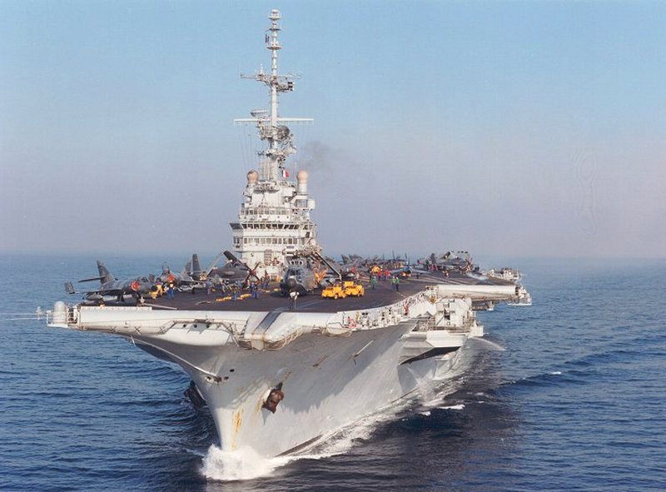

R 98 FS Clémenceau

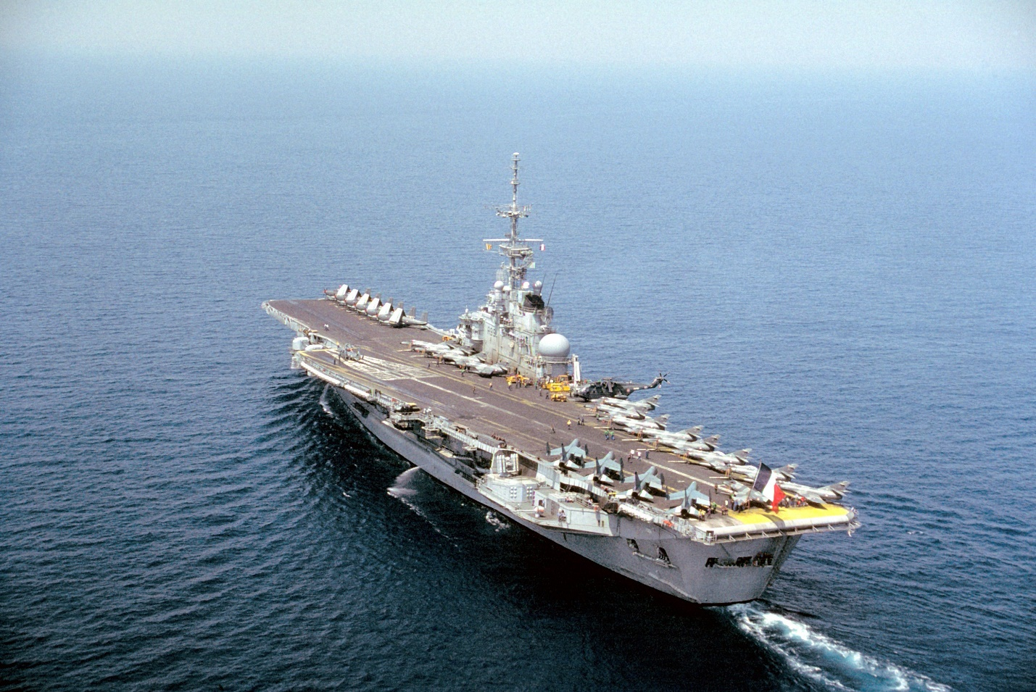

R 99 FS Foch

Rounding out the French carrier team is a ship almost complete relegated to officer training, but it does have a wartime Anti-Submarine Warfare role (ASW). The ASW Helicopter Carrier Jeanne D'Arc is based in the Atlantic at Brest but conducts annual world training tours, at the start of Northern Fury she is returning home through the Indian Ocean. Of a similar age and condition to the Clemenceau class, this ship is a cross between a cruiser and a carrier, similar to the Soviet Moskva Class.

