**FS Clemenceau (R 98)**

The Clemenceau was tied up at Toulon at war start undergoing routine maintenance and training. After three days of rapid preparation she was tasked to the Atlantic to work with the Royal Navy and re-take Vagar. She gathered her BG either in port of enroute through the western Mediterranean.

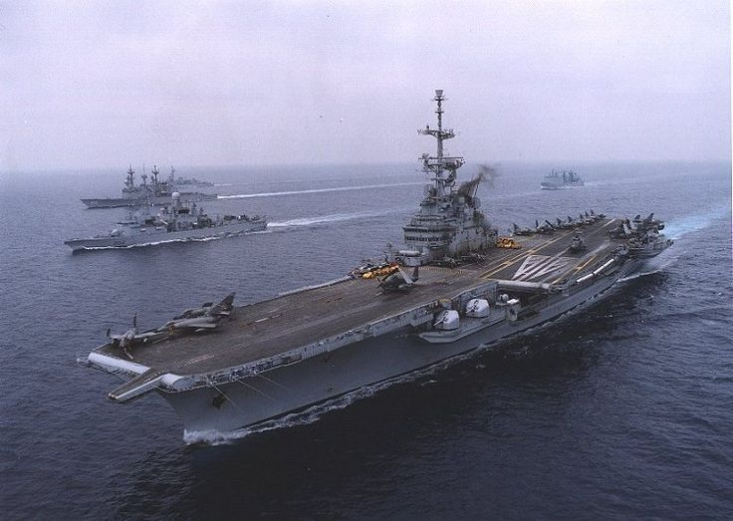

Organization 17 Feb

* + R 98 FS Clemenceau
  + Aviation Wing
    - Flottille 12F – 16x Super Etendard Mod
    - Flottille 14F – 8x F-8P Crusader
    - Flottille 22F – 8x BR.1050 Alize ALM
    - Flottille 32F – 2x SA.321G Super Frelon
    - Flottille 34S – 2x SA.365F Dauphin 2
  + D 602 FS Suffren
  + D 615 Jean Bart
  + D 642 Montcalm
  + D 612 De Grasse