**FS Jeanne d’Arc (R 97)**

The venerable Jeanne d’Arc conducts an annual world cruse as a training ship for naval officers, but her secondary role was as an Anti-Submarine Warfare command ship. At the start of the Northern Fury campaign she had just departed Reunion island in the Indian Ocean where she had undergone repairs to one of her engines.

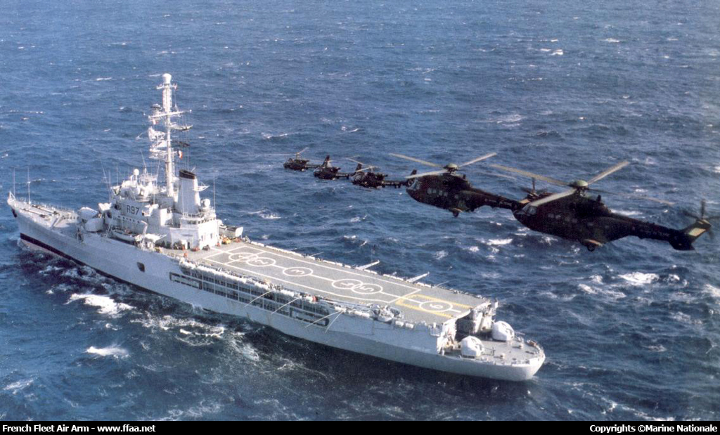

Battle Group

* + R 97 FS Jeanne d’Arc
  + Aviation Wing
    - Flottille 35F – 2x 1x SA.319B Alouette III
    - 3e RHC – 3x SA.342M Gazelle
    - 4e RHCM – 2x SA.332L1 Super Puma
  + F 787 FS Amyot d'Inville