**French Destroyers**

France classifies its escort ships by size and not function, therefore each class is assigned a role, either ASW or Missile which are primarily Air Defence (AD), the later classes are more universal in capability. The terms Destroyer and Frigate are also used interchangeably with the title of Frigate belonging to what other navies would term Offshore Patrol Vessels.

[**Suffren Class**](http://www.seaforces.org/marint/French-Navy/Destroyer-Frigate/Suffren-class.htm): Built in the 1960s from the ground up as Air Defence ships, the primary role of these two large ships is to protect the Clemenceau class aircraft carriers. Both were modernized between 1989 and 1991 and carry 48 MASURCA Surface to Air Missiles (SAM), these are medium range French designed and produced missiles that are unique to this class of ship. (They were retrofitted onto the cruiser *Colbert* but that retired in 1991).

| **Pennant** | **Class** | **Ship** | **Status** | **Location** | **Role** | **Task** |
| --- | --- | --- | --- | --- | --- | --- |
| D 602 | Suffren | Suffren | Active | Med | AD | Clem BG |
| D 603 | Suffren | Duquesne | Active | Med | AD | Foch BG |

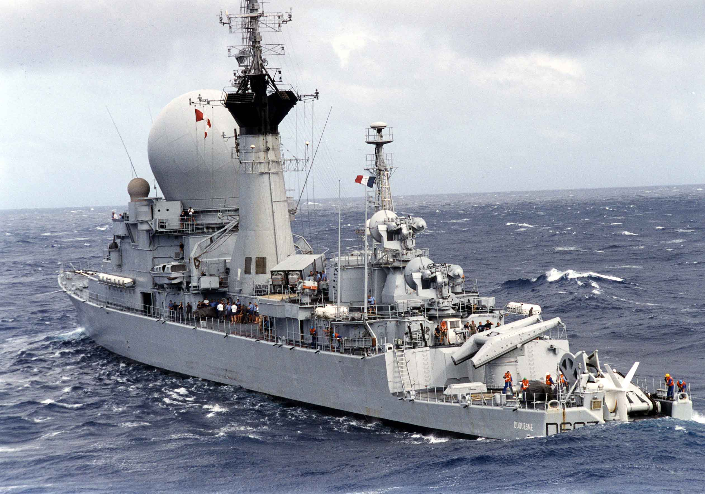

[**Aconit**](http://www.seaforces.org/marint/French-Navy/Destroyer-Frigate/D-609-FS-Aconit.htm): This ship was to be the lead ship in a class of five and was designed around two evolving technologies in the late 1960s; a Towed Array sonar and the MALAFON ASW missile. Unfortunately, she took 5 years to build and did not have helicopter facilities so the program was terminated. She was upgraded in the mid-80s and received Exocet Anti-Ship Missiles (ASM) and again in 1992 with a new Towed Array, some point defences against missile and air attack. She is smaller than her successors but works to augment ASW Task Groups.

| **Pennant** | **Class** | **Ship** | **Status** | **Location** | **Role** | **Task** |
| --- | --- | --- | --- | --- | --- | --- |
| D 609 | Aconit | Aconit | Active | Atlantic | ASW |  |

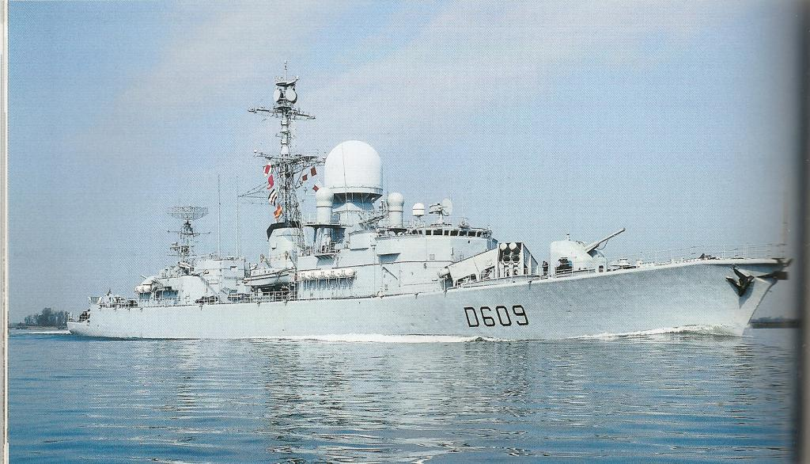

[**Tourville Class**](http://www.seaforces.org/marint/French-Navy/Destroyer-Frigate/Tourville-class.htm)**:** These three ships are optimized for ASW and were essentially an larger evolution of the Aconit class, equipped with two ASW helicopters and fitted with the Crotale SAM system. Focusing on ASW work in the North Atlantic where they performed admirably in company with NATO ships.

| **Pennant** | **Class** | **Ship** | **Status** | **Location** | **Role** | **Task** |
| --- | --- | --- | --- | --- | --- | --- |
| D 610 | Tourville | Tourville | Active | Atlantic | ASW |  |
| D 611 | Tourville | Duguay-Trouin | Active | Atlantic | ASW |  |
| D 612 | Tourville | De Grasse | Active | Atlantic | ASW |  |

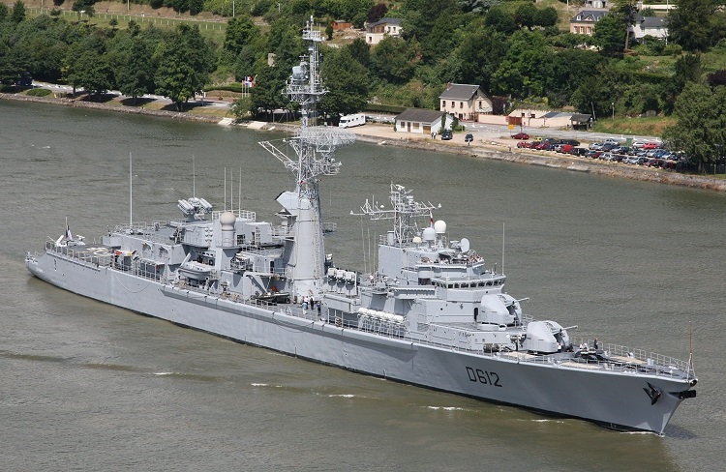

[**Cassard Class**](http://www.seaforces.org/marint/French-Navy/Destroyer-Frigate/Cassard-class.htm): Built in 1988 and 1991 the two ships of this class are an AD variation of the Georges Leygues Class of ASW ships. The two classes share the same hull and many systems but the Cassard Class has a different superstructure, weapons fit and propulsion system. Designed as a modern AD ship able to fire the NATO(US) Standard SM-1MR SAM and capable of coordinating airspace with NATO ships using the LINK-16 data communications system, these ships are a major improvement in the AD spectrum for the French Navy. They also carry one Lynx ASW helicopter and have Exocet ASMs. Both are based in the Mediterranean and often serve duty escorting the aircraft carriers along with the Suffern Class, but are well rounded ships that can lead small Task Groups or act independently.

| **Pennant** | **Class** | **Ship** | **Status** | **Location** | **Role** | **Task** |
| --- | --- | --- | --- | --- | --- | --- |
| D 614 | Cassard | Cassard | Active | Med | AAW | Foch BG |
| D 615 | Cassard | Jean Bart | Active | Med | AAW | Clem BG |

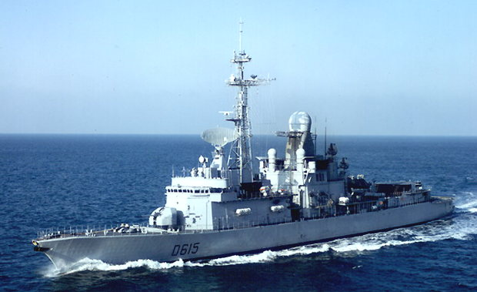

[**Georges Leygues class**](http://www.seaforces.org/marint/French-Navy/Destroyer-Frigate/Georges-Leygues-class.htm): Sharing the same hull as the Cassard class, the seven ships of this ASW oriented class replace the medium range SAMs for shorter ranged Crotale SAMs, a Towed Array Sonar and a second helicopter. These are well rounded general purpose ships which are used in many roles.

| **Pennant** | **Class** | **Ship** | **Status** | **Location** | **Role** | **Task** |
| --- | --- | --- | --- | --- | --- | --- |
| D 640 | Georges | Georges Leygues | Active | Med | ASW |  |
| D 641 | Georges | Dupleix | Active | Med | ASW | Foch BG |
| D 642 | Georges | Montcalm | Active | Med | ASW | Clem BG |
| D 643 | Georges | Jean de Vienne | Active | Red Sea | ASW | Djibouti |
| D 644 | Georges | Primauguet | Active | Atlantic | ASW |  |
| D 645 | Georges | Lamotte-Picquet | Active | Atlantic | ASW |  |
| D 646 | Georges | Latouche-Treville | Active | Atlantic | ASW |  |

