**French Frigates**

In the French Navy, Frigates are meant for either coastal ASW patrol or for overseas patrols in a low threat environment. France has many overseas possessions and to adequately patrol the protect its economic interests around the world it uses these small and versatile ships.

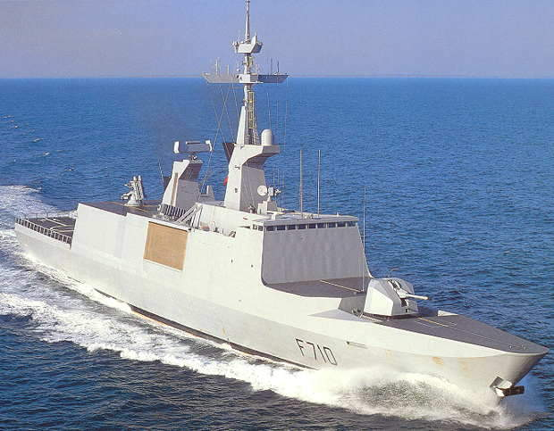

[**La Fayette Class**](https://en.wikipedia.org/wiki/La_Fayette-class_frigate): In the Northern Fury world the La Fayette class was started 2 years earlier then it was historically and the name-ship of the class is on her first deployment to the Persian Gulf when war breaks out. Called the ‘Stealth Frigate’, she has a sleek modern shape with a reduced radar cross section. The weapons suite is fairly standard although modernized with New Generation (NG) Crotale Surface to Air (SAM) short range missiles and Block II Exocet Anti-Ship Missiles (ASM), but the electronic and sensor suite is quite extensive.

| **Pennant** | **Class** | **Ship** | **Status** | **Location** | **Role** | **Task** |
| --- | --- | --- | --- | --- | --- | --- |
| F 710 | La Fayette | La Fayette | Active | Persian Gulf | Patrol | CTF 150 |

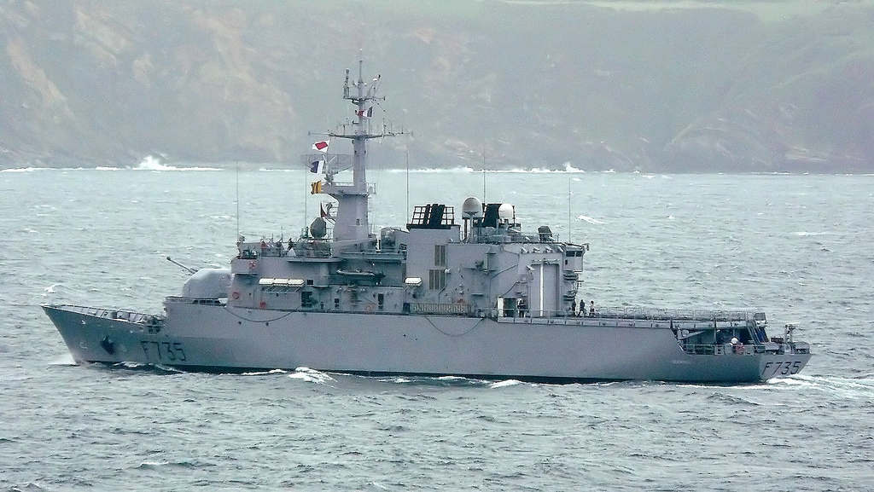

[**Floreal Class**](https://en.wikipedia.org/wiki/Floréal-class_frigate): These ships are small and inexpensive, built to commercial and not military standards, they are not meant for warfighting and have only a modest weapons suite; they are Offshore Patrol Vessels (OPV) more than Frigates. The two Exocet ASMs could not hope to succeed overcoming the defences to sink a warship, but they are enough to fend of pirates or commerce raiders. They can host a helicopter which is a major asset in any situation.

| **Pennant** | **Class** | **Ship** | **Status** | **Location** | **Role** | **Task** |
| --- | --- | --- | --- | --- | --- | --- |
| F 730 | Floreal | Florial | Active | Indian Ocean | Patrol | CTF 151 |
| F 731 | Floreal | Prairial | Active | Pacific Ocean | Patrol |  |
| F 732 | Floreal | Nivose | Active | Atlantic | Patrol |  |
| F 733 | Floreal | Ventose | Active | Caribbean | Patrol |  |
| F 734 | Floreal | Vendemiaire | Active | Pacific | Patrol |  |
| F 735 | Floreal | Germinal | Active | Atlantic | Patrol |  |

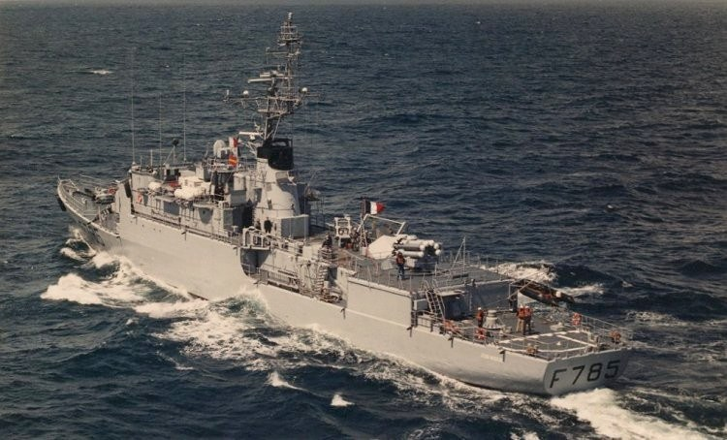

[***D'Estienne d'Orves*-class**](https://en.wikipedia.org/wiki/D%27Estienne_d%27Orves-class_aviso): Known as the A69 Type ship they are small and economical, primarily designed for coastal ASW patrol, they can also fulfill the overseas patrols. Many Navies would consider the A69 class to be a Corvette due to its small displacement of less than 1200 Tons. There are 17 ships of this class in service, the last seven having an improved weapons fit with 2x Exocet ASMs.

|  |  |  |  |  |  |  |
| --- | --- | --- | --- | --- | --- | --- |
| **Pennant** | **Class** | **Ship** | **Status** | **Location** | **Role** | **Task** |
| F 781 | A69 | D'Estienne d'Orves | Active | Pacific | ASW |  |
| F 782 | A69 | Amyot d'Inville | Active | Caribbean | ASW |  |
| F 783 | A69 | Drogou | Active | Persian Gulf | ASW | CTF 150 |
| F 784 | A69 | Détroyat | Active | Mediterranean | ASW |  |
| F 785 | A69 | Jean Moulin | Active | Indian | ASW |  |
| F 786 | A69 | Quartier-Maître Anquetil | Active | Indian | ASW | CTF 151 |
| F 787 | A69 | Commandant de Pimodan | Active | Pacific | ASW |  |
| F 788 | A69 | Second-Maître Le Bihan | Active | Caribbean | ASW |  |
| F 789 | A69 | Lieutenant de vaisseau Le Hénaff | Refit | Atlantic | ASW |  |
| F 790 | A69 | Lieutenant de vaisseau Lavallée | Active | Atlantic | ASW |  |
| F 791 | A69 | Commandant l'Herminier | Active | Atlantic | ASW |  |
| F 792 | A69 | Premier-Maître L'Her | Active | Atlantic | ASW |  |
| F 793 | A69 | Commandant Blaison | Active | Atlantic | ASW |  |
| F 794 | A69 | Enseigne de vaisseau Jacoubet | Active | Mediterranean | ASW |  |
| F 795 | A69 | Commandant Ducuing | Active | Mediterranean | ASW |  |
| F 796 | A69 | Commandant Birot | Refit | Mediterranean | ASW |  |
| F 797 | A69 | Commandant Bouan | Active | Mediterranean | ASW |  |