**The French Navy**

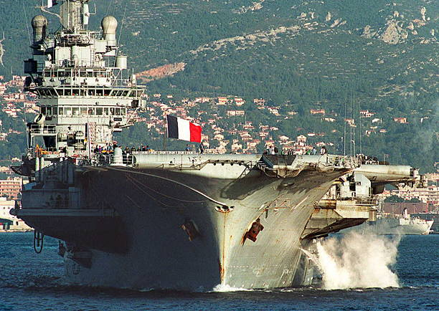

The French Navy is relatively large but stretched thin with global commitments and is suffering from some dated technology. In addition to maintaining its strategic Nuclear Ballistic Missile Submarines (SSBN) the French Navy stations fleets both in the Atlantic 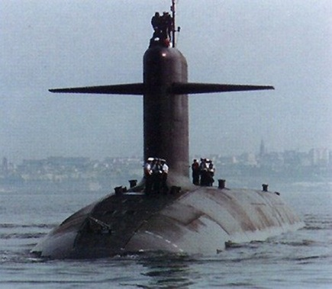and the Mediterranean as well as routine global deployments. The Naval Air Arm is of significant size but largely consists of older aircraft. The long lead time for delivery of the Rafale fighter and the new aircraft carrier (Charles de Gaulle) has put a strain on operational commitments and readiness.

