**French Submarines**

France, like Britain maintains a small fleet of submarines covering the full gamut of capabilities. The Redoubtable class nuclear powered Ballistic Missile submarines (SSBN) provide much of France’s strategic deterrence, the Rubis class nuclear powered fleet boats (SSN) provide operational flexibility while the small diesel powered Agosta class (SSK) provide the ability to operate in shallow coastal waters.

[**Redoutable Class**](https://en.wikipedia.org/wiki/Redoutable-class_submarine_(1967)): These SSBN (SNLE in French) form the naval arm of the French strategic nuclear triad, the five active boats have been heavily upgraded (*Foudroyant* completed in 1993) to fire the much improved M4 Ballistic missile with six MIRV (Multiple independently targetable reentry vehicle) warheads of 150 Kilotonnes. Generally, two boats are on patrol, one is refitting and the other two are preparing for patrol. The replacement class of SSBNs *Le Triomphant*, is under construction and the five remaining *Redoutable* class will retire as the four new boats are commissioned beginning in 1997.

| **Pennant** | **Class** | **Ship** | **Status** | **Location** | **Task** |
| --- | --- | --- | --- | --- | --- |
| S 611 | Redoutable | Redoutable | Mothballed | Brest | Deterrence |
| S 612 | Redoutable | Terrible | Active | Brest | Deterrence |
| S 610 | Redoutable | Foudroyant | Active | Brest | Deterrence |
| S 613 | Redoutable | Indomptable | Active | Patrol | Deterrence |
| S 614 | Redoutable | Tonnant | Refitting |  | Deterrence |
| S 615 | Redoutable | Invlexible | Active | Patrol | Deterrence |

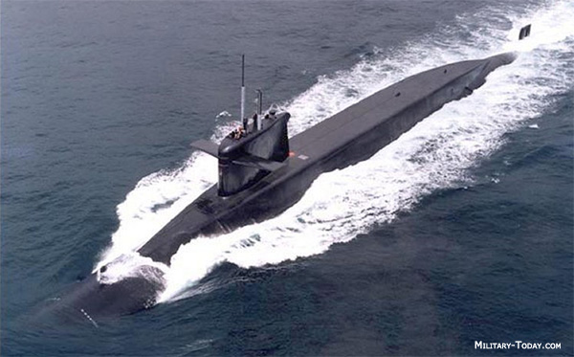

[**Rubis Class**](http://www.military-today.com/navy/rubis_class.htm): The smallest SSNs ever built, these are based on the same hull design as the *Agosta* class SSK with a French designed reactor. Initially four boats were built in the 1980s with two improved [*Amethyste* Class](http://www.military-today.com/navy/amethyste_class.htm) commissioned in 1992 and 1993. All four of the original boats were upgraded with equivalent systems and hull design to the *Amethyste* boats, the last is still undergoing that refit. In Northern Fury, the last two *Amethyste* boats have not been canceled and are still building. In addition to torpedoes, these boats can fire the Exocet Anti-Ship Missile (ASM)

| **Pennant** | **Class** | **Ship** | **Status** | **Location** | **Task** |
| --- | --- | --- | --- | --- | --- |
| S 601 | Rubis | Rubis | Active | Mediterranean | Foch BG |
| S 602 | Rubis | Saphire | Active | Indian Ocean | CTF 151 |
| S 603 | Rubis | Cassabianca | Active | Port |  |
| S 604 | Rubis | Emeraude | Refitting |  |  |
| S 605 | Amethyste | Amethyste | Active | Pacific | New Caledonia |
| S 606 | Amethyste | Perle | Active | Atlantic | Bay of Biscay |
| S 607 | Amethyste | Turquoise | Building | March 94 |  |
| S 608 | Amethyste | Diamant | Building | June 95 |  |

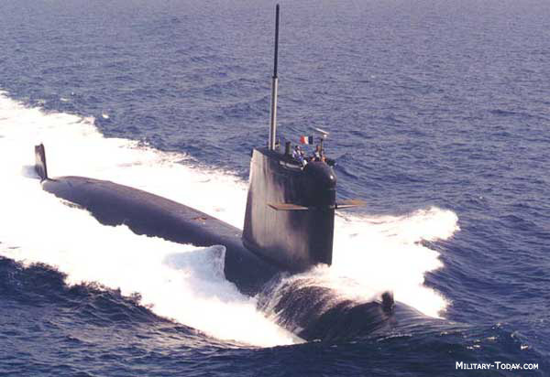

[***Agosta* class**](http://www.military-today.com/navy/agosta_class.htm): These small, maneuverable and very quiet boats represent the last conventionally powered submarines built by France. They have four unique torpedo tubes which can operate quietly at any depth and speed, they have all been refitted to fire the Exocet ASM. La Praya has the capacity to fit a removable swimmer delivery compartment, similar to the US Dry Dock Shelter (DDS)

| **Pennant** | **Class** | **Ship** | **Status** | **Location** | **Task** |
| --- | --- | --- | --- | --- | --- |
| S 620 | Agosta | Agosta | Active | Atlantic | Bay of Biscay |
| S 621 | Agosta | Bévéziers | Active | Adriatic | Op Sharp Guard |
| S 622 | Agosta | La Praya | Active | Port |  |
| S 623 | Agosta | Ouessant | Active | Atlantic | Azors |

